TABLE OF CONTENTS
TABLE OF CONTENTS 1
SECTION 1—INTRODUCTION 9
SUBMITTING AUDITED FINANCIAL STATEMENTS TO THE COMPTROLLER GENERAL’S OFFICE 9
ABOUT THIS MANUAL 10
Purpose of This Manual; Limitations 10
Scope of Application of This Manual’s Policies 11
Organization and Format 11
Policies Printed within a Boxed Border 11
Citations Referencing the GASB Codification and GASB Statements 11
June 30 vs. December 31 12
Annual Updates; Questions about Policies 12
OTHER HELPFUL MATERIALS 12
Comptroller General’s Office’s Financial Statement Review Checklist 12
The State of South Carolina’s ACFR 12
SECTION 2—APPLICATION OF PROFESSIONAL LITERATURE 13
STATEWIDE ACCOUNTING POLICIES 13
THE GAAP HIERARCHY’S APPLICATION TO GOVERNMENTAL ENTITIES 13
NEW GASB PRONOUNCEMENTS AND DATES FOR STATE AGENCIES AND COMPONENT UNITS TO IMPLEMENT NEW GASB PRONOUNCEMENTS 13
GFOA CERTIFICATE OF ACHIEVEMENT FOR EXCELLENCE IN FINANCIAL REPORTING 15
SECTION 3—FINANCIAL STATEMENTS AND REQUIRED SUPPLEMENTARY INFORMATION 16
INDEPENDENT AUDITORS’ OPINION 16
MANAGEMENT’S DISCUSSION AND ANALYSIS (MD&A) 16
Minimum and Maximum Requirements for MD&A 16
Comparative Data 16
Unnecessary Duplication 17
Focus on the Primary Government 17
GOVERNMENT-WIDE FINANCIAL STATEMENTS 17
Requirement to Present Government-Wide Financial Statements 17
Governmental and Business-Type Activities Defined 18
FUND FINANCIAL STATEMENTS 18
Presentation of Combining Financial Statements for Non-Major Funds and Multiple Fiduciary Funds 18
STATEMENTS OF POSITION 18
Government-wide Statement of Net Position—Classified Format 18
Government-wide Statement of Net Position—Net Position Format 19
Governmental Fund Balance Sheets—Minimum Level of Detail for Fund Balances 19
Proprietary Funds Statement of Net Position—Classified Format 20
Fiduciary Funds Statement of Net Position 20
OPERATING STATEMENTS AND STATEMENTS OF ACTIVITIES 20
Government-wide Statement of Activities—Intergovernmental Expenses, Grants and Revenue-Sharing 20
Statement of Revenues, Expenditures, and Changes in Fund Balances—Level of Detail 20
Statement of Revenues, Expenses, and Changes in Net Position—Proprietary Fund Revenues 21
Unusual or Infrequent Items 21
Statement of Changes in Assets and Liabilities—Fiduciary Funds 22
REQUIRED SUPPLEMENTARY INFORMATION—BUDGETARY COMPARISON 22
STATEMENTS OF CASH FLOWS 22
Statements of Cash Flows—Direct Method 22
Statements of Cash Flows—Focus on Cash and Cash Equivalents 23
Statements of Cash Flows—Appreciation/Depreciation in Investments 23
RECONCILIATION OF GOVERNMENT-WIDE STATEMENTS TO FUND FINANCIAL STATEMENTS 23
ELIMINATIONS 24
Eliminations within Government-wide Financial Statements 24
Eliminations within Fund Financial Statements 25
SECTION 4—COMPONENT UNITS 26
GOVERNMENTAL AND NON-GOVERNMENTAL COMPONENT UNITS 26
SEPARATE COLUMN REQUIRED FOR EACH BLENDED COMPONENT UNIT 28
Governmental Blended Component Units 28
Non-Governmental Blended Component Units 29
“The Number of Funds Principle” and the Notion of “Functional Basis Combining” 29
RESOURCE FLOWS INVOLVING BLENDED COMPONENT UNITS 30
SEPARATE COLUMN REQUIRED FOR EACH DISCRETELY PRESENTED COMPONENT UNIT 30
Non-Governmental Discretely Presented Component Units 30
Statements of Cash Flows Not Presented 31
AUDITED FINANCIAL STATEMENTS REQUIRED FOR EACH DISCRETELY PRESENTED COMPONENT UNIT 31
RESOURCE FLOWS INVOLVING DISCRETELY PRESENTED COMPONENT UNITS 32
NOTES TO THE FINANCIAL STATEMENTS FOR DISCRETELY PRESENTED COMPONENT UNITS 32
SECTION 5—FINANCIAL STATEMENT COMPONENTS 33
RESTRICTED ASSETS AND LIABILITIES 33
CASH AND INVESTMENTS 33
DISAGGREGATION OF RECEIVABLE AND PAYABLE BALANCES 34
CAPITAL IMPROVEMENT, ECONOMIC DEVELOPMENT, AND RESEARCH INFRASTRUCTURE BONDS RECEIVABLES/REVENUE 34
INTERFUND RECEIVABLES AND PAYABLES 36
INVENTORY REPORTING METHOD 36
PREPAID EXPENSES 36
CAPITAL ASSETS DEFINED 37
CAPITAL ASSETS—CATEGORIES FOR FINANCIAL REPORTING 37
Land and Nondepreciable Land Improvements 37
Depreciable Land Improvements 37
Infrastructure 37
Buildings and Improvements 38
Construction in Progress 39
Vehicles 39
Machinery and Equipment 39
Works of Art and Historical Treasures 40
Intangible Assets 40
CAPITAL ASSETS—CAPITALIZATION CRITERIA 42
CAPITALIZATION POLICY CRITERIA THROUGH JUNE 30, 2026 43
CAPITALIZATION POLICY CRITERIA EFFECTIVE JULY 1, 2026 44
Internal Control 45
CAPITAL ASSETS—BOOK VALUE 45
Book Value of Purchased or Constructed Capital Assets 45
Book Value of Donated Capital Assets 45
Book Value of Capital Assets Acquired by Forfeiture or Condemnation 45
Book Value of Capital Assets Received through Intra-State Transfers 45
Book Value of Capital Assets Acquired through Trade-in 46
Carrying Value of Right-to-Use Lease Assets Subject to GASB 87 or Right-to Use Subscription-Based Technology Agreements (SBITAs) Assets Subject to GASB 96 46
CAPITAL ASSETS—DEPRECIATION REQUIREMENTS 47
Calculation of Depreciation Using the Straight-Line Method 47
Selection of Useful Life for Depreciation Purposes 47
Re-evaluation of Assets’ Useful Lives 49
CAPITAL ASSETS—GAIN/LOSS ON SALES 50
CAPITAL ASSETS—IMPAIRMENT AND INSURANCE RECOVERIES 50
GOVERNMENTAL FUND LIABILITIES 51
LONG-TERM DEBT—LEVEL OF DETAIL 52
POSTEMPLOYMENT BENEFITS OTHER THAN PENSIONS 52
COMPENSATED ABSENCES 53
STATE CAPITAL IMPROVEMENT BONDS AND NET INVESTMENT IN CAPITAL ASSETS 53
RESTRICTED Position 53
Definition 53
Purpose Categories of Restricted Net Position to be Reported 54
OPERATING VS. NONOPERATING REVENUES AND EXPENSES 54
GRANT/CONTRIBUTION REVENUE—RECOGNITION 54
Enterprise, Internal Service, and Trust Funds Reported on Fund Financial Statements; Activities of Governmental, Enterprise, and Internal Service Funds Reported on Government-wide Financial Statements 55
Governmental Funds Reported on Fund Financial Statements 55
GRANT/CONTRIBUTION REVENUES IN PROPRIETARY FUNDS—OPERATING OR NON-OPERATING 56
CLASSIFICATION OF PROGRAM-SPECIFIC GRANTS AND CONTRIBUTIONS—OPERATING VERSUS CAPITAL 56
INDIRECT EXPENSES 57
REQUIRED RECOGNITION OF PLEDGES AS RECEIVABLES AND REVENUES 57
INTERNAL SERVICE FUNDS 57
FIDUCIARY FUNDS 58
SECTION 6—FOOTNOTE DISCLOSURES 60
LIST OF DISCLOSURES REQUIRED BY GAAP 60
SUMMARY OF SIGNIFICANT ACCOUNTING POLICIES 60
Reporting Entity Disclosures 60
Basis of Accounting—Modified Accrual Availability Period 61
Permanent Funds 61
Enterprise Funds—Reasons for Classification as Enterprise Fund 61
Fiduciary Funds 62
Cash Equivalents 62
Inventory Policy Disclosures 63
Capital Assets 63
Application of Restricted Net Position before or after Unrestricted Net Position 63
Proprietary Funds—Policy Defining Operating Revenues and Expenses 64
EFFECTS OF ACCOUNTING AND REPORTING CHANGES ON BEGINNING FUND EQUITY/NET POSITION 65
Changes in Capitalization Criteria 66
Implementation of GASB 103 and GASB 104 67
RESTRICTED ASSETS 67
CASH, DEPOSITS, AND INVESTMENTS DISCLOSURES 68
Reconciliation of Cash/Cash Equivalents Reported on the Statement(s) of Position to the Footnote Disclosures on Deposits and Investments 69
Deposits Disclosure 69
Investments Disclosure 71
GASB 31 & 72 Disclosures about Investments 75
DERIVATIVES 76
RECEIVABLES FOOTNOTE—MINIMUM LEVEL OF DETAIL 76
PAYABLES FOOTNOTE—MINIMUM LEVEL OF DETAIL 77
DISCLOSURES ABOUT BALANCES ARISING FROM INTRA-STATE ACTIVITIES 78
DISCLOSURES REGARDING MATERIAL INTERFUND BALANCES AND TRANSFERS 79
CAPITAL ASSET AND ACCUMULATED DEPRECIATION BALANCES 79
OTHER REQUIRED DISCLOSURES FOR CAPITAL ASSETS 81
Construction Commitments Outstanding 81
Capital Assets Held for Sale 82
Noncapitalized Collections of Works of Art and Historical Treasures 83
Capital Asset Impairment 83
SHORT-TERM DEBT 83
LONG-TERM OBLIGATIONS 83
Long-Term Obligations Disclosures—Level of Detail 84
Changes in Long-Term Obligations 85
Debt Service to Maturity 86
REFUNDINGS OF DEBT 87
LEASES 88
Separate Presentation for Leases with Different Types of Parties 88
Five-Year Increments after the First Five Subsequent Fiscal Years 88
Current Year Lease Payments 88
Schedules of Leases 88
Assets Acquired under Leases 89
Facilities Leased to Others 90
Contingent Rentals Associated with Leases 90
DETAIL OF STATE APPROPRIATIONS RECORDED AS REVENUE 92
REQUIRED DISCLOSURE OF UNRECOGNIZED PLEDGES DEEMED NOT MEASURABLE 95
INTERNAL SERVICE FUNDS—REVENUE FROM INTERNAL CUSTOMERS 95
SEGMENT REPORTING 96
RELATED ORGANIZATIONS, RELATED PARTY TRANSACTIONS, AND TRANSACTIONS WITH DISCRETELY PRESENTED COMPONENT UNITS 96
REQUIRED INFORMATION ON BUSINESS-TYPE ACTIVITIES FOR THE GOVERNMENT-WIDE STATEMENT OF ACTIVITIES 98
NET POSITION CATEGORIZED DIFFERENTLY IN STATEWIDE ACFR THAN IN AGENCY FINANCIAL STATEMENTS 101
SECTION 7—DEPARTMENT OF TRANSPORTATION 102
INFRASTRUCTURE 102
Reporting Roads and Bridges 102
Depreciation of Roads and Bridges 103
Maintenance of Infrastructure Records 103
CAPITAL OUTLAY 103
CLASSIFICATION OF STATE HIGHWAY BONDS 103
REQUIRED SUPPLEMENTARY INFORMATION—BUDGETARY COMPARISON 103
SECTION 8—COLLEGES AND UNIVERSITIES 105
FINANCIAL STATEMENT PRESENTATION—GENERAL 105
STATEMENT OF REVENUES, EXPENSES, AND CHANGES IN NET POSITION 106
FINANCIAL STATEMENT PRESENTATION—COLUMNS 106
FINANCIAL SPREADSHEETS 107
CLASSIFICATION OF STATE INSTITUTION BONDS 107
SCHOLARSHIP ALLOWANCES 107
Federal Pell Grant Activity 108
FEDERAL PERKINS LOAN PROGRAM ACTIVITY 108
THIRD-PARTY STUDENT LOANS 109
ACTIVITIES ACCOUNTED FOR IN fiduciary Funds under the AICPA Model 110
Footnote disclosure for DEBT SERVICE LIMITATION ON STATE INSTITUTION BONDS 110
Footnote disclosure for Donor-restricted endowments 110
APPENDIX A—THE STATE’S DISCRETELY PRESENTED COMPONENT UNITS 112
APPENDIX B—AGENCIES BY FUNCTION 114
APPENDIX C—THE STATE’S MAJOR ENTERPRISE FUNDS 115
APPENDIX D—FINANCIAL STATEMENT SPREADSHEETS AND FORMS, COLLEGES AND UNIVERSITIES 116
INTRODUCTION 116
ACTION REQUIRED BY THE INSTITUTION 117
DUE DATES 117
WORKING PAPERS 118
GENERAL INSTRUCTIONS—RESPONSIBILITY AND ACCURACY FORM 119
SPECIFIC INSTRUCTIONS—RESPONSIBILITY AND ACCURACY FORM 119
GENERAL INSTRUCTIONS—FOUNDATIONS ANALYSIS FORM 120
SPECIFIC INSTRUCTIONS—FOUNDATIONS ANALYSIS FORM 120
GENERAL INSTRUCTIONS—STATEMENT OF NET POSITION SPREADSHEET 121
SPECIFIC INSTRUCTIONS—STATEMENT OF NET POSITION SPREADSHEET 121
GENERAL INSTRUCTIONS—STATEMENT OF ACTIVITES SPREADSHEET 124
SPECIFIC INSTRUCTIONS—STATEMENT OF ACTIVITIES SPREADSHEET 124
GENERAL INSTRUCTIONS—CASH AND INVESTMENTS 125
SPECIFIC INSTRUCTIONS—CASH AND INVESTMENTS 126
GENERAL INSTRUCTIONS—COLLEGE/UNIVERSITY CHECKLIST 127
SPECIFIC INSTRUCTIONS—COLLEGE/UNIVERSITY CHECKLIST 127
APPENDIX E—CLASSIFICATION OF AMOUNTS RECEIVED BY COLLEGES AND UNIVERSITIES FROM THE COMMISSION ON HIGHER EDUCATION (CHE) 128

SECTION 1—INTRODUCTION

SUBMITTING AUDITED FINANCIAL STATEMENTS TO THE COMPTROLLER GENERAL’S OFFICE
The Comptroller General's Office (CGO) expects to receive draft and final financial statements in accordance with contractual arrangements between the auditors and the State Auditor’s Office. If the audit was not contracted by the State Auditor’s Office, the CGO expects to receive financial statements for the most recently ended fiscal year no later than October 1. If applicable, refer to the contract between your agency, the State Auditor’s Office, and your auditors, as your due date might be sooner than October 1. If your contract date is sooner than October 1, the earlier date is your due date. Please submit a draft of your audited financial statements 15 days prior to your final due date.

Proviso 117.55 of the State’s 2025-20256 Appropriations Act regarding late submissions of audited financial statements became effective July 1, 2024. The Proviso reads:
Agencies, institutions, and other reporting entities required to submit annual audited financial statements for inclusion in the State’s Annual Comprehensive Financial Report must submit final audited financial statements to the Comptroller General not later than October first for those with fiscal year-end June thirtieth. The South Carolina Retirement Systems, Insurance Benefits, and Other Post-Employment Benefits Trust Funds administered by the South Carolina Public Employee Benefit Authority must submit their final audited financial statements no later than October fifteenth. For institutions and reporting entities with fiscal year-ends other than June thirtieth, final audited financial statements must be submitted to the Comptroller General within 120 days of that fiscal year-end. The Comptroller General shall provide a written report of each agency, institution, or other reporting entity not in compliance with this provision to the State Fiscal Accountability Authority by November thirtieth.

To minimize review comments and review time taken by the CGO, agencies and their auditors are strongly encouraged to apply the CGO’s Financial Statement Checklist before submitting their draft statements to the CGO for review. (Go to http://www.cg.sc.gov/; click on State Agency Info, then on GAAP Reporting, then on Agencies That Submit Financial Statements.)

For audits contracted by the State Auditor’s Office, the draft and final financial statements must be sent directly to that office for subsequent transmittal to the CGO.
For audits not contracted by the State Auditor’s Office, the CGO asks that only an electronic copy be sent of the draft and final financial statements directly to our office. Contact information is as follows:
E-mail: ACFR@cg.sc.gov

If you are unable to send the financial statements in the preferred electronic format, send one hard copy to the following address:
Comptroller General’s Office
Financial Reporting Division
1200 Senate Street, Room 305
Columbia, South Carolina 29201

In person deliveries may be made to Third Floor of the Wade Hampton Office Building, Capitol Complex (directly behind the State House). The division’s main telephone number is
(803) 734-2128.

ABOUT THIS MANUAL

Purpose of This Manual; Limitations
This policy manual is designed to provide policies and guidance to the accountants and auditors of those State agencies, higher education institutions, and other entities that have separate audits of their financial statements and that submit their audited reports to the State of South Carolina’s Office of the Comptroller General for incorporation in the statewide annual comprehensive financial report (ACFR).
This policy manual is not intended to constitute a comprehensive guide to Generally Accepted Accounting Principles (GAAP) applicable to entities reported as part of the State of South Carolina. In fact, it assumes that users are thoroughly knowledgeable about basic GAAP for governmental entities. Instead, this manual focuses on selected complex GAAP issues that have caused problems in the past and on reporting requirements that derive from the State’s participation in the Government Finance Officers Association’s Certificate of Achievement for Excellence in Financial Reporting Program and goes beyond the requirements of GAAP pronouncements.
Further, this manual is limited to matters that directly affect incorporation of agency financial statements into the State of South Carolina’s ACFR. For example, the manual does not address other post-employment benefit disclosures because the CGO obtains information for these statewide ACFR disclosures directly from the South Carolina Employee Insurance Programs. Stand-alone agency financial statements must be produced in such a way as to satisfy the requirements of the State Auditor’s Office as well as the requirements of the CGO.

Scope of Application of This Manual’s Policies
In accordance with State law, the Comptroller General’s Office (CGO) determines and issues policies that will apply to entities within the State’s primary government submitting financial statements for incorporation into the statewide ACFR. These policies also apply to component units that meet the GASB 14 (as amended by GASB 39 and GASB 61) criteria for blending.
Discretely presented component units are required to implement and follow all relevant GASB statements. Discretely presented component units are encouraged, but not required, to adopt the same accounting policies that apply to the State primary government. Regardless of possible differences in policies, the Comptroller General’s Office depends on the management of discretely presented component units to supply supplementary data needed for inclusion in the statewide ACFR if not supplied in the component unit’s stand-alone financial statements.
The guidance in this policy manual does not apply to the audited financial statements for agencies that are included in the statewide ACFR through submission of Reporting Packages (such as Department of Public Safety, Governor’s Office, and Department of Disabilities and Special Needs).

Organization and Format
This policy manual is divided into eight sections. The sections related to the Department of Transportation and to colleges and universities (Sections 7 and 8) are specific to those agencies and apply exclusively to those agencies. The remaining sections (Sections 1 through 6, plus this introductory section) apply to all State agencies, colleges and universities, and other entities that submit audited financial statements for inclusion in the statewide ACFR.

Policies Printed within a Boxed Border
State policies for entities incorporated into the statewide ACFR from audited financial statements are formatted with a boxed border for emphasis.

Citations Referencing the GASB Codification and GASB Statements
Most references to the GASB’s Codification of Governmental Accounting and Financial Reporting Standards are cited by specific paragraph, for example, GASB Cod. Sec. 2300.103 (Section 2300, paragraph .103), rather than by reference to a specific GASB, NCGA, or AICPA pronouncement.
If a particular GASB statement is referenced, the short, abbreviated form such as “GASB 34” rather than “GASB Statement No. 34” is typically used.

June 30 vs. December 31
Policies within this manual focus on reporting at June 30 because the State’s fiscal year ends on
June 30. Some entities incorporated into the statewide ACFR from audited financial statements have a fiscal year ending December 31. When reading this manual, those entities generally should substitute “December 31” for “June 30.”

Annual Updates; Questions about Policies
The CGO updates this policy manual annually for new authoritative literature, changes in State policy and clarifications on issues identified in the preceding year. The manual is posted to the Comptroller General’s Office’s website at http://www.cg.sc.gov/.
Agencies should address questions related to State accounting policies to the staff of the Financial Reporting Division of the Comptroller General’s Office.

OTHER HELPFUL MATERIALS

Comptroller General’s Office’s Financial Statement Review Checklist
Under an agreement with the State Auditor’s Office (SAO), certain staff members of the Office of Comptroller General (CGO) review draft financial statements for each agency incorporated into the statewide ACFR from separately issued financial statements. To facilitate its review process, the CGO has developed a checklist that applies to each set of draft financial statements reviewed. The CGO has made this checklist available to the public on its website. Agency personnel and their auditors are strongly encouraged to complete the checklist themselves before the draft financial statements are submitted to the SAO and CGO for review. Use of the checklist will help to identify many problems that, if left uncorrected, will result in review comments.

The State of South Carolina’s ACFR
The most recently issued ACFR for the State of South Carolina is available at http://www.cg.sc.gov/. The CGO recommends that accountants responsible for preparing financial statements incorporated into the statewide ACFR (as well as their auditors) refer to the most recently issued statewide ACFR in conjunction with their use of this policy manual and the above-described checklist.

SECTION 2—APPLICATION OF PROFESSIONAL LITERATURE

STATEWIDE ACCOUNTING POLICIES
Generally Accepted Accounting Principles (GAAP) require that governments establish various policies. Some of these policies must be disclosed in the notes to the financial statements.
In accordance with the Annual Appropriations Act, the Office of the Comptroller General (CGO) determines and issues policies that will apply to entities in the State primary government that submit financial statements for inclusion in the statewide Annual Comprehensive Financial Report (ACFR). These policies also apply to component units that meet the GASB 14 (as amended by GASB 39 and GASB 61) criteria for blending.

THE GAAP HIERARCHY’S APPLICATION TO GOVERNMENTAL ENTITIES
The GAAP hierarchy determines the status of various professional pronouncements with respect to their application to governments. All GASB statements and interpretations that have not been amended or superseded apply to all activities, funds, and governmental component units (but not to non-governmental component units) reported in the State of South Carolina’s Annual Comprehensive Financial Report (ACFR).

NEW GASB PRONOUNCEMENTS AND DATES FOR STATE AGENCIES AND COMPONENT UNITS TO IMPLEMENT NEW GASB PRONOUNCEMENTS
It is generally advisable, and sometimes required by GAAP, for all state agencies and component units to initially implement new GASB pronouncements on a schedule that is specifically coordinated with the State of South Carolina’s implementation plans. This is especially true if the new pronouncement changes accounts or account balances presented in the financial statements and/or reduces or eliminates previously required disclosures. The Comptroller General has issued a directive that new pronouncements will be implemented on the required date as applied against the State’s ACFR and there will be no early implementations.

The new GASB pronouncements that apply to fiscal year 2026 are as follows:
Statement No. 103, Financial Reporting Model Improvements, is effective for fiscal years beginning after June 15, 2025, and all reporting periods thereafter. For June 30, 2026, financial statements, agencies and component units should apply GASB 103 to MD&A; unusual or infrequent items; proprietary fund presentation, including operating and nonoperating classifications and the required operating income (loss) and noncapital subsidies subtotal; major component unit presentation; budgetary comparison information; and related statistical-section trend information, as applicable.

Statement No. 104, Disclosure of Certain Capital Assets, is effective for fiscal years beginning after June 15, 2025, and all reporting periods thereafter. For June 30, 2026, financial statements, agencies and component units should apply GASB 104 to capital asset note disclosures for certain capital assets and to capital assets held for sale, including the evaluation criteria and required disclosures. GASB 104 should be applied retroactively to all periods presented, if practicable.
Agencies and component units also should evaluate how the implementation of GASB 103 affects statistical-section trend information or other schedules included in separately issued financial statements or submitted for inclusion in the statewide ACFR. Affected schedules should be updated consistently with the revised presentation requirements, as applicable. As this is a change in accounting principle, the amounts included in supplementary information and other information should not be retroactively adjusted (GASB 100-Paragraph 36). Information included in the required supplementary information (RSI), such as the MD&A, should be adjusted for all years presented.

GFOA CERTIFICATE OF ACHIEVEMENT FOR EXCELLENCE IN FINANCIAL REPORTING
The State of South Carolina’s policy is to prepare the statewide ACFR in accordance with the requirements for the Government Finance Officers Association’s (GFOA’s) Certificate of Achievement for Excellence in Financial Reporting. The 2024 edition of Governmental Accounting, Auditing, and Financial Reporting (otherwise known as the “Blue Book”) is an excellent resource to use in ensuring compliance with GFOA’s reporting requirements.
The Comptroller General’s Office encourages preparers and auditors to apply the appropriate Certificate of Achievement Program’s checklist to the stand-alone financial statements of State of South Carolina entities that will be incorporated into the statewide ACFR.
To access the GFOA checklists, go to www.gfoa.org, from the left selection box under Award Programs, select the Certificate of Achievement for Excellence in Financial Reporting (COA) Award Program. The checklists appear in the program information section. The State of South Carolina utilizes the General-Purpose Governments list primarily. However, the other checklists provide excellent references for promulgated literature on other specific topics.

SECTION 3—FINANCIAL STATEMENTS
AND REQUIRED SUPPLEMENTARY INFORMATION

INDEPENDENT AUDITORS’ OPINION
The Independent Auditors’ Report (the opinion) should accurately identify your agency’s or institution’s status relative to the State of South Carolina in the introductory paragraph. For example, the opinion should not state that your agency is a component unit of the State if, in fact, it is part of the State’s primary government. The opinion also should accurately reflect the method of presentation within the statewide ACFR of any component units (i.e., blended vs. discretely presented). Check to be sure that the assertions within the opinion regarding the status of the agency/institution and/or its component units match their presentation in the State’s ACFR. (The preceding year’s statewide ACFR is available at https:// cg.sc.gov/.)
Additional guidance on appropriate reference in the opinion is available from AICPA resources including its Audits of State and Local Governments.

MANAGEMENT’S DISCUSSION AND ANALYSIS (MD&A)

Minimum and Maximum Requirements for MD&A
GASB 103, paragraphs 4–8, establish the current requirements for MD&A and supersede the prior GASB 34 framework. The MD&A should provide an objective and easily readable analysis based on currently known facts, decisions, or conditions; compare current-year balances and results of operations with the prior year; and explain why balances and results changed rather than only presenting dollar or percentage changes (GASB 103, paragraphs 4–5). The MD&A should avoid unnecessary duplication and boilerplate language and should focus on the primary government while distinguishing information of discretely presented component units when such information is included (GASB 103, paragraphs 6–7). The information presented in MD&A should be limited to the five sections required by GASB 103, paragraph 8: (a) Overview of the Financial Statements, (b) Financial Summary, (c) Detailed Analyses, (d) Significant Capital Asset and Long-Term Financing Activity, and (e) Currently Known Facts, Decisions, or Conditions.
Each specific requirement in subparagraphs a through e in paragraph 8 should be considered both a minimum and a maximum for content allowed to be presented within the MD&A.
Information that does not relate to the required topics may not be included in MD&A but may be provided elsewhere, such as in the letter of transmittal, in the notes if there is a required disclosure, or in other forms of supplementary information.
The MD&A is considered to be Required Supplementary Information (RSI).

Comparative Data
Paragraph 5 of GASB 103 indicates that MD&A should discuss the current year’s results in comparison with the prior year, with an emphasis on the current year. This analysis should be fact based and should discuss the activities that have had either a significant positive impact or a significant negative impact on the government’s balances and results of operations in comparison with the prior year. The analysis should assist users in understanding why balances and results of operations reported in the current year’s financial statements changed from the prior year rather than simply presenting the amounts or percentages by which they changed. The use of charts, graphs, and tables is encouraged to enhance the understandability of the information.
The financial summary information required by GASB 103, paragraph 8(b), should be presented in the form of condensed financial information. Charts and graphs may be used to supplement, or elaborate on, information in the condensed financial information, but should not be used in place of the required comparative analysis and explanation of significant changes required by GASB 103, paragraph 5.

Unnecessary Duplication
Paragraph 6 of GASB 103 notes the analysis in the MD&A should avoid unnecessary duplication and paragraph 8 notes the need to avoid “boilerplate” discussion. Certain explanations may be relevant to the discussion in multiple sections of the MD&A. Those explanations may be repeated after they have been presented initially, but that is not required. Determining whether to repeat explanations within multiple sections of the MD&A is a matter of professional judgment.

Focus on the Primary Government
Paragraph 7 of GASB 103 requires that MD&A focus on the primary government, which would include the blended component units. Comments in MD&A should distinguish between information pertaining to the primary government and that of its discretely presented component units. Determining whether to discuss matters related to a discretely presented component unit is a matter of professional judgment and should be based on the nature and significance of the individual component unit’s relationship to the primary government. If appropriate, the reporting entity’s MD&A should refer users to the component units separately issued financial statements.

GOVERNMENT-WIDE FINANCIAL STATEMENTS

Requirement to Present Government-Wide Financial Statements
The State’s policy is that agencies reporting any governmental funds must present government-wide statements within their basic financial statements as required by GASB 34, including a reconciliation between the governmental fund statement and the amounts reported in the government-wide statements. The purpose of agency government-wide statements is to present the agency’s balances that should be incorporated into the State’s government-wide statements. A note disclosure may be included to explain how the reader should interpret the agency’s government-wide statements and the fact that the agency is merely a part of the State, not a separate independently operated government.

Stand-alone business-type activities, if not required by GAAP to present government-wide financial statements, must comply with the policies set forth in Section 6, FOOTNOTE DISCLOSURES, of this manual within the sub-section on REQUIRED INFORMATION ON BUSINESS-TYPE ACTIVITIES FOR THE GOVERNMENT-WIDE STATEMENT OF ACTIVITIES .

Governmental and Business-Type Activities Defined
Governmental activities of the State of South Carolina include general, special revenue funds, capital projects funds, permanent funds, and internal service funds. Business-type activities of the State include only enterprise funds. Agency financial statements should reflect this policy.

FUND FINANCIAL STATEMENTS
All agencies submitting financial statements to be incorporated into the statewide ACFR must prepare fund financial statements to comply with GAAP.

Presentation of Combining Financial Statements for Non-Major Funds and Multiple Fiduciary Funds
The State of South Carolina participates in the Certificate of Achievement for Excellence in Financial Reporting Program of the Governmental Finance Officers Association. To be eligible for the Certificate of Achievement, the State must present combining statements for non-major funds and for multiple fiduciary funds as supplementary information, even though this is not required by GAAP. As a result, the State’s policy is to present combining financial statements for its nonmajor funds and for its fiduciary funds.
State agency financial statements incorporated in the statewide ACFR must present combining statements for all non-major funds (including non-major blended component units) and for multiple fiduciary funds, if applicable.

STATEMENTS OF POSITION

Government-wide Statement of Net Position—Classified Format
The State of South Carolina’s policy is to use a classified format (rather than an order-of-liquidity format) for its government-wide Statement of Net Position.
Agencies should use the classified format for their government-wide Statement of Net Position if they are required to present that statement.
Agencies using the format of example A-4 in Appendix C of GASB 34 must submit a separate schedule showing the current and non-current portions of assets and liabilities for the government-wide Statement of Net Position column.
The CGO believes that the State’s financial statement users will find the classified format easier to comprehend because that format is required for certain other financial statements. The classified format distinguishes between current and long-term assets as well as between current and long-term liabilities.

Government-wide Statement of Net Position—Net Position Format
Paragraph 8 of GASB 63 encourages governments to present the government-wide Statement of Net Position using a format that displays Total Assets, plus Deferred Outflows of Resources, less Total Liabilities, less Deferred Inflows of Resources, equals Net Position, rather than a traditional balance sheet format. The CGO plans to present a statewide Statement of Net Position using a net position format.
The CGO, however, has concluded that the difference between the two formats is a purely formal difference and that it can determine the information it needs for the statewide ACFR from agency financial statements, regardless of which format agencies use.
Agencies that present a government-wide statement of position may use either the net position format or the traditional balance sheet format.

Governmental Fund Balance Sheets—Minimum Level of Detail for Fund Balances
Under the balance sheet format, as revised by GASB 63, assets equal liabilities plus deferred inflows of resources plus fund balances. Please note that there are no items that have been identified as deferred outflows of resources for the governmental funds.
Classification of governmental fund balances shall be segregated in accordance with GASB 54 including nonspendable fund balance, restricted fund balance, committed fund balance, assigned fund balance, and unassigned fund balance. Nonspendable should be shown separately on the face of the statements for not in spendable form and legally or contractually required to be maintained intact. Details in the disclosure must distinguish between the major restricted purposes within the restricted fund balances and specific purposes for the committed and assigned fund balance classifications. Any deficits in unassigned fund balance must be explained in the notes to the financial statements.

Proprietary Funds Statement of Net Position—Classified Format
Paragraph 97 of GASB 34 requires that assets and liabilities of proprietary funds be presented in a classified format to distinguish between current and long-term assets and liabilities.
Paragraph 8 of GASB 63 allows the State to use either a net position format or a balance sheet format to report the State’s proprietary funds. The State of South Carolina will use the net position format (rather than the balance sheet format) for its proprietary fund statement of position.
The CGO, however, has concluded that the difference between the net position format and the balance sheet format is a purely formal difference and that it can determine the information it needs for the statewide ACFR from agency proprietary fund financial statements, regardless of which format agencies use.
Agencies that present proprietary funds must present a classified statement of position but may use either the net position format or the traditional balance sheet format.

Fiduciary Funds Statement of Net Position
Paragraph 8 of GASB 63 requires that fiduciary funds present a Statement of Fiduciary Net Position using a net position format (i.e., assets plus deferred outflows of resources, less liabilities less deferred inflows of resources equal net position).

OPERATING STATEMENTS AND STATEMENTS OF ACTIVITIES

Government-wide Statement of Activities—Intergovernmental Expenses, Grants and Revenue-Sharing
States may include an "intergovernmental" functional category on their government-wide Statement of Activities (as shown on page 169 of the first GASB 34 Implementation Guide) rather than reporting state grants issued to local governments and state revenues shared with local governments in their other functional categories.
Agency financial statements that report governmental funds must report any grants or State shared revenues disbursed to non-State governmental entities separately from other “programs” or “functions” that they include on their Statement of Activities.

Statement of Revenues, Expenditures, and Changes in Fund Balances—Level of Detail
Revenues should be presented by source. Expenditures in governmental funds should be presented by character and function within character. Additional details (such as department, object of expenditure) may be presented but are not required by GAAP.
The expenditure’s character is based on the periods it is presumed to benefit. Expenditures that benefit the present period (current expenditures) are distinguished from those that benefit both present and future periods (debt service expenditures) and from those presumed to benefit both the present and future fiscal periods (capital outlay expenditures). GASB Cod. Sec. 1800.120 states: “'Intergovernmental,' a fourth character classification, is appropriate where one governmental unit transfers resources to another, such as when states transfer ‘shared revenues’ to local governments or act as an intermediary in federally financed programs.” The State of South Carolina uses the “intergovernmental” functional category on its Statement of Revenues, Expenditures, and Changes in Fund Balances, Governmental Funds.
Agency financial statements that report governmental funds must report grants or State shared revenues disbursed to external parties separately from other expenditures that they include in their fund operating statement.

Statement of Revenues, Expenses, and Changes in Net Position—Proprietary Fund Revenues
GASB 103, paragraphs 11–14, establish the current presentation requirements for the proprietary fund statement of revenues, expenses, and changes in fund net position. Agencies should continue to distinguish operating revenues and expenses from nonoperating revenues and expenses (paragraph 11), define operating revenues and expenses as revenues and expenses other than nonoperating revenues and expenses (paragraph 13), and define nonoperating revenues and expenses as subsidies received and provided, contributions to permanent and term endowments, revenues and expenses related to financing, resources received from the disposal of capital assets and inventory, and investment income and expenses (paragraph 13). Agencies should present operating income (loss) and noncapital subsidies as a subtotal before reporting other nonoperating revenues and expenses (paragraph 12) and should apply the GASB 103 subsidy definition in paragraph 14.
Further, the presentation of revenues should reflect the effect of discounts and allowances. This can be accomplished in one of two ways. One approach is to report revenues on a net basis, with discounts and allowances disclosed separately, either parenthetically or in the notes to the financial statements. The other approach is to report gross revenues followed immediately by deductions for discounts and allowances to arrive at net revenues.
The State’s policy is to report revenues on a net basis with a detailed note on receivables. Please see RECEIVABLES FOOTNOTE in Section 6 for agency presentation requirements.

Unusual or Infrequent Items
GASB 103, paragraphs 9–10, replace the previous special and extraordinary items presentation model with requirements for unusual or infrequent items. An unusual or infrequent item is a transaction or other event that is either unusual in nature or infrequent in occurrence. Inflows and outflows related to unusual or infrequent items should be presented separately and should not be netted. Unusual or infrequent items should be presented as the last presented flow of resources before the net change in resource flows in the government-wide, governmental fund, and proprietary fund statements of resource flows.
Agencies should evaluate unusual or infrequent items each reporting period. When an unusual or infrequent item is reported, the notes to the financial statements should disclose the program, function, or identifiable activity to which the item is related and whether the item is within the control of management.

Statement of Changes in Assets and Liabilities—Fiduciary Funds
The GFOA Certificate of Achievement Program requires that the State of South Carolina prepare, as supplementary information, a combining statement of changes in fiduciary net position for all fiduciary funds. For each agency/institution that has fiduciary funds and issues audited financial statements, the Comptroller General’s Office must be able to obtain this information from the separately issued audited financial statements.
Separately issued agency financial statements for GAAP agency funds must include a supplemental statement of changes in assets and liabilities.

REQUIRED SUPPLEMENTARY INFORMATION—BUDGETARY COMPARISON
GASB 103, paragraph 16, requires budgetary comparison information to be presented as required supplementary information using a single method of communication for the general fund and each major special revenue fund that has a legally adopted annual budget. Budgetary comparison information should include variances between original and final budget amounts and variances between final budget and actual amounts.
Agencies that present budgetary comparison information as required supplementary information should include explanations of significant variances in the notes to the RSI. Detailed budget-to-actual variance explanations generally should not be presented in MD&A unless they also relate to currently known facts, decisions, or conditions expected to significantly affect financial position or results of operations.

STATEMENTS OF CASH FLOWS

Statements of Cash Flows—Direct Method
Paragraph 105 of GASB 34 requires presentation of a Statement of Cash Flows for proprietary funds based upon the provisions of Statement 9, as amended by GASB 34. The direct method of presenting cash flows from operating activities (including a reconciliation of operating cash flows to operating income) is required.
The GASB 9 Implementation Guide and Exercise #7 on pages 241 through 243 of the first GASB 34 Implementation Guide provide additional guidance relative to preparing the
direct method cash flows statement.

Statements of Cash Flows—Focus on Cash and Cash Equivalents
The focus of the statewide statements of cash flows is Cash and Cash Equivalents (also see Cash Equivalents in Section 5).
The focus of agency cash flows statements to be incorporated into the statewide basic financial statements must be Cash and Cash Equivalents.

Statements of Cash Flows—Appreciation/Depreciation in Investments
Paragraph 37, “Information about Noncash Investing, Capital, and Financing Activities,” of GASB 9, Reporting Cash Flows of Proprietary and Nonexpendable Trust Funds and Governmental Entities That Use Proprietary Fund Accounting, requires that your agency’s financial statements report all noncash investing, capital, and financing activities that affect recognized assets, deferred outflows of resources, liabilities, or deferred inflows of resources (i.e., investing, capital, and financing activities that affect recognized assets or liabilities but do not result in cash receipts or cash payments in the period). Paragraph 37 further requires that such activities be presented in either narrative or tabular form in a separate schedule accompanying the Statement of Cash Flows.
An often-overlooked example of a noncash transaction that must be reported in accordance with the above guidance is the net appreciation/depreciation in the value of investments reported at fair value but not classified as cash and cash equivalents. Another example of an often-overlooked noncash transaction is the entering into a lease transaction as recognized in accordance with GASB 87.
Agencies must include any net appreciation/depreciation in the fair value of any investments not classified as cash and cash equivalents in a narrative or tabular schedule of noncash activities accompanying the Statement of Cash Flows.

RECONCILIATION OF GOVERNMENT-WIDE STATEMENTS TO FUND FINANCIAL STATEMENTS
Paragraph 77 of GASB 34 requires governments to present a summary reconciliation to the government-wide financial statements at the bottom of the fund financial statements or in an accompanying schedule. In many cases, brief explanations presented on the face of the statements will be sufficient to allow users to assess the relationship between the statements. However, if aggregated information in the summary reconciliation obscures the nature of the individual elements of a particular reconciling item, governments should provide a more detailed explanation in the notes to financial statements.
Generally, the amounts reported as net position and changes in net position in the proprietary fund statements for total enterprise funds will be the same as the net position and changes in net position of business-type activities in the government-wide Statement of Activities. However, if there are differences (for example, in connection with consolidating the activities of internal service funds), they should be explained on the face of the fund financial statement or in an accompanying schedule as discussed in paragraph 77 of GASB 34.
GAAP does not specify the minimum level of detail required for a summary reconciliation. The CGO has concluded that the minimum level of detail should be at least that described in paragraph 90 of GASB 34. That is the State’s summary reconciliation will separately address the following:
- Reporting revenues on the full accrual basis.
- Reporting annual depreciation expense and changes in capital assets instead of expenditures for capital outlays.
- Reporting long-term debt proceeds in the Statement of Net Position as liabilities instead of other financing sources.
- Reporting debt principal payments in the Statement of Net Position as reductions of liabilities instead of expenditures.
- Reporting other expenses and revenues on the accrual basis (i.e. amortization of deferred outflows related to debt refunding).
- Adding the net revenue (expense) of internal service funds, as discussed in paragraph 62 of GASB 34.
- Reporting balances and changes in balances of other long-term items such as the net pension liability,
Each agency presenting government-wide financial statements must present a reconciliation that meets the above specifications. An agency also must present a reconciliation that meets the above specifications if it presents only business-type activities and the amounts reported as net position and changes in net position in the proprietary fund statements for total enterprise assets differ in any way from the net position and changes in net position of the agency’s business-type activities to be reported in the State’s government-wide Statement of Activities.

ELIMINATIONS

Eliminations within Government-wide Financial Statements
The statements should include the primary government and its component units, except for the fiduciary funds of the primary government and component units that are fiduciary in nature. Those funds and component units should be reported only in the statements of fiduciary net position and changes in fiduciary net position. Paragraphs 57 through 62 of GASB 34 specify certain eliminations and reclassifications that are to be performed with respect to government-wide financial statements.

Eliminations within Fund Financial Statements
Although GAAP does not require interfund eliminations (between funds), GAAP implicitly require intrafund eliminations (within the same fund) by virtue of the fact that all GASB references to internal activity and balances reported in the basic financial statements discuss only interfund activity and balances and by virtue of its use of the word "consolidation" in a number of places. Another indication that the GASB intends governments to eliminate intrafund activity and balances is the answer to Question 7.47.23 in the GASB’s Comprehensive Implementation Guide—2011-2012.
The State's policy is to eliminate revenue/expenditure activity and receivable/payable balances that exist wholly internal to a single reported fund (i.e., to perform intrafund eliminations), but to record no interfund eliminations except for certain assets held for others (certain deposits, for example). Agency financial statements must reflect this policy.

SECTION 4—COMPONENT UNITS
Governments are required to report their component units in accordance with GASB 14 as amended by paragraphs 124-128 of GASB 34, GASB 39 and GASB 61, and the guidance outlined in Chapter 4 of the GASB’s Comprehensive Implementation Guide—2011-2012.

GOVERNMENTAL AND NON-GOVERNMENTAL COMPONENT UNITS
Component units may be governmental or non-governmental. Financial statement preparers should classify each component unit based on the following definition that has been agreed upon by the GASB:
- Public corporations and bodies corporate and politic are governmental organizations. Other organizations are governmental organizations if they have one or more of the characteristics listed below:
- Legally Separate Organization
- The financial statements are material to the primary government’s financial statements.
- Possess corporate powers (i.e., ability to have its own name, the right to sue and be sued without recourse to the state government and right to buy, sell, lease and mortgage property in its own name).
- Financial Accountability
- Popular election of officers or appointment (or approval) of a controlling majority of the members of the organization’s governing body by officials of one or more state or local governments.
- Ability by the state or local government to impose its will to significantly influence programs, activities or level of service.
- Fiscally dependent on the state or local government.
- Financial benefit or financial burden on the state or local government.

- Furthermore, organizations are presumed to be governmental if they have the ability to issue directly (rather than through a state or municipal authority) debt that pays interest exempt from federal taxation. However, organizations possessing only that ability (to issue tax-exempt debt) and none of the other governmental characteristics may rebut the presumption that they are governmental if their determination is supported by compelling, relevant evidence.
Component units that meet the above definition of governmental are required to follow GASB accounting. It is unacceptable for a governmental component unit to use a not-for-profit reporting model. Question 140 of the second GASB 34 Implementation Guide (Question 7.103.2 in the GASB’s Comprehensive Implementation Guide—2011-2012) provides guidance on this issue. Non-governmental organizations (ones that do not meet the above definition of governmental) follow FASB accounting but can qualify as component units of state government entities.
It is the policy of the Comptroller General’s Office (CGO) that agencies prepare financial statements for inclusion in the statewide ACFR provide to the CGO the following information about component units that meet the GASB 14 (as amended by GASB 39 and GASB 61) criteria for blending:
- The identity of each non-governmental component unit and why it does not meet the above GASB definition of a governmental entity; and
- An assertion that the remaining component units that meet the criteria for blending are governmental. (A list that identifies each component unit that meets the criteria for blending as governmental or non-governmental also would satisfy this second requirement.)
If the State agency and/or its auditor do not wish to include the above data within the audited financial statements (such as within the notes to the financial statements or as other supplementary information), the agency must submit a letter detailing this information to the CGO at the same time as it submits financial statements to that office.

SEPARATE COLUMN REQUIRED FOR EACH BLENDED COMPONENT UNIT
Financial statements to be incorporated into the statewide ACFR must display each blended component unit in a separate column of either the basic financial statements or combining
non-major financial statements. This requirement applies whether the blended component unit is governmental or non-governmental.
Additional details regarding this policy are provided below.

Governmental Blended Component Units
In accordance with Question 7.56.1 in the GASB’s Comprehensive Implementation Guide—2011-2012) and GASB Cod. Sec. 2600.114, governmental component units presented as governmental or enterprise funds must be evaluated under the major fund criteria if they meet the GASB 14 (as amended by GASB 39 and GASB 61) criteria for blending set forth in
GASB Cod. Sec. 2600.113. That is, in the basic financial statements, component units that both meet the criteria for blending and qualify as major funds must be presented as separate columns, while component units that meet the criteria for blending but do not qualify as major funds must be aggregated (along with any other non-major funds) into the single non-major funds column.
The Certificate of Achievement for Excellence in Financial Reporting Program of the Government Finance Officers Association also requires that each blended component unit be presented in a separate column—in the basic financial statements if it qualifies as a major fund and otherwise in combining financial statements for non-major funds. (The Certificate Program requires combining statements for non-major funds even though this is not a requirement of GAAP.) Governmental Accounting, Auditing, and Financial Reporting, published by the Government Finance Officers Association in 2005 (pages 301-302), expresses this as follows:
- Normally, a government has considerable flexibility in determining what constitutes a “fund” for external financial reporting purposes. Such is not the case, however, for funds that represent blended component units. In such cases, the activity’s status as a separate fund for external financial reporting purposes is established automatically by virtue of its status as a legally separate entity.

- By definition, information on each individual fund and component unit must be provided in either the basic financial statements or the combining financial statements.

Non-Governmental Blended Component Units
Question 4.33.1 in the GASB’s Comprehensive Implementation Guide—2011-2012 and paragraph 55 in Appendix E (Illustrations) of GASB 39 provide guidance regarding the mechanics of incorporating a non-governmental component unit that uses a GAAP financial reporting model that is inconsistent with or incompatible with the governmental model. An example would be a non-governmental blended component unit that reports using the FASB’s not-for-profit financial reporting model (FASB Statement 117). In accordance with the GASB’s answer to Question 4.33.1, the State’s policy is as follows:
When it is possible to do so, the financial statements for non-governmental blended component units should be presented within the governmental, proprietary, or fiduciary fund financial statements in the basic financial statements. Any “noncompatible” or additional statements required by the component unit’s reporting model, however, should not be combined with either governmental or proprietary funds or component units but instead should be presented as separate financial statements within the basic financial statements.

“The Number of Funds Principle” and the Notion of “Functional Basis Combining”
As stated above, blended component units generally must be presented in separate columns in financial statements. However, GAAP’s “number of funds principle” reads as follows: “The general rule is to establish the minimum number of separate funds consistent with legal specifications, operational requirements, and the principles of fund classification. Using too many funds causes inflexibility and undue complexity ... and is best avoided in the interest of efficient and economical financial administration.” The Government Finance Officers Association advises governments to carefully consider the proper application of the number of funds principle to its particular situation before proceeding to present a large number of individual funds in its ACFR. The GFOA has provided similar guidance in its recommended practice, Improving the Effectiveness of Fund Accounting.
The Comptroller General’s Office encourages agencies to consider whether any of their blended component units might serve an identical purpose and, therefore, in accordance with the notion of “functional basis combining,” be combined, for agency financial reporting purposes and/or for statewide financial reporting purposes, into a single fund. If an agency believes that two or more of its blended component units serve an essentially identical purpose, it is asked to disclose this fact in the notes to the financial statements or as supplemental information.

RESOURCE FLOWS INVOLVING BLENDED COMPONENT UNITS
Resource flows between the primary government and blended component units should be reclassified as internal activity (i.e., interfund loans, interfund services provided and used, interfund transfers, or interfund reimbursements) in the financial statements of the reporting entity. Lease arrangements between the primary government and blended component units (or between blended component units) should not be reported as leases in the financial reporting entity’s financial statements. Instead, the blended component unit’s lease-related debt and assets should be reported as a form of the primary government’s debt and assets. In the accounting records the blended component unit carries a balance as a lease receivable and the lease-related principal and the primary government carries a balance for the lease principal and capital assets. For presentation purposes a consolidation entry should be made to reduce the lease receivable in the blended component unit column and reduce the lease obligation in the primary government column.

SEPARATE COLUMN REQUIRED FOR EACH DISCRETELY PRESENTED COMPONENT UNIT
Financial statements to be incorporated into the statewide ACFR must display each discretely presented component unit in a separate column of either the basic financial statements or the combining non-major financial statements. This requirement applies whether the discretely presented component unit is governmental or non-governmental.
GASB Cod. Sec. 2600.107 states that “discrete column(s) should be located to the right of the financial data of the primary government, distinguishing between the financial data of the primary government (including its blended component units) and those of the discretely presented component units by providing descriptive column headings”.
GASB 103, paragraph 15, requires each major component unit to be presented separately in the reporting entity’s statement of net position and statement of activities if separate presentation does not reduce readability. If separate display on those statements would reduce readability, combining statements of major component units should be presented after the fund financial statements.
Additional details regarding this policy are provided below.

Non-Governmental Discretely Presented Component Units
Question 4.33.1 in GASB’s Comprehensive Implementation Guide—2011-2012 provides guidance regarding the mechanics of incorporating a non-governmental component unit that uses a GAAP financial reporting model that is inconsistent with or incompatible with the governmental model. An example would be a non-governmental discretely presented
component unit that reports using the FASB’s not-for-profit financial reporting model (FASB Statement 117). In accordance with the GASB’s answer to Question 4.33.1 in its Comprehensive Implementation Guide—2011-2012, the State’s policy is as follows:
When it is possible to do so, a state agency should present its non-governmental discretely presented component units on the same pages as its normal basic financial statements. (By “normal basic financial statements” we mean the basic financial statements that the agency would present if it had no discretely presented component units.) Any “noncompatible” or additional statement required by the component unit’s reporting model, however, should instead be presented on a separate page immediately following the appropriate normal basic financial statement.

Statements of Cash Flows Not Presented
Under the current financial reporting model, governments present their discretely presented component units only in their government-wide financial statements, not in their fund financial statements. Statements of cash flows are required only in fund financial statements, not in government-wide financial statements. Accordingly, governmental entities normally do not present statements of cash flows for their discretely presented component units.
However, the GFOA Certificate of Achievement Program requires a government to present a statement of cash flows for any discretely presented component unit that does not issue its own separate set of audited financial statements.

AUDITED FINANCIAL STATEMENTS REQUIRED FOR EACH DISCRETELY PRESENTED COMPONENT UNIT
Component units that do not meet the GASB 14 (as amended by GASB 39 and 61) criteria for blending are called discretely presented component units. The GAAP rules for reporting discretely presented component units are extensive, and they can be complicated.
Agencies must notify the CGO as soon as they learn that a new discretely presented component unit is to be presented within their agency’s financial statements.

Discretely presented component units are encouraged, but not required, to adopt the same accounting policies that apply to the State primary government. Regardless of possible differences in policies, the CGO depends on the management of discretely presented component units to supply to it supplementary data needed for inclusion in the statewide ACFR but not supplied in the component unit’s stand-alone financial statements.

RESOURCE FLOWS INVOLVING DISCRETELY PRESENTED COMPONENT UNITS
Resource flows (except those that affect the balance sheet only, such as loans and repayments) between a primary government and its discretely presented component units should be reported as if they were external transactions, such as revenues and expenses. However, amounts payable and receivable between the primary government and its discretely presented component units or between those components should be reported on a separate line. Lease arrangements between the primary government and discretely presented component units (or between those component units) should be treated in the same manner as any other lease agreement of a state or local government. These agreements, therefore, should be considered long-term contracts for accounting and financial reporting purposes and afforded lease treatment if they meet the criteria of GASB 87. However, related receivables and liabilities should not be combined with other amounts due to/from component units or with lease receivables and liabilities with organizations outside the reporting entity.

NOTES TO THE FINANCIAL STATEMENTS FOR DISCRETELY PRESENTED COMPONENT UNITS
GASB Cod. Sec. 2600.121 requires that the notes to the financial statements “distinguish between information pertaining to the primary government (including its blended component units) and that of its discretely presented component units.”
Financial statement users must be able to trace amounts for the primary government (including any blended component units) from the notes to the “total primary government” columns on the financial statements. Further, the notes for each discretely presented component unit must be presented separately; it would be inappropriate to aggregate balances for two or more discretely presented component units in displays within the notes to the financial statements because each discretely presented component unit is a separate legal entity.
GASB Cod. Sec. 2600.122 states that notes essential to fair presentation include those relating to “major discretely presented component units considering both: (1) the unit’s significance relative to the total discretely presented component units and (2) the nature and significance of the unit’s relationship to the primary government.” That section further states: “Determining which discretely presented component unit disclosures are essential to fair presentation is a matter of professional judgment and should be done on a component unit-by-component unit basis. A specific type of disclosure might be essential for one component unit but not for another depending on the component unit’s significant relative to the total component units included in the component units column(s) and the individual component unit’s relationship with the primary government.”

SECTION 5—FINANCIAL STATEMENT COMPONENTS

RESTRICTED ASSETS AND LIABILITIES
Generally Accepted Accounting Principles require that externally restricted assets and liabilities be reported separately from other assets and liabilities on the face of the financial statements. For example, assets being used to repay maturing debt may need to be reported as restricted assets because of the existence of certain bond covenants.
The GFOA’s Certificate of Achievement for Excellence in Financial Reporting Program requires that governmental entities using a classified format report Restricted Assets and Liabilities Payable from Restricted Assets in the same classified category (i.e., current or non-current). For example, if restricted assets are being used to repay debt, a portion of the restricted assets equal to the current portion of debt payable should be reported as current assets.
Agency financial statements must separately report, by specific asset category (e.g., cash, investments, etc.), any of the following that are applicable:
- Current restricted assets.
- Liabilities payable from current restricted assets.
- Non-current restricted assets.
The 2024 edition of Governmental Accounting, Auditing, and Financial Reporting (GAAFR) states the following regarding statements of net position using the classified format: “When restricted assets are being used to repay maturing debt, the appropriate portion of each should be treated as a current asset and a current liability. To report the debt as current, but the restricted assets that will be used to repay it as non-current, would result in a distortion of working capital (i.e., current assets less current liabilities = working capital).” (Authoritative guidance on classifying assets and liabilities as current or non-current is found in ARB 43, Chapter 3A, particularly paragraphs 6 and 8.)

CASH AND INVESTMENTS
Generally Accepted Accounting Principles require that the State's balance sheet/statement of net position includes all cash and investments under State control at midnight, June 30. This includes all:
- Cash and investments that the State or its agencies own.
- Cash and investments that the State or its agencies hold as trustee or agent for others.
Agencies will provide a reconciliation of cash and investments using the confirmation of cash and investments provided by the Comptroller General’s Office. This includes:
- Petty cash accounts (on hand, change funds, or in banks).
- Composite reservoir bank accounts.
- FMV at a fund level for the State’s internal investment pool under Treasury control
- All other cash and investment accounts that agencies control.
Agencies will report cash and investments on June 30 that are:
  - On hand.
  - The FMV of the State’s internal pool as cash and cash equivalents.
  - On deposit in financial institutions.
  - Held by a financial institution or other party for the agency or State.
In accordance with GASB 31, Accounting and Financial Reporting for Certain Investments and for External Investment Pools, the State values its securities and other instruments held for investment purposes at fair value. Also see the subsection on Cash Equivalents in the Footnote Disclosure section.

DISAGGREGATION OF RECEIVABLE AND PAYABLE BALANCES
Paragraph 13 of GASB 38, Certain Financial Statement Note Disclosures, addresses the fact that balances of receivables and payables reported on the statements of net position and balance sheet may be aggregations of different components, such as balances due to or from taxpayers, other governments, vendors, customers, beneficiaries, and employees. Compliance with GASB 38 requires disaggregation of receivable and payable balances, either on the face of the financial statements or in the notes to the financial statements. See Section 6 RECEIVABLES FOOTNOTE-MINIMUM LEVEL OF DETAIL and PAYABLES FOOTNOTE—MINIMUM LEVEL OF DETAIL for specific information.

CAPITAL IMPROVEMENT, ECONOMIC DEVELOPMENT, AND RESEARCH INFRASTRUCTURE BONDS RECEIVABLES/REVENUE
Agencies and higher education institutions should report Capital Improvement, Economic Development, and Research Infrastructure Bonds receivable from the State’s capital projects fund (and a corresponding revenue) only if they are entitled to submit a valid request to the State Treasurer’s Office to draw down proceeds on or before the balance sheet date, but they have not yet received the related cash by that date.
In the past, some agencies/institutions have reported revenue and receivable as soon as a Capital Improvement Bond Bill mentioning a planned project for that agency/institution was signed. When the agency/institution is incorporated into the statewide ACFR, however, such a receivable must be converted to an Interfund Receivable (From Capital Projects Fund) and a corresponding Interfund Payable balance in the State’s General Fund. If the related bonds have not yet been issued, this process would create an artificial deficit in the State Capital Projects Fund.
The Comptroller General’s Office (CGO) takes the position that the “capital budget” included within a Capital Improvement Bond Bill does not represent a legal liability of the State’s Capital Projects Fund to the accounts of the particular State agencies mentioned in such Bond Bill and, therefore, also does not represent a receivable of the particular State agency mentioned in such Bond Bill. The primary reasons for this position are as follows:
- The total amount of bonds “authorized” in bond bills for the State often would cause the Constitutional limit on debt service to be exceeded if all such “authorized” bonds were actually issued when authorized. It is the Budget and Control Board’s responsibility to control actual bond issuances in such a manner as to ensure compliance with the Constitutional limitation. The Constitutional limitation takes precedence over the authorizing statutory bond bills.
- A bond bill merely authorizes the eventual issuance of bonds, possibly several years in the future. Operating agencies lack substantial control over when bond proceeds will become available to them. Code of Laws Section 11-1-100 specifically directs the Budget and Control Board and the Joint Bond Review Committee to “regulate the starting date of the various projects approved for funding through the issuance of Capital Improvement Bonds” so as to ensure that the appropriations for debt service on these bonds are sufficient.
- In effect, federal arbitrage regulations prevent the State from issuing bonds as soon as they are authorized by preventing the State from investing bond proceeds for any substantial amount of time until needed to pay for construction projects. In practice, the existence of these federal regulations means that the State issues bonds only to meet its immediate cash flow needs.
- Projects and amounts to be funded are subject to change after a bond bill is signed. As an example, Code of Laws Section 11-9-140 provides for the transfer of certain project balances determined “not to be usable or needed.”
- In practice, agencies/institutions are entitled to seek reimbursement for costs, including construction costs, only when they have bills that are “owing and due.” (This principle is set forth in each year’s Annual Appropriations Act.)

INTERFUND RECEIVABLES AND PAYABLES
Paragraph 112a of GASB 34 describes reciprocal interfund activity within and among the three fund categories (governmental, proprietary, and fiduciary) as the internal counterpart to exchange and exchange-like transactions which include interfund receivables in lender funds and interfund payables in borrower funds. See also Questions 7.59.2 and 7.82.1 in the
GASB’s Comprehensive Implementation Guide—2011-2012). This activity should not be reported as other financing sources or uses in the fund financial statements. If repayment is not expected within a reasonable time, the interfund balances should be reduced and the amount that is not expected to be repaid should be reported as a transfer from the fund that made the loan to the fund that received the loan.
State budgetary accounting practices require that the State record revenues, expenditures, and interfund receivables or payables in the fiscal year in which your agency received goods or services from, owes a refund of revenue to, or owes grant funds to, another State agency or another GAAP fund within your agency.
The State will record Interfund Payables (Interfund Receivables) as current liabilities (current assets) in the appropriate individual GAAP funds.

INVENTORY REPORTING METHOD
Generally Accepted Accounting Principles specifically provide for the use of the purchase method to account for inventories in governmental funds. Since inventories are commonly consumed during a relatively short period after purchase, GAAP also permits inventories in governmental funds to be reported using the consumption approach characteristic of accrual accounting. That is, governments may initially report the inventories they purchase as an asset and defer the recognition of expenditure until the period in which the inventories actually are consumed.
GAAP specifically allow governments to account for the inventories and prepaid items in governmental funds using either the purchase method or the consumption method.
It is the State’s policy to report inventories using the consumption method in all funds. Financial statements incorporated into the statewide ACFR should be prepared using the same policy. Also see Section 6 Inventory Policy Disclosures.

PREPAID EXPENSES
Generally Accepted Accounting Principles allow governmental funds in the fund financial statements (a) to apply the consumption approach to reporting prepaid expenses or (b) to apply the purchase method to prepaid expenses and not report balances of prepaid items in the governmental fund financial statements at all. However, governmental activities must report prepaid items using the consumption approach in the government-wide financial statements.
It is the State’s policy to report prepaid expenses using the consumption method in all funds. Financial statements incorporated into the statewide ACFR should be prepared using the same policy.

CAPITAL ASSETS DEFINED
Capital assets are defined as land, improvements to land, buildings, building improvements, vehicles, machinery, equipment, works of art and historical treasures, infrastructure, software, and all other tangible or intangible assets that are used in operations and that have initial useful lives extending beyond a single reporting period (GASB Cod. Sec. 1400.103). Capital assets also include assets purchased with federal funds in which the federal government retains a reversionary interest. In order to be considered capital assets, however, the assets must meet the State’s established capitalization policies (see the CAPITALIZATION CRITERIA section that follows.)

CAPITAL ASSETS—CATEGORIES FOR FINANCIAL REPORTING
The State will report the following categories of capital assets in its Annual Comprehensive Financial Report: Land and Nondepreciable Land Improvements, Depreciable Land Improvements, Infrastructure, Buildings and Improvements, Construction in Progress (Assets Under Construction), Vehicles, Machinery and Equipment, Nondepreciable Works of Art and Historical Treasures, Depreciable Works of Art and Historical Treasures, Software, Nondepreciable Easements, Depreciable Easements, Nondepreciable Intellectual Property Rights, Depreciable Intellectual Property Rights, Lease Land and Nondepreciable Land Improvements, Lease Depreciable Land Improvements, Lease Building and Improvements, Lease Vehicles, Lease Machinery and Equipment, and SBITAs. Agency financial statements also should separately report the above categories of capital assets.

Land and Nondepreciable Land Improvements
Agencies should report parcels of real estate, including rights-of-way that they own as Land.
A right-of-way is land, property, or interest therein, often in a strip, acquired for infrastructure such as a highway, rail bed, pipeline, electric power lines, or telephone facilities.
Nondepreciable land improvements are improvements that produce permanent benefits, primarily related to preparing land for its intended use. Examples include filling and grading costs.

Depreciable Land Improvements
Depreciable land improvements are those that are considered part of a structure or that deteriorate with use or with the passage of time. Examples include fencing, landscaping, parking lots, pavements, and signs.

Infrastructure
GASB Cod. Sec. 1400.103 defines infrastructure as long-lived capital assets that normally are stationary in nature and normally can be preserved for a significantly greater number of years than most capital assets. Examples include roads, bridges, tunnels, drainage systems, water and sewer systems, dams, and lighting systems.
The State of South Carolina’s primary government will report only the Department of Transportation’s roads and bridges as Infrastructure in the State’s basic financial statements. All other State agencies that have assets that appear to meet the definition of infrastructure should report those assets as Depreciable Land Improvements or Buildings and Improvements if their cost exceeds the applicable capitalization limit.
The following list is not all-inclusive but provides examples of assets that State agencies should report in the Depreciable Land Improvements or the Buildings and Improvements categories of capital assets:
 | Access roads | Power lines/electrical systems
 | Drainage systems | Fiber optic cable networks
 | Water and sewer systems | Fencing
 | Lighting systems | Parking lots
Agencies should choose the Buildings and Improvements category if the asset is associated with a particular building or group of buildings. In contrast, agencies should use the Depreciable Land Improvements category if the assets continue to retain their usefulness without the presence of any existing building.

Buildings and Improvements
Buildings are permanent structures for housing persons or personal property.
Building improvements are subsequent additions to, or renovations to, existing buildings that meet any one of the following three criteria:
- The improvement adds square footage to the existing building.
- The improvement is a major renovation that prepares an existing building for new use.
- The improvement extends the useful life of the existing building. (Documentation should be retained that provides evidence of the extension of the useful life. A formal engineering assessment as to whether the building’s useful life has been extended is an example of documented evidence. )
Ordinary repairs and maintenance, such as a roof replacement, or extensive repairs and maintenance from neglect or deferral of regular maintenance are not building improvements, even though they could cost a significant amount.
When a building is improved, the improvement should be capitalized as a separate asset from the original building and assigned its own useful life for depreciation, which may or may not be the same as the original building’s useful life.
Leasehold improvements include capitalizable improvements to a leased building rather than to an owned building. Agencies must report leasehold improvements in the Buildings and Improvements category. The depreciation period for leasehold improvements may be limited by the lease term. If renewal of the lease is likely, and the useful life of the leasehold improvement extends beyond the lease term, the depreciation period should include all or part of the renewal period. If renewal of the lease is uncertain, the depreciation period is limited to the remaining lease term, and the salvage value is the amount, if any, that the lessor will pay to the lessee at the end of the lease term.
Equipment that becomes a permanent fixture of a building and is not easily separable from the building should be recorded in Buildings and Improvements; otherwise, it should be recorded in Machinery and Equipment.

Construction in Progress
The balance reported in Construction in Progress represents the costs incurred through June 30 for construction of capital assets that are not yet substantially complete as of June 30. Do not depreciate Construction in Progress. When construction is substantially complete and the asset(s) is/are placed into service, you must reclassify Construction in Progress to the appropriate capital asset categories.
The Construction in Progress balance your agency reports must include contract retentions, if any. On some construction project contracts (or other long-term project contracts, such as systems projects), a portion of the completion value is retained or withheld from payment until the project is complete. These amounts are contract retentions.

Vehicles
The Vehicles category includes all cars, trucks, vans, buses, aircraft, boats, trailers, and other vehicles used for operations.

Machinery and Equipment
Machinery and Equipment consist of all movable tangible assets used for operations. Examples include furniture and fixtures, office equipment, and other miscellaneous movable equipment. Equipment that becomes a permanent fixture of a building and is not easily separable from the building should be recorded in Buildings and Improvements; otherwise, it should be recorded in Machinery and Equipment.
Report breeding livestock in Machinery and Equipment. The State’s policy is to report its Vehicles separately from other types of Machinery and Equipment. Agency financial statements likewise should reflect these policies.

Works of Art and Historical Treasures
The requirements of GAAP regarding capitalization and depreciation of individual works of art and historical treasures differ from the requirements for collections of such items (GASB Cod. Sec. 1400.109 and 1400.111.)
Agencies must capitalize individual works of art or historical treasures that exceed $5,000. Agencies must record depreciation on exhaustible individual works or treasures. A work or treasure is considered exhaustible if its useful life is expected to be diminished by its display or by its educational or research uses.
Agencies must continue to capitalize collections of works of art or historical treasures that exceed $5,000 if those collections were capitalized as of June 30, 1999.
Agencies should apply the $5,000 capitalization threshold to a collection, as a whole, only if the individual cost of collection items cannot be easily determined. When adding an asset to a capitalized collection, agencies should apply the $5,000 threshold to the individual collection item.
A collection not capitalized as of June 30, 1999, is not required to be capitalized if it meets all three of the following conditions:
- The collection is held for public exhibition, education, or research in furtherance of public service, rather than for financial gain.
- The collection is protected, kept unencumbered, cared for, and preserved.
- The collection is subject to an organizational policy that requires the proceeds from sales of collection items to be used to acquire other items for collections.
Agencies must record depreciation on exhaustible collections.
GASB Cod. Sec. 1400.110 requires agencies to recognize as revenue donations of works of art and historical treasures, in accordance with Section N50, “Non-exchange Transactions.” When donated collection items are added to noncapitalized collections, agencies should recognize program expenses equal to the amount of revenues recognized.

Intangible Assets
Intangible assets generally lack physical existence. This category includes such items as right-to-use lease assets, right-to-use SBITA assets, computer software, easements, and intellectual property rights (trademarks, copyrights, and patents). Most intangible assets are amortizable, but an intangible asset may be nonamortizable if it is considered to have an infinite useful life. See Section 6, Capital Asset and Accumulated Depreciation Balances, for the GASB 104 note disclosure requirements for intangible assets and other certain capital assets.
An easement gives one party (party A) the right to go onto, and/or to use, another party’s (party B’s) property for specified purposes without disturbing party B’s ownership of, or ability to use, the property for other purposes. For example, a conservation easement is a legal agreement a property owner makes to restrict the type and amount of development that may take place on his or her property. The easement spells out the rights the landowner retains and the restrictions on use of the property. Each of these rights and restrictions are negotiated between the landowner and the State agency that holds the easement. Easements should be amortized unless they are considered to have an infinite useful life.
State agencies are required to capitalize purchased software, websites, and internally generated software which is developed in-house by agency personnel or by a third-party contractor.
The following criteria should be used to determine which internally generated software costs should be capitalized:
- Preliminary Project Stage – Expense costs as incurred
  - Conceptual formulation and evaluation of alternatives
  - Determination of existence of needed technology
  - Final selection of alternatives
- Application Development State – Capitalize once criteria have been met; cease capitalization when software is operational
  - Design of the chosen path
  - Coding
  - Installation of hardware
  - Testing and parallel processing
- Post-Implementation/Operation Stage – Expense costs as incurred
  - Application user training
  - Software maintenance
Note that data conversion costs should be considered an activity of the application development stage (and capitalized) only to the extent it is determined to be necessary to make the computer software operational; otherwise, data conversion should be considered an activity of the post-implementation/operation stage (and expensed).

Agencies should view the purchase of a single software program as the purchase of a single intangible asset subject to the $100,000 capitalization threshold, regardless of the number of licensed seats the agency purchases. (The Comptroller General’s Office views the seats as components of the cost of a single piece of intellectual property rather than viewing each seat as a separate capital asset.) If your agency purchases additional seats after initial capitalization, you should not capitalize the cost of the additional seats unless their cost exceeds $100,000 in total. (The Comptroller General’s Office would consider seat costs totaling more than $100,000 as representing a substantial addition to the initial software purchase that should be capitalized.
State agencies sometimes purchase software modules that are attached to a base software program owned by their own agency or another State agency. Because the base software can operate without the module, and because the module increases the capabilities of the base software, the module should be accounted for as an asset separate from the base software. Agencies should capitalize a software module if its cost exceeds the $100,000 capitalization threshold.
Agencies should capitalize software upgrades that exceed $100,000 only if the upgrades increase the software’s functionality.

CAPITAL ASSETS—CAPITALIZATION CRITERIA
Short-lived assets and those costing small amounts are not capital assets. "Capitalization criteria" are policies regarding the minimum useful life and minimum dollar value of capital assets.
The State’s capitalization policy requires agencies to capitalize assets that meet both the minimum dollar value and minimum useful life requirements described below:

CAPITALIZATION POLICY CRITERIA THROUGH JUNE 30, 2026
The State’s capitalization policy requires agencies to capitalize assets with useful lives greater than one year and with total capitalizable costs that exceed the minimum threshold shown below:

capital asset class | threshold
Land | $0 (all items capitalized)
Nondepreciable Land Improvements | $0 (all items capitalized)
Depreciable Land Improvements | $100,000
Buildings and Building Improvements | $100,000
Leasehold Improvements | $100,000
Vehicles | $5,000
Machinery and Equipment | $5,000
Works of Art and Historical Treasures* | $5,000
Software | $100,000
Nonamortizable Easements | $0 (all items capitalized)
Amortizable Easements | $100,000
Nonamortizable Intellectual Property Rights | $0 (all items capitalized)
Amortizable Intellectual Property Rights | $100,000
Lease Land | $0 (all items capitalized)
Lease Buildings | $0 (all items capitalized)
Lease Machinery and Equipment | $5,000 per individual item
Lease Vehicles | $5,000 per individual item
SBITAs | $100,000 per contract
* GAAP requirements regarding capitalization and depreciation of individual works of art and historical treasures differ from the requirements for collections of such items. See the definition of Works of Art and Historical Treasures above for explanation of requirements.
Do not capitalize any assets with a cost below the thresholds described above.
The State’s policy is to apply the above capitalization thresholds to individual items rather than to groups. This means that if you purchase several items of the same type at one time (for example, 5 computer workstations, 25 library books, or 15 pieces of modular furniture (cubicles)), the cost of each individual item must be examined to determine if it should be capitalized.

CAPITALIZATION POLICY CRITERIA EFFECTIVE JULY 1, 2026
The State’s capitalization policy requires agencies to capitalize assets with useful lives greater than one year and with total capitalizable costs that exceed the minimum threshold shown below:

capital asset class | threshold
Land | $0 (all items capitalized)
Nondepreciable Land Improvements | $0 (all items capitalized)
Depreciable Land Improvements | $100,000
Buildings and Building Improvements | $100,000
Leasehold Improvements | $100,000
Vehicles | $5,000
Machinery and Equipment | $5,000
Works of Art and Historical Treasures* | $5,000
Software | $100,000
Nonamortizable Easements | $0 (all items capitalized)
Amortizable Easements | $100,000
Nonamortizable Intellectual Property Rights | $0 (all items capitalized)
Amortizable Intellectual Property Rights | $100,000
Lease Land | $100,000 per lease agreement
Lease Buildings | $100,000 per lease agreement
Lease Machinery and Equipment | $100,000 per lease agreement
Lease Vehicles | $100,000 per lease agreement
SBITAs | $100,000 per contract
* GAAP requirements regarding capitalization and depreciation of individual works of art and historical treasures differ from the requirements for collections of such items. See the definition of Works of Art and Historical Treasures above for explanation of requirements.
Do not capitalize any assets with a cost below the thresholds described above.
The State’s policy, generally, is to apply the above capitalization thresholds to individual items rather than to groups. This means that if you purchase several items of the same type at one time (for example, 5 computer workstations or 15 desks), you must examine the cost of each individual item to determine if it should be capitalized. As of July 1, 2023, there is an exception to this policy, which is described below.
If an agency purchases a group of similar assets that, individually are below the applicable capitalization threshold listed above, but, in the aggregate, exceed $1,000,000, please contact the CGO. This revision to State policy was made to comply with GASB Implementation Guide No. 2021-1, Question 5.1

Internal Control
Agency directors will be responsible for maintaining appropriate controls over all agency assets, including items costing less than the capitalization threshold. In addition to tagging reported movable capital assets, agencies will be required to tag all movable assets between $2,500 and $5,000 and maintain a listing of these assets. The listing must include information such as tag number, description, location, and cost and must be made available upon request. No depreciation should be recorded on these assets. This listing is for control purposes only.

CAPITAL ASSETS—BOOK VALUE
Book value is the dollar amount of a capital asset that appears on the agency's (and the State's) financial statements and ledgers. A capital asset’s book value depends on how the agency acquired the asset.

Book Value of Purchased or Constructed Capital Assets
Capital assets that are purchased or constructed must be recorded at historical cost. Historical cost equals the original cost of the asset, including all charges necessary to place the asset into service. For example, taxes, freight charges, site preparation costs, and professional fees are included in the historical cost of a capital asset (GASB Cod. Sec. 1400.102). If actual cost records are not available, agencies should estimate the cost as of the date acquired. If the agency estimates the cost, it should fully document its estimate and the estimation methods it used.

Book Value of Donated Capital Assets
In the case of a capital asset given to a State agency by a non-State party, the asset should be recorded at its fair value on the date of donation (GASB Cod. Sec. 1400.102). Fair value is the price at which an asset would change hands if both buyer and seller are willing parties and have knowledge of all related facts.
Record depreciation for a depreciable donated asset using its estimated remaining useful life at the date of donation.

Book Value of Capital Assets Acquired by Forfeiture or Condemnation
The book value at acquisition of an asset acquired by forfeiture or condemnation is the lesser of:
- The asset's fair value.
- The amount the former owner owes plus amounts the State pays to obtain the forfeiture and put the asset into use.
Record depreciation for a depreciable asset acquired by forfeiture or condemnation using its estimated remaining useful life at the date of forfeiture or condemnation.

Book Value of Capital Assets Received through Intra-State Transfers
An agency may receive capital assets through an intra-State transfer from another agency within State government. The receiving agency should record the capital asset and accumulated depreciation at the same amount the transferring agency or fund removes from its books.
As explained in the “Depreciation Requirements” section, the State’s general policy is to record a full year of depreciation in the first year a capital asset is in service and to record no depreciation in the final year of the asset’s useful life. To be consistent with this depreciation policy as it relates to intra-State transfers, agencies should record no depreciation on a capital asset during the year that it is transferred to another agency. You should record depreciation during the current year for capital assets that were transferred from another agency during the current year. (An exception to this policy may occur if your agency calculates depreciation monthly.)
The most important part of accounting for transfers between agencies is making sure the dollar amounts for book value and accumulated depreciation being added to the receiving agency are the same dollar amounts being removed from the transferring agency. Communication between agencies is extremely important when accounting for intra-State transfers.
Question 7.74.4 in the GASB’s Comprehensive Implementation Guide—2011-2012) provides guidance regarding the recording of transfers of capital assets between and among a government’s various funds. That guidance specifically requires that the State report a transfer of capital assets from a governmental fund to an enterprise fund as an inflow of resources in the “capital contributions” section of the enterprise fund’s financial statements and as a transfer in and out in the government-wide Statement of Activities.

Book Value of Capital Assets Acquired through Trade-in
The book value of an asset acquired through trade-in is:
- The invoice or contract price of the new asset.
- Less the trade-in value of the old asset.
- Plus the net book value of the old asset.
Record depreciation for a depreciable asset acquired through trade-in using its estimated remaining useful life at the date acquired.

Carrying Value of Right-to-Use Lease Assets Subject to GASB 87 or Right-to Use Subscription-Based Technology Agreements (SBITAs) Assets Subject to GASB 96
Per GASB 87 and 96, a lease or SBITA asset generally should be adjusted by the same amount as the corresponding lease or SBITA liability when that liability is remeasured. However, if that change reduces the carrying value of the lease or SBITA asset to zero, any remaining amount should be reported in the resource flows statement (for example, a gain).
Right-to-use lease assets subject to GASB 87 or right-to-use SBITA assets subject to GASB 96 are capital assets of the State.

CAPITAL ASSETS—DEPRECIATION REQUIREMENTS
Generally Accepted Accounting Principles require depreciation of capital assets, including those acquired from governmental funds. Governments must report both depreciation expense for the current fiscal year and accumulated depreciation at the beginning and end of the current fiscal year.

Calculation of Depreciation Using the Straight-Line Method
The State will record depreciation for its depreciable capital assets using the straight-line method over the asset’s useful life.
Effective July 1, 2011, the State has adopted a monthly depreciation convention for the straight-line method. Under this convention depreciation is recognized in the month of purchase on a prorata basis of days placed in service. At the end of the life of the asset, a prorated amount of depreciation is recognized for the days within the month until the assets are removed from service. Agencies must use straight-line depreciation but may apply a convention other than this monthly convention previously described or choose a useful life based on months rather than whole years if it has a valid reason to do so and the policies are applied consistently. Salvage value should not be considered in the calculation of depreciation unless it is substantial.

Selection of Useful Life for Depreciation Purposes
The useful life chosen should fall within the range provided in the schedule below for the particular type of asset. Express the useful life as a whole number of years. If you disagree with the range of useful lives for a particular type of asset as listed on the useful lives schedule, please contact the Comptroller General’s Office so that we may agree on an appropriate useful life.
If your agency owns a type of asset not listed on the useful lives schedule, please select a useful life that falls within the range provided for the broad category of capital assets under which the asset in question will be reported. For example, if the type of asset in question belongs in Machinery and Equipment but is not listed on the schedule, choose a useful life that falls within the range of 2 to 25 years (i.e., the range from the shortest to the longest useful life allowable for Machinery and Equipment). Please restrict the use of this procedure, however, to situations where the type of asset is not listed on the useful lives schedule. In addition, when using this procedure, documentation should be prepared and maintained for the reasoning of the specific useful life decision (for example, a statement that, in your agency’s experience, the type of asset in question generally lasts for X years as well as any other documentation you may have to support this statement.)
Use the following schedule to determine the useful life over which to depreciate a capital asset:
Depreciable Land Improvements:
Fencing | 10-20 years
Landscaping | 5-15 years
Lighting | 15-20 years
Parking Lots | 15-20 years
Paving (Access Roadways and Walks) | 10-15 years
Signs | 10-15 years
Ports Authority Wando River Channel Dredging Project | 50 years
Other Land Improvements (drainage systems, water/sewer systems, power lines, etc.) | 3-60 years
Infrastructure:
DOT’s Bridges | 50 years
DOT’s Roads | 75 years
Buildings and Building Improvements:
Hospitals | Determine individually
Maintenance Facilities/Garages/Machine Shops | 20-40 years
Military Facilities (Armories) | Determine individually
Office Buildings | 40-50 years
Prison Facilities | Determine individually
Recreational Buildings | Determine individually
Residential Buildings | 20-30 years
Schools and Libraries | Determine individually
Wooden Sheds/Metal Buildings | 10-20 years
Concrete/Masonry Buildings | 20-40 years
Other Buildings | 5-50 years
Hydro-Electric Utility Plants | 55 years
Other Utility Plants | 22-37 years
Building Improvements | Determine individually
Vehicles:
Airplanes and Helicopters | 15-20 years
Automobiles | 3-6 years
Light General Purpose Trucks and Vans | 4-8 years
Heavy General Purpose Trucks and Vans | 6-15 years
Tractors | 4-10 years
Trailers | 6-10 years
Boats  Buses | 5-10 years  5-15 years
Machinery and Equipment:
Computer Equipment (Hardware) | 3-7 years
Office Equipment (Copiers, Fax Machines, Paper Shredders, Filing Systems, etc.) | 3-10 years
Office Furniture (Desks, Chairs, Bookcases, Cabinets, Credenzas, Tables, etc.) | 10-20 years
Other Furnishings and Equipment | 2-25 years
Hospital Equipment | Determine individually
Breeding Livestock | Determine individually
Assets for Storage of Petroleum Products | 10-20 years
Assets Used in Manufacture of Fabricated Metal Products | 5-15 years
Assets Used in Manufacture or Repair of Furniture | 5-15 years
Assets Used in Printing Activities | 5-15 years
Nurseries, Greenhouses, Related Equipment | 10-15 years
Works of Art and Historical Treasures:
Patriots Point Naval Museum Exhibits | 10-25 years
All Other Items | Determine individually
Amortizable Intangible Assets:
Software – Allowable useful life through June 30, 2026 | 3 years
Software – Allowable useful life effective July 1, 2026 | 3-7 years
Easements | 2-50 years
Intellectual Property Rights | 10-50 years
Right-to-Use Lease Assets | Length of the Lease
SBITA Assets – Allowable useful life through June 30, 2026 | Lesser of contract term or 3 years
SBITA Assets – Allowable useful life effective July 1, 2026 | Length of the Contract

Re-evaluation of Assets’ Useful Lives
At some point in time after an agency has placed a capital asset into service, the agency may realize that the asset will not last for the remaining assigned useful life. Many factors may contribute to an asset not meeting its originally estimated useful life, including damage to the asset or failure to perform periodic maintenance. It is important for the useful life of an asset to approximate its true service life because the purpose of depreciation is to spread an asset’s cost over the period of time in which it is used.
Agencies are required to re-evaluate the useful lives of their reported assets annually and adjust them downward if necessary to reflect the remaining service life.
A change in the estimated useful life of a capital asset is considered a change in accounting estimate, which must be accounted for prospectively (i.e., the change in estimate is accounted for and reported in current and future periods). The following example demonstrates the proper way to account for a change in the estimated useful life of a capital asset:
Assume you purchased equipment for $50,000 in FY2004 and assigned it a useful life of 10 years. Depreciation expense would be $5,000 per year ($50,000 divided by 10 years). At June 30, 2007, the asset has a net book value of $30,000, calculated as follows:
Original cost $50,000
Accumulated depreciation ($5,000/year x 4 years) (20,000)
Net book value $30,000
During FY2008, you realize that the asset’s usefulness will end during FY2011 (total useful life is expected to be only 7 years instead of the original estimate of 10 years). Depreciation expense for FY2008 and later years is calculated as follows:

Book value at beginning of FY2008 ($30,000)
= $10,000/year
Remaining life based on new estimate (3 years)

- By recognizing depreciation expense of $10,000 per year for the remainder of the asset’s useful life, the accumulated depreciation will reach $50,000 in FY2011. (Remember that because we took a full year of depreciation in the year of acquisition, we do not take depreciation in the year of disposition.) The asset will be fully depreciated after 7 years instead of the original estimate of 10 years.

CAPITAL ASSETS—GAIN/LOSS ON SALES
The State’s policy for reporting gains and losses on sales of capital assets in the government-wide Statement of Activities is to report losses as general government-type expenses and to report gains as general revenues. Agency financial statements should reflect this State policy.
In enterprise fund financial statements, agencies should report gains as nonoperating revenues and losses as nonoperating expenses.

CAPITAL ASSETS—IMPAIRMENT AND INSURANCE RECOVERIES
GASB Cod. Sec. 1400.144 defines asset impairment as a significant, unexpected decline in the service utility of a capital asset. Therefore, a capital asset should be considered impaired only if both (a) the magnitude of the decline in the service utility of the capital asset is significant and (b) the event or change in circumstance is outside the normal life cycle of the capital asset. Neither a small, unexpected decline in service utility nor loss of service capability due to normal aging would be considered impairments. Generally, impairments should be considered permanent.
GASB Cod. Sec. 1400.151 describes three acceptable methods for measuring impairment losses for capital assets that should be used by agencies:
- Restoration cost approach.
- Service units’ approach.
- Deflated depreciated replacement cost approach.
GASB Cod. Sec. 1400.156 requires entities to report the loss from impairment in the Statement of Activities and the Statement of Revenues, Expenses, and Changes in Fund Net Position, if appropriate, as a program or operating expense or as an unusual or infrequent item in accordance with GASB 103, paragraphs 9–10. Impairment losses reported as program expense generally should be reported as a direct expense of the program that uses or used the impaired capital asset.
GASB Cod. Sec. 1400.160 states that the impairment loss should be reported net of the associated insurance recovery when the recovery and loss occur in the same year. Insurance recoveries reported in subsequent years should be reported as a program revenue, nonoperating revenue, or unusual or infrequent item, as appropriate. Insurance recoveries should be recognized only when realized or realizable.

GOVERNMENTAL FUND LIABILITIES
GASB Interpretation 6 clarifies the application of standards for modified accrual recognition of certain liabilities and expenditures in areas where differences have arisen, or potentially could arise, in interpretation and practice.
For governmental funds, a series of specific accrual modifications have been established pertaining to the reporting of certain forms of long-term indebtedness. For example:
- Debt service on formal debt issues (such as bonds and leases) generally should be recognized as a governmental fund liability and expenditure when due (matured) with optional additional accrual under certain conditions, as interpreted in paragraph 13, regarding debt service funds.
- Compensated absences, sick leave, claims and judgments, special termination benefits, and landfill closure and post closure care costs should be recognized as governmental fund obligations and expenditures to the extent the liabilities are "normally expected to be liquidated with expendable available financial resources.” In all cases, the criterion for modified accrual recognition is whether and to what extent the liability has matured, independent of the method and timing of resource accumulation.

The Comptroller General’s Office agrees with the GFOA interpretation of these requirements for governmental funds. Accordingly, no expenditure and liability ordinarily should be reported in a governmental fund in connection with the unmatured principal and interest of long-term debt. Similarly, no expenditure and liability should be reported in a governmental fund for compensated absences, sick leave, claims and judgments, special termination benefits, and landfill closure and post closure care costs. Such amounts are considered to function as unmatured liabilities of the general government. Agencies, however, must report the current and non-current portions of these long-term obligations for the Governmental activities in the government-wide statements as well as in the Changes in Long-Term Obligations note.

LONG-TERM DEBT—LEVEL OF DETAIL
The State's policy is that audited financial statements to be incorporated into the State's basic financial statements must, at a minimum, separately present Bonds Payable, Notes Payable, Certificates of Participation Payable, Loans Payable, Leases Payable, Claims and Judgments Payable, Compensated Absences Payable, Sick Leave, etc., on the face of the financial statements.
Bonds Payable and Notes Payable information must be separated further into General Obligation and Revenue debt for the note disclosures. This includes the debt service to maturity schedules. Any liability for Arbitrage Rebates actually owed to the federal government at the end of the fiscal year must be disclosed in the notes if not presented separately on the face of the financial statements. This disclosure must identify which line(s) of the financial statements include the arbitrage liability and the amount(s). (Also see LONG-TERM OBLIGATIONS in Section 6, FOOTNOTE DISCLOSURES.)

POSTEMPLOYMENT BENEFITS OTHER THAN PENSIONS
The State's benefits plans are cost sharing multiple-employer plans. As with the State’s SCRS and PORS pension plans, the South Carolina Public Employee Benefit Authority (PEBA) will send all participating entities a schedule with their percentages of related net OPEB liabilities, deferred outflows of resources, deferred inflows of resources, and OPEB expenses as of the previous fiscal year end. As with the pension plans, the prior fiscal year end is reported with contributions made after the measurement date (the current year’s OPEB contributions) being reported as a deferred outflow of resources. See GASB 75 for further details and for a template of the related note and required supplemental information section.

COMPENSATED ABSENCES
Accumulated employee balances of annual leave, sick leave, compensatory time, and holiday compensatory time are compensated absences, regardless of whether employees will be compensated in the form of paid time off work or extra pay. In accordance with GASB 101, Compensated Absences, the basic compensated absence liability should equal the employee’s accumulated compensated absence balance at the balance sheet date that is attributable to services already rendered, the leave accumulates, and the leave is more likely than not to be used for time off or otherwise paid in cash or settled through noncash means.
The compensated absence liability for an employee is based on the daily or hourly pay rate that is in effect at June 30. The pay rate in effect at June 30 does not include one-time lump sum bonuses that do not increase the employee's base salary. The employer payments for fringe benefits associated with those salaries/wages should be calculated and included in the compensated absence liability.

STATE CAPITAL IMPROVEMENT BONDS AND NET INVESTMENT IN CAPITAL ASSETS
State Capital Improvement Bonds are general obligation bonds repaid from State general government resources rather than from resources of particular agencies. That is, individual agencies may own capital assets acquired with State Capital Improvement Bond proceeds, but those same agencies are not responsible for repaying the Capital Improvement Bonds.
The Net Investment in Capital Assets account that an agency reports in its financial statements should include any capital assets acquired with State Capital Improvement Bond proceeds unreduced by the related debt.
The Comptroller General’s Office will offset the agency-reported Net Investment in Capital Assets with the related Capital Improvement Bond debt in the statewide ACFR. Annually, the Comptroller General’s Office may contact agencies and ask them to provide certain information regarding assets acquired with State Capital Improvement Bond proceeds.

RESTRICTED Position

Definition
Paragraph 34 of GASB 34 (as amended by GASB 63) requires that net position should be reported as restricted when restrictions are either:
- Externally imposed by creditors (such as through debt covenants), grantors, contributors, or laws or regulations of other governments
- Imposed by law through constitutional provisions or enabling legislation.
In addition, paragraph 35 of GASB 34 (as amended by GASB 63) requires that when permanent endowments or permanent fund principal amounts are included, “restricted net position” should be displayed in two additional components, expendable and nonexpendable. The nonexpendable category of net position relates to permanent endowments.
As outlined in GASB 54 definitions of fund balance classifications may be different in governmental fund statements. Nonspendable, committed, restricted, and assigned will generally be different from amounts reported as restricted in the Statement of Net Position.
Each restriction on net position should be based solely on the criteria of paragraph 34 of GASB 34 noted above. Additionally, each restriction on fund balance should be based solely on the criteria of paragraph 8 of GASB 54.

Purpose Categories of Restricted Net Position to be Reported
The State will report the following restricted net position purpose categories:
- Insurance Programs
- Loan Programs
- Unemployment compensation benefits
- Education
- Health
- Transportation
- Capital Projects
- Debt Service
- Administration of Justice
- General Government
- Waste Management
- Other
Agencies should use purpose categories at least as detailed as those listed above. Titles for purpose categories in agency financial statements should be such that the Comptroller General’s Office will be able to determine in which of the above categories the balance in question best fits.

OPERATING VS. NONOPERATING REVENUES AND EXPENSES
Proprietary funds must define subsidies, and on-operating revenues and expenses. All other revenues and expenses and considered operating. Please see Section 6, FOOTNOTE DISCLOSURES, under SUMMARY OF SIGNIFICANT ACCOUNTING POLICIES.

GRANT/CONTRIBUTION REVENUE—RECOGNITION
Generally Accepted Accounting Principles relating to recognition of Grant/Contribution Revenues differ for different categories of GAAP funds and activities.

Enterprise, Internal Service, and Trust Funds Reported on Fund Financial Statements; Activities of Governmental, Enterprise, and Internal Service Funds Reported on Government-wide Financial Statements
For this group of funds and activities:
- Recognize Grant/Contribution Revenue when your agency has met all applicable eligibility requirements.
- Record Grant/Contribution Receivables at June 30 if, at that date, both of the following conditions are true:
- Your agency has met the revenue recognition criteria above.
- Your agency has not yet received the related cash from the grantor.
- Current Grant/Contribution Receivables must be reported separately from Non-Current Grant/Contribution Receivables for these funds/activities. Current receivables at June 30 are those expected to be collected on or before next June 30 (within one year) whereas Non-Current Receivables at June 30 are those expected to be collected after the next June 30.
- Record Deferred Revenue at June 30 if, at that date, both of the following conditions are true:
- Your agency has received cash on or before June 30.
- Your agency has not yet met all applicable eligibility requirements.

Governmental Funds Reported on Fund Financial Statements
For this group of funds:
- Recognize Grant/Contribution Revenue when both of the following are true:
- Your agency has met all applicable eligibility requirements.
- The grant funds or contributions are available. (Funds are considered available at June 30 if they are received or expected to be received by the next June 30.)
- Record Grant/Contribution Receivables at June 30 if, at that date, both of the following criteria are met:
- Your agency has met the revenue recognition criteria above.
- Your agency has not yet received the related cash from the grantor.
- Record Deferred Revenue at June 30 if either of the following is true:
- Your agency has received cash on or before June 30 but has not yet met all applicable eligibility requirements.
- Your agency has met all applicable eligibility requirements at June 30 but the grant funds or contributions at that date are not yet available (that is, the funds were not yet received or expected to be received by June 30 of the next fiscal year).

GRANT/CONTRIBUTION REVENUES IN PROPRIETARY FUNDS—OPERATING OR NON-OPERATING
Agencies are encouraged to reference the examples in Appendix D of GASB 33 and to use the two-page questionnaire in Appendix A of this manual to evaluate grant-like arrangements against the criteria included in the State’s policy on distinguishing operating from non-operating revenues. (For further information, please see SUMMARY OF SIGNIFICANT ACCOUNTING POLICIES in Section 6, FOOTNOTE DISCLOSURES.)

CLASSIFICATION OF PROGRAM-SPECIFIC GRANTS AND CONTRIBUTIONS—OPERATING VERSUS CAPITAL
Program-specific grants and contributions must be classified as either operating or capital. Operating grants/contributions are used to finance an agency’s operations. Capital grants/contributions are restricted by the grantor/contributor for capital purposes. Capital purposes include the acquisition, construction, or renovation of capital assets but do not include costs to repair or maintain existing capital assets. If a grant/contribution may be used either for operating or capital purposes, the grant/contribution is classified as operating, even if your agency uses it for capital purposes.
The capitalization thresholds established by the Comptroller General’s Office for the reporting of capital assets do not affect the classification of capital grants and contributions. In other words, a grant/contribution that is restricted for capital purposes will be reported as capital even if the cost of the asset being acquired falls below the capitalization threshold, resulting in your agency not reporting the acquired asset as a capital asset. The following example illustrates such a situation:
Assume your agency receives a $25,000 grant, the proceeds of which are restricted by the grantor for the purchase of a network server and four computers. The network server costs $15,000, and the four computers cost $2,500 each. Although the four computers would not be reported as capital assets because their cost does not exceed the current threshold (i.e. $5,000 each), the grant would still be considered a capital grant.

INDIRECT EXPENSES
Paragraphs 41 and 42 of GASB 34 establish the requirements for reporting direct and indirect expenses. Paragraph 41 states that governments should report all expenses by function except for those presented as unusual or infrequent items in accordance with GASB 103. As a minimum, governments should report direct expenses for each function. Direct expenses are those that are specifically associated with a service, program, or department and, thus, are clearly identifiable to a particular function.
Paragraph 42 of GASB 34 does not require governments to allocate indirect expenses to other functions. However, some governments may prefer to allocate some indirect expenses or use a full-cost allocation approach among functions. If indirect expenses are allocated, direct and indirect expenses should be presented in separate columns to enhance comparability of direct expenses between governments that allocate indirect expenses and those that do not. A column totaling direct and indirect expenses may be presented but is not required.
Question 7.28.5 of the GASB’s 2015 Implementation Guide states that if the government chooses not to allocate indirect costs in the Statement of Activities, the allocations should be completely reversed so that the indirect expenses are included in “general government” or its equivalent.
It is the State’s policy not to allocate indirect expenses. Accordingly, the State does not plan to report indirect expenses in a separate column.
Agencies are encouraged not to allocate indirect expenses and not to report indirect expenses in a separate column in the agency’s government-wide Statement of Activities. If an agency does report indirect expenses in a separate column, it also must provide a sufficiently detailed footnote disclosure that would allow the Comptroller General’s Office to completely reverse such allocations.

REQUIRED RECOGNITION OF PLEDGES AS RECEIVABLES AND REVENUES
Generally Accepted Accounting Principles require governmental entities that receive pledges (i.e., promises to provide cash or other assets from nongovernmental donors) to “recognize receivables and revenues (net of estimated uncollectible amounts) when all eligibility requirements are met, provided that the promise is verifiable, and the resources are measurable and probable of collection.”

INTERNAL SERVICE FUNDS
For the statewide financial statements, the State will be required to eliminate the “doubling-up effect of internal service fund activity.” According to paragraphs 59 and 314 of GASB 34, this is accomplished by “adjusting the internal service fund’s internal charges to break even.” (This requirement is for financial reporting purposes only. Internal service funds are not required to actually change the amounts they charge to customers.)
The following information is required to be included in separately issued financial statements for internal service funds:
- The Statement of Revenues, Expenses, and Changes in Fund Net Position must report separate balances for revenue derived from internal and external customers. With a few exceptions, internal customers can generally be defined as other State agencies (including State-supported colleges and universities). However, the State agencies and entities listed in Appendix B are considered external customers as a result of their classification as discrete component units of the State.
- An example of the required statement is provided in Exhibit 4D on page 231 of the first GASB 34 Implementation Guide.
- The notes to the financial statements must include a breakdown of revenue derived from internal customers. For governmental payer funds, revenue must be reported by function. For proprietary payer funds, revenue must be reported by activity.
One other requirement of GASB 34 for internal service funds is the preparation of the cash flow statement by using the direct method in accordance with GASB 9.
For the State of South Carolina to prepare cash flow statements by the direct method in accordance with GASB 9, State internal service funds must report transactions with other State funds separately from other operating transactions. For example, amounts representing supplies purchased from vendors should be separated on the Statement of Cash Flows from the amounts representing supplies purchased from other funds of State government. This provision also would apply to receipt transactions.
Specific guidance concerning this required presentation appears in the Content and Format Issues section of the GASB 9 Implementation Guide, questions 65 and 67 (Questions 2.29.1 and 2.29.3 in the GASB’s Comprehensive Implementation Guide—2011-2012).
Also see Section 6 INTERNAL SERVICE FUNDS-REVENUE FROM INTERNAL CUSTOMERS for information regarding a required footnote disclosure.

FIDUCIARY FUNDS
Under GAAP (GASB 84), fiduciary funds are limited to reporting assets held in a trustee or agency capacity for others. That is, assets reported in fiduciary funds in the statewide ACFR cannot be used to support the State’s own programs.
If an agency’s financial statements include a fiduciary fund that holds assets that can be used to support State programs, the agency’s financial statements also must include supplementary information that presents this fund as it should be presented in the statewide ACFR (i.e., as a fund other than a fiduciary fund).

SECTION 6—FOOTNOTE DISCLOSURES

LIST OF DISCLOSURES REQUIRED BY GAAP
GASB Cod. Secs. 2300.106 and 2300.107 provide a list of footnotes required for fair presentation of basic financial statements. The Comptroller General’s Office needs the data in most of these footnotes in order to incorporate agency financial statements into the statewide ACFR properly.

Agency financial statements to be incorporated into the statewide ACFR must include all footnote disclosures required for fair presentation in accordance with GAAP as well as any additional disclosures described in this manual.

SUMMARY OF SIGNIFICANT ACCOUNTING POLICIES

Reporting Entity Disclosures
Generally Accepted Accounting Principles require that the notes to the reporting entity’s financial statements include “a discussion of the criteria for including the component units in the financial reporting entity and how the component units are reported.”
The Government Finance Officers’ Association and the Comptroller General’s Office interpret this as requiring a description of the component unit’s specific characteristic(s) that led to its classification as a blended or discretely presented component unit. For example, if a blended component unit provides services entirely or almost entirely to the State, that fact should be disclosed if it is the primary characteristic that distinguishes the component unit from discretely presented component units.
Generally Accepted Accounting Principles require that the notes to the reporting entity’s financial statements “include information about how the separate financial statements for the individual component units may be obtained.”
The Comptroller General’s Office interprets this as requiring disclosure of a postal mailing address to which the interested reader may write a letter requesting a copy of the agency’s financial statements or webpage within a website where the full set of agency’s financial statements may be viewed.

Section 4 of this manual (COMPONENT UNITS) discusses the fact that component units may be governmental or non-governmental. That section further requires disclosure or supplemental information regarding whether the component units that are included in stand-alone agency statements are governmental or non-governmental and the reasons for that classification. For further details, please see GOVERNMENTAL AND NON-GOVERNMENTAL COMPONENT UNITS in Section 4, COMPONENT UNITS.

Basis of Accounting—Modified Accrual Availability Period
GASB Cod. Sec. 1600.106 requires disclosure within the Summary of Significant Accounting Policies of the length of time used to define available for purposes of revenue recognition in the governmental fund financial statements.
The State’s availability period for purposes of reporting its governmental funds is one year for all revenues with the exception of revenues generated from the sale of goods and services. Charges for goods and services are considered available only if they are to be received within one month after fiscal year end.

Permanent Funds
In accordance with Paragraph 65 of GASB 34, only earnings (not principal) of a permanent fund may be used. Further, the earnings of a permanent fund must be usable to support State government (rather than individuals, private organizations, or other governments).
For each permanent fund displayed in the basic financial statements, the notes to the financial statements should provide enough data regarding the allowed uses of the fund’s resources that a financial statement user could readily determine that such resources are usable to support State government.

Enterprise Funds—Reasons for Classification as Enterprise Fund
Paragraph 67 of GASB 34 requires activities for which a fee is charged to external users for goods or services to be reported as enterprise funds if any one of three criteria is met. Governmental entities should apply each of the three criteria in the context of the activity’s principal revenue sources.
In accordance with Paragraph 67 of GASB 34, an activity may be classified as an enterprise fund only if it charges one or more fees to external users for goods or services. “External users” should be interpreted as meaning “users outside State government.”
For each enterprise fund (and component unit using enterprise fund accounting) displayed in the basic financial statements, the notes to the financial statements should provide enough information about fund revenues that a financial statement user could readily determine that the fund charges fees for goods and/or services to users external to the government of the State of South Carolina.
Paragraph 67a of GASB 34 requires that certain debt-issuing activities be classified as enterprise funds. (Also see Question7.51.2 of the 2015 Comprehensive Implementation Guide) Specifically, paragraph 67a of GASB 34 requires enterprise fund classification for any activity that is financed with debt secured solely by a pledge of the net revenues from fees and charges of the activity. Debt that is secured by a pledge of net revenues from fees and charges and the full faith and credit of a related primary government or component unit, even if that government is not expected to make any payments, is not payable solely from fees and charges of the activity. (Some debt may be secured, in part, by a portion of its own proceeds but should be considered as payable “solely” from the revenues of the activity.)
If significant debt (generally bonds or notes) is associated with a fund other than an enterprise fund, the notes to the financial statements must disclose the specific circumstances that cause the activity not to meet the conditions set forth in Paragraph 67a of GASB 34.

Fiduciary Funds
Paragraph 69 of GASB 34 allows an activity to be classified within a fiduciary fund type (pension trust fund, investment trust fund, private-purpose trust fund, or agency fund) only if it holds assets in a trustee or agency capacity for parties outside State government and the assets cannot be used to support the State’s own programs.
For each fiduciary fund displayed in the basic financial statements, the notes to the financial statements should provide enough data regarding the allowed uses of fund resources that a financial statement user could readily determine that the resources cannot be used to support State programs.
Paragraphs 69 and 73 of GASB 34 explain that trust funds (pension trust, investment trust, or private-purpose trust) generally have both of the following characteristics:
- A signed trust agreement between the State agency and one or more non-State parties governs operation of the fund or are legally required to keep their funds with the State.
- Management of the State agency is significantly involved in managing the operation of the fund.
In contrast, agency funds generally are not governed by a formal trust agreement, and State managers do not exercise any significant discretion in managing the fund. Agency funds generally exist only to receive and temporarily invest resources that actually belong to parties outside State government.
For each fiduciary fund displayed in the basic financial statements, the notes to the financial statements should describe whether a formal trust agreement exists and the level of discretion that State managers have over the operation of the fund.
Also see FIDUCIARY FUNDS.

Cash Equivalents
GAAP allows flexibility in the definition of what constitutes cash equivalents. A government’s selection must be disclosed in the notes to the financial statements.
Cash and Cash Equivalents generally includes investments in short-term, highly liquid securities with an original maturity of three months or less. (Also see STATEMENTS OF CASH FLOWS in Section 3, FINANCIAL STATEMENTS.) Original maturity is measured from the date the investment is purchased. Restricted amounts (other than investments) are also within this definition.
The State’s cash management pool, administered by the State Treasurer, is an internal investment pool. Because this cash management pool operates as a demand deposit account, agencies should classify the FMV of all amounts invested in the pool as Cash and Cash Equivalents, even though the pool includes some long-term investments. The Comptroller General’s Office will provide a confirmation of the FMV amount of your agency’s reportable balance in the State’s cash management pool.

Inventory Policy Disclosures
Agencies must report inventories using the consumption method (rather than the purchases method) in governmental funds.
Consistent with requirements of GASB 34, the option selected for governmental funds must be disclosed in the Summary of Significant Accounting Policies. Other required policy disclosures related to inventories are the basis used to value inventories (cost basis, for instance) as well as the method used to apply that basis (specific identification, weighted average, first-in-first-out, or last-in-first-out).

Capital Assets
In the Summary of Significant Accounting Policies, agencies must disclose their policies for capitalizing assets and estimating the useful lives of those assets for depreciation purposes (GASB Cod. Sec. 2300.106a(7)).
Your agency’s policies must be in compliance with the State’s policies described in CAPITAL ASSETS—CAPITALIZATION CRITERIA and CAPITAL ASSETS—DEPRECIATION REQUIREMENTS.

Application of Restricted Net Position before or after Unrestricted Net Position
Paragraph 14 of GASB 34 (as amended by GASB 63) for net position and Paragraph 8 of GASB 54 for fund balance requires recipients of resources with purpose restrictions to report the resulting net position (or fund balance, as appropriate) as restricted until the purpose restrictions are met. Paragraph 115 of GASB 34 and Paragraph 23 of GASB 54 require that the State formulate a policy to determine whether to first apply restricted or unrestricted resources when an expense is incurred for purposes for which both restricted and unrestricted categories of net position are available. This policy must be disclosed in the notes.
For governmental funds, paragraph 23 of GASB 54 requires determining whether to first apply committed, assigned, or unassigned resources when an expense is incurred for purposes for which any of these unrestricted fund balances are available. The policy for the determination is required to be disclosed in the notes.
The State’s policy is to first apply restricted resources when an expense is incurred for purposes for which both restricted and unrestricted net position are available. Within the unrestricted resource fund balance classifications, the policy is to first apply committed, followed by assigned and unassigned as available.

Proprietary Funds—Policy Defining Operating Revenues and Expenses
GASB 103, paragraphs 11–14, require the Statement of Revenues, Expenses, and Changes in Net Position for proprietary funds (enterprise and internal service funds) to distinguish operating revenues and expenses from nonoperating revenues and expenses. Operating revenues and expenses are defined as revenues and expenses other than nonoperating revenues and expenses; nonoperating revenues and expenses include the categories identified in GASB 103, paragraph 13. This policy must be disclosed in the Summary of Significant Accounting Policies and used consistently from period to period. GASB 103, paragraph 13, defines nonoperating revenues and expenses as: (1) subsidies received and provided, (2) contributions to permanent and term endowments, (3) revenues and expenses related to financing, (4) resources from the disposal of capital assets and inventory, and (5) investment income and expenses. Paragraph 102 of GASB 34 states that transactions for which cash flows are reported as capital and related financing activities, noncapital financing activities, or investing activities normally would not be reported as components of operating income. This includes most revenues considered nonexchange and exchange-like, such as tax revenues and, in some cases, fees and charges (such as passenger facilities charges).
GASB 103 controls for distinguishing operating from nonoperating revenues and expenses for proprietary fund reporting. GASB 9 cash flow classifications may be used as supporting context only when they are consistent with GASB 103, paragraphs 11–14. Grants and grant-like transactions are reportable as operating revenues only if they are essentially the same as contracts for services (i.e., exchange transactions) and finance programs that the proprietary fund would not otherwise undertake.
Nonoperating revenues and expenses on agency proprietary fund financial statements should include the categories described in GASB 103, paragraph 13, including subsidies received and provided, applicable contributions, financing-related revenues and expenses, resources from the disposal of capital assets and inventory, and investment income and expenses. Agencies should not classify revenues or expenses as operating solely based on historical practice if GASB 103 requires nonoperating presentation.
Appropriations are classified as subsidies. Annual appropriations from the State of South Carolina should be recognized in their entirety as revenue in the period eligibility requirements are met (GASB 33), NOT when the cash is drawn down. Any undrawn amounts should be recorded as receivables, not deferred inflow/outflow of resources or unrecognized revenue.

Agencies that report proprietary funds should include policy language consistent with the GASB 103 requirements above in the Summary of Significant Accounting Policies, except for portions that are entirely inapplicable to their operations. One or more additional paragraphs should describe the specific principal operating revenues and expenses of the particular fund or funds.

Interest income shall be considered operating revenue only if lending, investing, or other interest-generating activity is the primary activity of the fund. Accordingly, interest income for risk management funds shall be classified as nonoperating revenue.
Agencies are encouraged to reference the examples in Appendix D of GASB 33 and to use the two-page questionnaire in Appendix A of this manual to evaluate grants and grant-like arrangements against the criteria included in the State’s policy.

EFFECTS OF ACCOUNTING AND REPORTING CHANGES ON BEGINNING FUND EQUITY/NET POSITION
Generally Accepted Accounting Principles, including paragraph 144 and footnote 13 of
GASB 34, require disclosure of the effects of accounting and reporting changes on beginning fund equity and/or net position. Because the financial reporting model requires presentation of both fund financial statements and government-wide financial statements, the State’s policy is to present two separate schedules to detail these effects.
Agencies with accounting and financial reporting changes must disclose both (a) changes in beginning fund equity or net position on the fund financial statements and (b) changes in beginning net position on the government-wide financial statements, if there is any difference between the fund and government-wide statements. The following example shows how these requirements can be met.
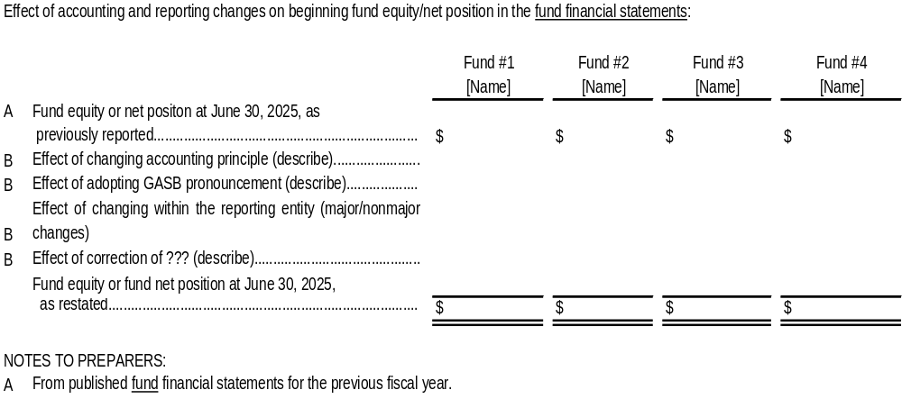
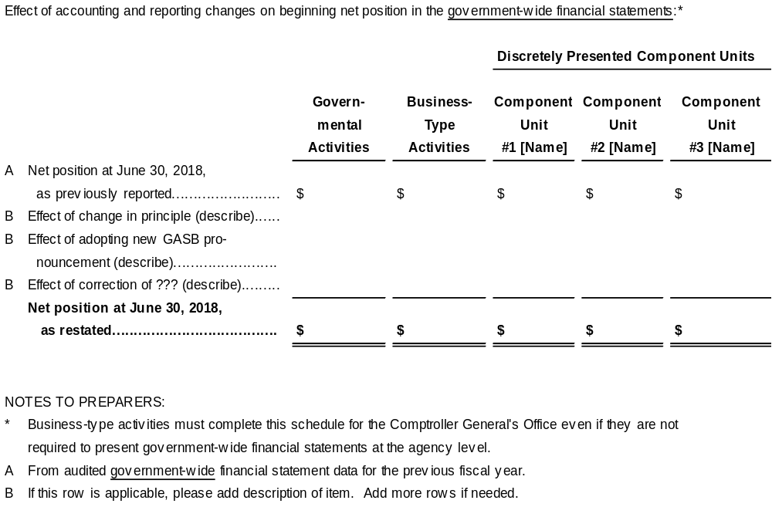

Changes in Capitalization Criteria
The capitalization criteria for capital assets are uniform for all state agencies (see CAPITAL ASSETS—CAPITALIZATION CRITERIA). If the State were to change such limits, the change would constitute a change in accounting principles that would be treated as a direct adjustment to beginning equity, essentially in the same manner as a prior-period adjustment.

Implementation of GASB 103 and GASB 104
Implementation of GASB 103 should be reported as a change in accounting principle in accordance with GASB Statement No. 100, as applicable. Agencies should evaluate whether implementation affects beginning fund equity or beginning net position and should disclose the nature of the change, the reason for the change, and the effects on beginning balances when required.
Implementation of GASB 104 should be applied retroactively to all periods presented, if practicable. If retroactive application affects prior-period balances or disclosures, agencies should disclose the implementation, the line items affected, and the effect on beginning balances or prior-period information. If retroactive application is not practicable, agencies should disclose that fact and explain the reason.

RESTRICTED ASSETS
The details of restricted asset accounts (both purpose and amount) must be disclosed in the notes to the agency’s financial statements if it is not otherwise visible on the face of the financial statements. The CGO requires at a minimum that current and noncurrent restricted assets be reported separately by each type of asset (cash and cash equivalents, investments, accounts receivable, loans receivable, and other assets) in the following purpose categories: debt service, capital projects, student loan programs, donor/sponsor specified, endowments, Second Injury Fund claims, and other. If the “other” category is significant, please provide a sufficient description of the purpose.
The following example note to the financial statements on restricted assets illustrates the level of detail described in the above policy and a suggested format for presenting the information:
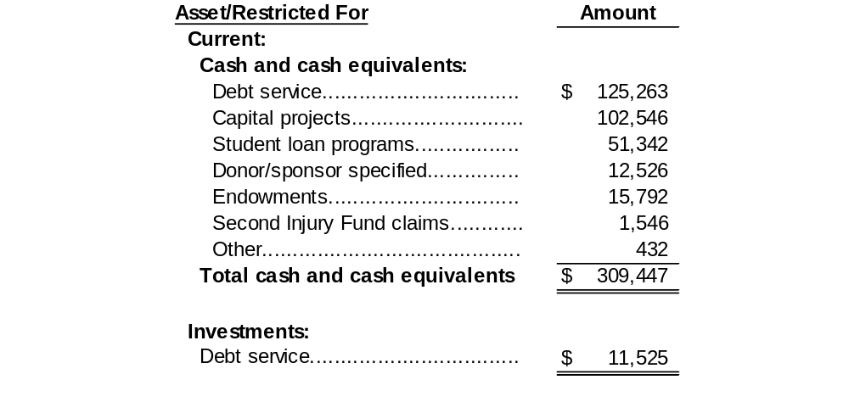
The above will help to ensure that the statewide ACFR meets the requirements of the GFOA Certificate of Achievement Program.

CASH, DEPOSITS, AND INVESTMENTS DISCLOSURES
Required Completion of Reconciliation for Deposits and Investments Disclosure
The Comptroller General’s Office has developed a reconciliation of cash and investments as presented in your financial statements and note disclosures. Your entity will receive this template which will serve as both a confirmation of cash held at the state treasury and a reconciliation to your financial statements. All AFS entities are required to complete and turn into the Comptroller General’s Office.
GASB 3, GASB 31, GASB 40, and GASB 72 all pertain to deposits and investments. Additional investment management activities and securities lending are included in the guidance in GASB 28.
As part of the audit of the statewide ACFR, the CGO must reconcile cash and investments reported in the ACFR to the cash and investments held by the State Treasurer. Agencies that prepare financial statements incorporated into the statewide ACFR, therefore, must provide an appropriate level of detail within the notes to the financial statements that will allow for this reconciliation. This entails providing certain separate disclosures regarding amounts held by the State Treasurer and amounts not held by the State Treasurer.
In reporting cash, deposits, and investments in the footnotes, agencies must use formats that show at least the level of detail shown in the subsections below. The following schedule reconciles Cash and Investments as reported on the statements of position to the footnote disclosure provided for deposits and investments. Note that the pair of amounts marked “a” must be the same, as must the pairs of amounts marked “b” and “c”.

Reconciliation of Cash/Cash Equivalents Reported on the Statement(s) of Position to the Footnote Disclosures on Deposits and Investments
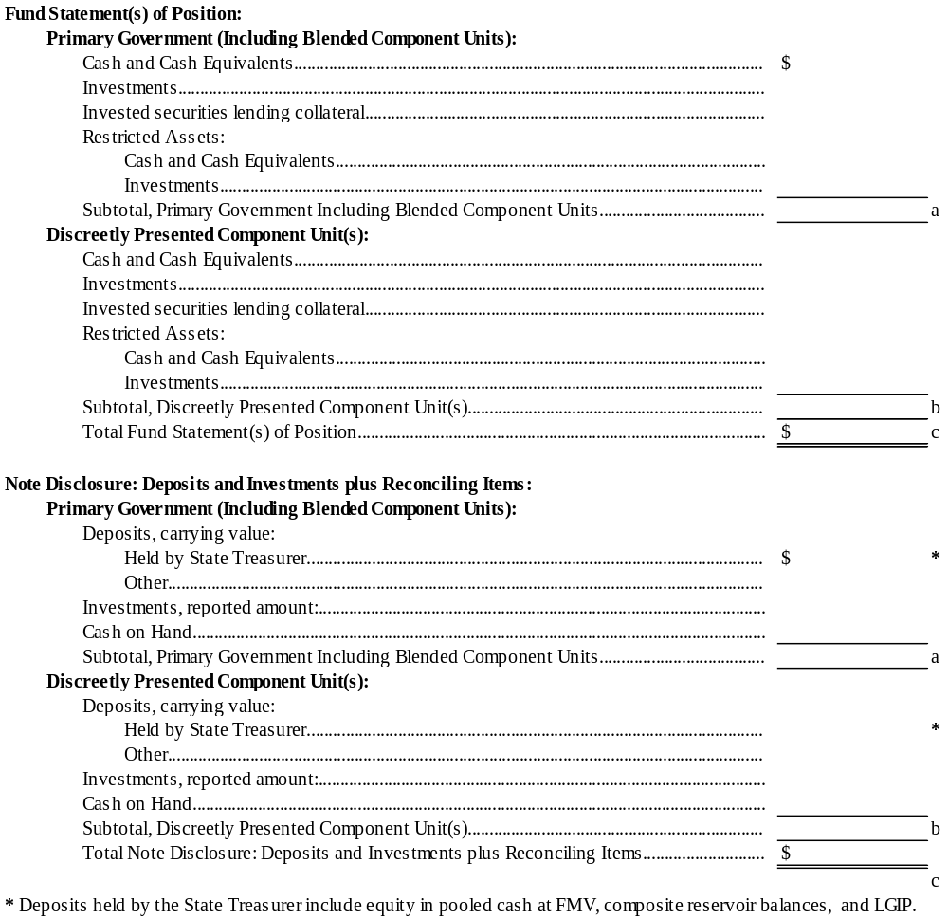

Deposits Disclosure
Generally Accepted Accounting Principles require five types of disclosures regarding cash deposits with financial institutions:

Legal and Contractual Provisions
The notes to the financial statements should disclose any legal restrictions governing cash deposits with financial institutions such as insurance and collateralization requirements. Any material violations of these requirements during the period must also be disclosed, as well as the actions taken to address those violations.

Policies Governing Deposits
The note disclosure should also include your agency’s policies concerning custodial credit risk and foreign currency risk (see descriptions below), if applicable.
If no deposit policy to address a particular type of risk has been adopted as of year-end, the disclosure should indicate that fact.

Exposure to Custodial Credit Risk as of the Date of the Statement of Position
If your agency’s deposits only include deposits held by the State Treasurer, your footnote disclosure should indicate this fact and refer readers to the Annual Comprehensive Financial Report of the State of South Carolina. No other disclosure concerning custodial credit risk is required.
For any deposits not held by the State Treasurer, the following information must be included in your footnote disclosure.
GASB Statement 3 disclosures previously referred to as category one and two deposits have generally been eliminated by GASB 40. Deposits are exposed to custodial credit risk if they are not covered by depository insurance and the deposits are:
- Uncollateralized,
- Collateralized with securities held by the pledging financial institution, or
- Collateralized with securities held by the pledging financial institution’s trust department or agent but not in the depositor-agency’s name.
If your agency has deposits at fiscal yearend that are exposed to custodial credit risk, you should disclose the amount of those bank balances, the fact that the balances are uninsured, and which of the circumstances listed above caused the balances to be exposed to this risk.

Defaults and Recovery of Prior-period Losses
If your agency incurs a loss resulting from a default on your deposits, this loss should be disclosed in the notes if it is not separately identifiable on the face of your financial statements. Likewise, any subsequent recovery of prior-period losses should be disclosed, if not otherwise identifiable in the financial statements.

Exposure to Foreign Credit Risk
If your agency’s deposits only include deposits held by the State Treasurer, your footnote disclosure should indicate this fact and refer readers to the Annual Comprehensive Financial Report of the State of South Carolina. No other disclosure concerning foreign credit risk is required.
For any deposits not held by the State Treasurer, the following information must be included in your footnote disclosure:
If your agency maintains deposits that are denominated in a currency other than the US dollar, then you must disclose the inherent risks associated with foreign currency fluctuation. This disclosure would consist of the value of such deposits in US dollars and include separate disclosure for each foreign currency in which deposits are maintained.

Investments Disclosure
At a minimum, agencies must present a schedule of investments by reported amount not with the State Treasurer at June 30, classified by the following types of investments:
- Repurchase agreements
- U.S. government securities
- Certificates of deposit
- Corporate bonds
- Municipal bonds
- Equity securities
- Asset-backed securities
- Collateralized mortgage obligations
- Commercial paper
- Land and other real estate held by endowments, including permanent and term endowments, and permanent funds
- Other (describe)
Note that the reported amount may be a mixture of cost-based and fair-value based measures because certain investments may meet the GASB 31 criteria for reporting at amortized cost or GASB 72 criteria for net asset value.
Generally Accepted Accounting Principles require the following types of disclosures regarding investments:
Any Participation in External Investment Pools
There are two separate disclosure requirements for agencies that participate in external investment pools unrelated to the State Treasury:
- If the pool is not registered with the Securities and Exchange Commission (SEC), the agency should describe any regulatory oversight of the pool, if any, and state whether the fair value of its position in the pool is the same as the value of the pool shares.
- Also, an agency’s involuntary participation in a pool should be disclosed.

Information Concerning Realized Gains and Losses (when disclosed)
GAAP does not permit agencies to distinguish realized gains and losses from unrealized gains and losses on the face of the financial statements. (Except for separately issued financial statements of any agency that may participate in an external investment pool.) GAAP permits agencies to disclose information on realized gains and losses in the footnotes to the financial statements. When preparing this optional disclosure, agencies must accompany their disclosure of realized gains and losses with the following additional information:
- An indication that the calculation of realized gains and losses is independent of the calculation of the net change in the fair value of investments; and
- An indication that realized gains and losses of the current year include unrealized gains and losses on those same investments that were recognized in previous periods as part of the net appreciation in the fair value of investments.
Legal and Contractual Provisions Governing Investments
The notes to the financial statements should disclose the following:
- Any legal restrictions on investments
- Any material violations of these restrictions or requirements during the fiscal year
- Actions your agency has taken to resolve any violations that may have occurred.
Investment Policies
The notes to the financial statements must include your agency’s policies concerning credit risk (including custodial credit risk), concentration risk, interest rate risk, and foreign-currency risk, if any. If your agency does not have a policy addressing one of the risks to which you may be exposed, your disclosure should indicate that fact.
Under GAAP, to qualify as an investment policy, a given item must either be formally adopted in some way by the agency or be incorporated into a contract. Managerial “policies” that have not been approved by your agency’s board, or past practice alone are not sufficient to constitute a policy under GAAP.
Sometimes agencies adopt the state law or regulation governing investments as their investment policy. Note, however, it is not enough simply to provide a citation or relevant state law or regulation without also providing a reasonable description of its specific provisions.
Exposure to Custodial Credit Risk as of the Date of the Statement of Position
If your agency’s investments only include investments held by the State Treasurer, your footnote disclosure should indicate this fact and refer readers to the Annual Comprehensive Financial Report of the State of South Carolina. No other disclosure concerning custodial credit risk is required.
For any investments not held by the State Treasurer, the following information must be included in your footnote disclosure:
Custodial credit risk is the risk that in the event of the failure of the counterparty to a transaction, an agency will not be able to recover the investment value or collateral securities that are in the possession of an outside party.
Any investments that are both uninsured and unregistered are exposed to custodial credit risk in either of the following situations:
- investments are held by the counterparty; or
- investments are held by the counterparty’s trust department or agent but not in the name of the investor agency.
When investments are exposed to custodial credit risk at the end of the fiscal year, an agency must disclose the following:
- the investment type
- their reported amount
- how the securities are held
All deposits are potentially subject to custodial credit risk. Investments, however, are subject to custodial credit risk only if they are evidenced by securities that exist in physical or book entry form. The following types of investment would not be subject to custodial credit risk disclosure as they do not meet this test:
- positions in external investment pools
- positions in open-end mutual funds
- securities underlying reverse repurchase agreements
- limited partnerships
- real estate
- direct investments in mortgages and other loans
- annuity contracts
- guaranteed investment contracts
Defaults and Recovery of Prior-period Losses
An agency that incurs a loss resulting from a default on its investments should disclose this information in the notes if it is not separately visible on the face of the financial statements.
Likewise, any subsequent recovery of prior-period losses should be disclosed if not otherwise visible in the financial statements.
Other Credit Risk Exposures Including
If your agency’s investments include investments held by the State Treasurer, your footnote disclosure should indicate this fact and refer readers to the Annual Comprehensive Financial Report of the State of South Carolina. See disclosure language provided above. No other disclosure concerning these other credit risk exposures is required.
For any investments not held by the State Treasurer, the following information must be included in your footnote disclosure:
Credit ratings: The notes must disclose the credit ratings of all investments in debt securities, whether held directly or indirectly. If no rating is available from a nationally recognized statistical rating organization (Standard & Poor’s, Moody’s Investors Service, or Fitch Ratings), that fact must be stated. Agencies may consolidate their presentation of credit ratings by aggregating their disclosure by investment type or by credit quality. If securities are rated by more than one nationally recognized statistical rating organization, agencies must at a minimum disclose the least favorable rating issued. Rating agencies have in recent years used modifiers to fine-tune certain credit ratings. Agencies are not required to disclose such modifiers as part of their credit risk disclosure. The requirement to disclose credit ratings does not apply to debt securities of the U.S. government or obligations of U.S. government agencies that are explicitly guaranteed by the U.S. government.
The Comptroller General’s Office submitted a Technical Inquiry to the GASB staff requesting clarification on the requirement for credit rating information. GASB responded that only one credit rating is required in the footnote disclosure. However, if an entity is aware of more than one credit rating, the lowest rating should be disclosed.
Concentration risk: The footnotes must disclose concentration risk defined as positions of 5 percent or more in the securities of a single issuer. The term issuer refers to the underlying investments themselves rather than to the investment-company manager or pool sponsor in the case of mutual funds, external investment pools, and other similar pooling arrangements. Concentration risk does not apply to concentrations of U.S. government obligations and obligations explicitly guaranteed by the U.S. government.

Interest-rate risk: Interest-rate risk occurs because potential purchasers of debt securities will not agree to pay face value for those securities if interest rates subsequently increase, thereby affording potential purchasers more favorable rates on essentially equivalent securities. Therefore, holders of debt securities must use one of these five specified methods to disclose interest-rate risk:
- Specific identification
- Segmented time distribution
- Weighted average maturity
- Duration
- Macauley duration
- Modified duration
- Effective duration
- Simulation model
Five methods are offered to allow agencies to choose a disclosure method that is most consistent with the manner in which the agency manages its interest-rate risk.
Foreign currency risk: Any investments denominated in a currency other than the U.S. dollar, are subjected to the risks associated with currency fluctuation. Accordingly, any agencies holding investments denominated in a foreign currency must disclose the value of such investments in U.S. dollars (separate disclosure is necessary for each different foreign currency denomination and investment type).

GASB 31 & 72 Disclosures about Investments
If your agency’s investments only include investments held as part of the State Treasurer’s investment pool, certificates of deposit, or investments the fair value of which was determined by quoted market price, your footnote disclosure should indicate this fact.
A disclosure of the fair value level must be made for investments reported at fair value. Level 1 inputs are quoted prices (unadjusted) for identical assets or liabilities in active markets that a government can access at the measurement date. Level 2 are inputs—other than quoted prices included within Level 1—that are observable for an asset or liability, either directly or indirectly. Level 3 inputs are unobservable inputs for an asset or liability. The fair value hierarchy gives the highest priority to Level 1 inputs and the lowest priority to Level 3 inputs. If a price for an identical asset or liability is not observable, a government should measure fair value using another valuation technique that maximizes the use of relevant observable inputs and minimizes the use of unobservable inputs.
If your agency holds any investment position in an external investment pool, disclose that information.
Disclose any regulatory oversight of participation in an external investment pool, other than the SEC, and whether the fair value of the position in the pool is the same as the value of the pool shares. Disclose the details of any involuntary participation in an external investment pool. Lastly, if your agency could not obtain information from the pool sponsor to allow determination of fair value of its investment, provide the methods used and significant assumptions made in determining that fair value and the reasons for having made such an estimate.

DERIVATIVES
The State and its agencies must comply with GASB 53, Accounting and Financial Reporting for Derivative Instruments, GASB 59, Financial Instruments Omnibus, and GASB 64 Derivative Instruments: Application of Hedge Accounting Termination Provisions – an amendment of GASB Statement No. 53. Under these statements, a derivative instrument is a financial instrument or other contract that has all of the following characteristics:
- Settlement factors. It has (1) one or more reference rates and (2) one or more notional amounts or payment provisions or both. Those terms determine the amount of the settlement or settlements and, in some cases, whether or not a settlement is required.

- Leverage. It requires no initial net investment or an initial net investment that is smaller than would be required for other types of contracts that would be expected to have a similar response to changes in market factors.

- Net settlement. Its terms require or permit net settlement, it can readily be settled net by a means outside the contract, or it provides for delivery of an asset that puts the recipient in a position not substantially different from net settlement.
Derivatives may be either asset or liability oriented. Some of the more common examples of derivatives encountered in practice include interest-rate swaps, basis swaps, swaptions, commodity swaps, and interest rate caps.
Agencies/institutions involved in complex contracts and securities should carefully review the provisions of GASB 53, GASB 59, and GASB 64 and take care to comply with any applicable accounting and reporting requirements.

RECEIVABLES FOOTNOTE—MINIMUM LEVEL OF DETAIL
Paragraph 13 of GASB 38, Certain Financial Statement Note Disclosures, requires governments to disaggregate their receivables, either on the face of the financial statements or in the notes to the financial statements. GASB Cod. Sec. 2300.107(dd) also requires disclosure of any applicable allowances in the notes if not reported on the face of the financial statements. In addition, GASB 38 requires the State to disclose the non-current portion of net receivables in governmental and fiduciary funds.
In accordance with State policy and paragraph 13 of GASB 38, agencies at a minimum must report receivable balances on the face of the statements or in note disclosure in the following categories: patient accounts receivable, student accounts receivable, other accounts receivable, income taxes receivable, sales and other taxes receivable, contributions receivable, loans and notes receivable, restricted loans and notes receivable, assessments receivable, and due from federal government and other grantors. Agencies must report restricted receivables separately from other receivables.
The example below illustrates the minimum level of detail that the Comptroller General’s Office must obtain from agencies regarding receivables. This example assumes that the agency did not disaggregate its receivable components on the face of its financial statements. (If it had done so, it could have omitted the gross receivable amounts from the note disclosure.)
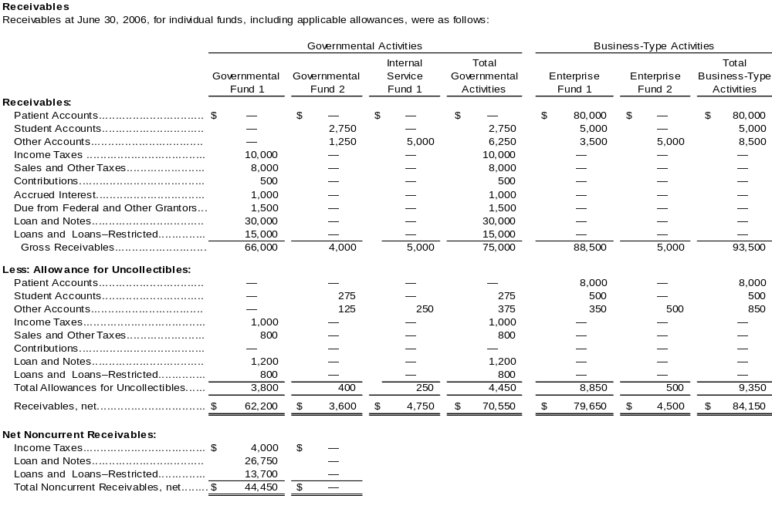

PAYABLES FOOTNOTE—MINIMUM LEVEL OF DETAIL
Paragraph 13 of GASB 38 (as amended by GASB 63) concerns itself with the fact that balances of receivables and payables reported on the Statement of Net Position and Balance Sheet may be aggregations of different components, such as balances due to or from taxpayers, other governments, vendors, customers, beneficiaries, and employees.
In addition to the GAAP mandated disclosures in connection with receivable and payable balances, the notes to the financial statements should provide details when significant components have been obscured by aggregation.
At a minimum, agencies must report payable balances on the face of the financial statements or in note disclosure in the following categories: accounts payable, retainages payable, intergovernmental payables, claims payable, benefits payable, prizes payable, unsettled investment purchases payable, accrued salaries and related payroll expenses, accrued compensated absences, sick leave, accrued interest, and other accrued liabilities. Agencies must report amounts payable from restricted assets separately from other payables.

DISCLOSURES ABOUT BALANCES ARISING FROM INTRA-STATE ACTIVITIES
The last sentence of Paragraph 81 of GASB 34 states: “Liabilities arising from interfund activities (see paragraph 112) do not constitute general long-term liabilities and therefore should be reported in governmental funds.” This principle applies to all liabilities arising from interfund activities.
In addition, paragraph 112a (1) of GASB 34 provides the following specific guidance limited to interfund loans: “Interfund loans should be reported as interfund receivables in lender funds and interfund payables in borrower funds. This activity should not be reported as other financing sources or uses in the fund financial statements. If repayment is not expected within a reasonable time, the interfund balances should be reduced and the amount that is not expected to be repaid should be reported as a transfer from the fund that made the loan to the fund that received the loan.”
In order for the State to comply with Paragraphs 81 and 112 of GASB 34, some interfund activities for the State (i.e., “intra-State activities”) may need to be reported quite differently in the statewide ACFR than they have been reported in separately issued State agency financial statements. If such a difference is material relative to the agency’s financial statements, the notes to its financial statements must detail the different reporting that would be required in the statewide ACFR, including the presentation of pro forma information to show any differences in account balances.

For example, for a long-term intra-State payable arising from a loan payable to a different State agency, the note disclosure must provide details about: (a) the identity of the lending agency/fund and (b) a schedule of payments on principle that, at a minimum, distinguishes between current and long-term payables. If the liability is payable from a governmental fund and the agency’s governmental fund financial statements recorded only the current payable, the agency’s disclosure must include pro-forma data to show the changes in account balances (including fund equity/net position) that must occur when the total liability (current and long-term) is recorded in the State’s governmental fund financial statements as an interfund payable in accordance with paragraph 81 of GASB 34.

DISCLOSURES REGARDING MATERIAL INTERFUND BALANCES AND TRANSFERS
Paragraph 14 of GASB 38 requires certain details regarding interfund balances and activities to be reported in a footnote. Some of the information required by this part of GASB 38 has been required for many years for governments that participate in the Government Finance Officers Association’s Certificate of Achievement for Excellence in Financial Reporting Program.
The Comptroller General’s Office obtains most data regarding intra-State due to/from balances by analyzing SCEIS balances. However, not all of the required data is available in SCEIS without retrieving, examining, and analyzing, individual documents.
Paragraph 15 of GASB 38 requires disclosure of information about interfund transfers that are reported in the fund financial statements. A transaction between your agency and another State agency could represent an interfund transfer from the State’s perspective even if it is reported in your stand-alone financial statements as a revenue or expenditure. The Comptroller General’s Office must disclose the purpose and amount of all significant transfers from the State’s perspective.
The Comptroller General’s Office requires that an agency provides a description of the intended purpose and amount of each State transfer in or out greater than $5 million that is included in its fund financial statements, even if it is reported as a revenue or expenditure. Your agency must include this information in the footnote disclosures or in a separate document you submit to the Comptroller General’s Office.

CAPITAL ASSET AND ACCUMULATED DEPRECIATION BALANCES
Your agency must disclose the following data within each asset category (with depreciable assets reported separately from nondepreciable assets, and assets associated with governmental activities reported separately from those associated with business-type activities) (GASB Cod. Secs. 2300.111 and 2300.112):
- Beginning-of-year and end-of-year balances, with accumulated depreciation presented separately from historical cost.
- Capital acquisitions.
- Sales or other dispositions.
- Current-period depreciation expense (only for depreciable capital asset classes).
These requirements apply to all fund types, including enterprise and internal service funds.
GASB 104 requires certain capital assets to be disclosed separately in the capital asset note disclosures. Lease assets should be disclosed separately by major class of underlying asset; public-private and public-public partnership right-to-use assets should be disclosed separately by major class of underlying PPP asset; subscription assets should be disclosed separately; and other intangible assets should be disclosed separately by major class. Right-to-use assets should not be combined with owned capital assets of the same type.
Capital asset note disclosures should identify, as applicable, owned tangible capital assets, lease assets, PPP right-to-use assets, subscription assets, other intangible assets by major class, accumulated depreciation, and accumulated amortization. This disclosure requirement should be applied consistently with the capital asset categories used for financial reporting in Section 5.
The following exhibit, adapted from the displays on page 245 of GASB 34 and page 136 of the first GASB 34 Implementation Guide, is intended to illustrate the minimum level of detail that the Comptroller General’s Office must obtain from agencies regarding their capital assets.

- Please note the following regarding the footnote disclosure schedule:
- Reclassifications and corrections of prior-period balances should represent adjustments to the “Beginning Balance” column, with the addition of “As Restated” to that column.
- Current-year depreciation affects the accumulated depreciation portion of the “Increases” column.
- When construction-in-progress (CIP) projects are completed, the constructed assets’ costs are reclassified by reporting a negative amount in the “Decreases” column for CIP and reporting corresponding positive amounts in the “Increases” column of the appropriate asset categories (land and improvements, buildings and improvements, etc.). The accumulated depreciation portion of the schedule is not affected.

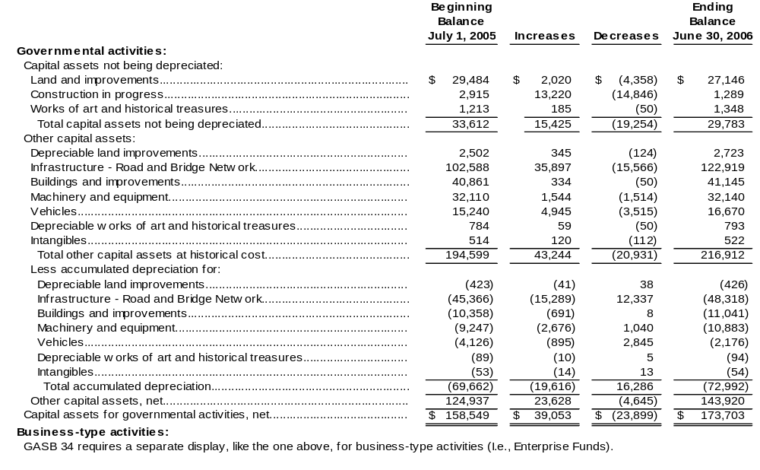

OTHER REQUIRED DISCLOSURES FOR CAPITAL ASSETS
Agencies must disclose certain information in the notes to the financial statements regarding construction commitments outstanding, capital assets held for sale, and noncapitalized collections of works of art and historical treasures as explained in the following sections.

Construction Commitments Outstanding
Your agency must disclose any construction commitments outstanding at year-end in the notes to the financial statements (GASB Cod. Sec. 2300.106(k)). Your agency may have projects to construct new capital assets or to repair or maintain existing capital assets. Some such projects may be only partially completed at June 30. If there are signed contracts in existence at June 30 that commit the agency to pay amounts in the future for portions of projects that were incomplete at June 30, these amounts are said to represent construction commitments outstanding at June 30.
State policy requires agencies to separately report their construction commitments outstanding at June 30 for: (a) capital projects and (b) repair/maintenance projects. Your agency needs only report construction commitments that exceed $100,000 per category. For example, if you had commitments of $350,000 for capital projects and commitments of $75,000 for repair/maintenance projects, report only the $350,000 for capital projects in the notes to the financial statements.
To compute the amount of commitments outstanding:
- Determine your agency's construction projects in progress at June 30.
- Compute the outstanding commitment for each project in progress at June 30 as follows:
- The contract price.
- Less: Amounts the agency has paid contractors from the start of the project through June 30.
- Less: Amounts relating to the project that your agency has reported as accounts payable and/or retainages payable as of June 30 of the current fiscal year.
- Add together the outstanding amounts for all capital projects in progress at June 30.
- Add together the outstanding amounts for all repair/maintenance projects in progress at June 30.

Capital Assets Held for Sale
GASB 104, paragraph 5, notes a capital asset is a capital asset held for sale if (a) the government has decided to pursue the sale of the asset and (b) it is probable (likely to occur) that the sale will be finalized within one year of the financial statement date. Factors to consider when evaluating whether it is probable that the sale will be finalized within one year of the financial statement date include, but are not limited to, the following (GASB 104, paragraph 6):
a. Whether the asset is available for immediate sale in its present condition.
b. Whether an active program to locate a buyer has been initiated, which may include the asset being put out for bid.
c. Market conditions for selling that type of asset
d. Regulatory approvals needed to sell the assets.
A government should evaluate whether a capital asset is a capital asset held for sale each reporting period (GASB 104, paragraph 7). A capital asset held for sale should continue to be reported within the appropriate major class of capital asset. Additionally, a government should disclose capital assets held for sale in notes to financial statements, with separate disclosure of historical cost and accumulated depreciation (or amortization), by major class of asset. A government also should disclose the carrying amount of debt for which capital assets held for sale are pledged as collateral, for each major class of asset. The disclosure of capital assets held for sale should be made for both governmental activities and business-type activities (GASB 104, paragraph 8).

Noncapitalized Collections of Works of Art and Historical Treasures
GAAP does not require capitalization of certain collections (refer to page 41 for the characteristics that a collection must have in order to qualify for this treatment). For collections of works of art and historical treasures not capitalized, your agency must disclose a description of the collection and the reasons these assets are not required to be capitalized.

Capital Asset Impairment
Paragraph 17 of GASB 42 requires disclosure for any capital asset impairment losses that have occurred during the fiscal year, if not otherwise apparent from the face of the financial statements. The disclosure should provide a general description, the amount of loss, the carrying amount of the impaired asset (only if idle at year-end), and the financial statement function classification of the impairment loss.
Paragraph 21 of GASB 42 requires disclosure of the amount and financial statement function classification of any insurance recoveries received from asset impairments, if not apparent from the face of the financial statements.

SHORT-TERM DEBT
Paragraph 12 of GASB 38 requires governments to provide details in the notes to the financial statements about short-term debt activity during the year, even if no short-term debt is outstanding at year-end. Short-term debt results from borrowings characterized by anticipation notes, use of lines of credit, and similar loans. Details should include:
- A schedule of changes in short-term debt, disclosing beginning and end-of-year balances, increases, and decreases.
- The purpose for which the short-term debt was issued.
Short-term debt for purposes of this disclosure is limited to amounts owed to a lending institution or to another entity outside of State government.

LONG-TERM OBLIGATIONS
Paragraph 119 of GASB 34 requires that note disclosure about long-term obligations include:
- Beginning- and end-of-year balances (regardless of whether prior-year data are presented on the face of the government-wide financial statements).
- Increases and decreases (separately presented).
- The portions of each item due within one year of the statement date.
- Which governmental funds typically have been used to liquidate other long-term obligations (such as compensated absences and pension liabilities) in prior years.
In addition to the GAAP mandated disclosures in connection with long-term obligations, the notes to the financial statements should include all of the following information for individual long-term debt issues that are not reported in the State Treasurer’s Office Debt Management System. These are bonds and notes for which the State Treasurer’s Office does not make the debt service payments.
- Purpose for which the debt was issued.
- Original amount of the debt.
- Type of debt (revenue bonds or general obligation bonds, for instance).
- Significant debt covenants.
- Amounts of installments.
- Interest rate.
- The terms by which interest rates change for variable rate debt outstanding.
- Range of maturities.
- Applicability of federal arbitrage regulations.

This information is needed to comply with the GFOA Certificate of Achievement for Excellence in Financial Reporting Program.

Long-Term Obligations Disclosures—Level of Detail
The GFOA's Certificate of Achievement Program requires participants to present several statistical tables related to debt, including the following:
- Net General Obligation Bonds and Notes Per Capita.
- Ratio of Annual Debt Service Expenditures for General Obligation Debt to Total General Governmental Expenditures.
- Revenue Bond Coverage-Enterprise Funds.
The financial amounts presented in these tables, such as liability amounts, must be traceable to the financial section of the statewide ACFR. This means that the State's notes to the financial statements must present general obligation debt and revenue debt in separate accounts and must disclose debt service to maturity separately for general obligation debt and revenue debt.
Note disclosures in agency financial statements must present general obligation debt and revenue debt in separate accounts and must detail debt service to maturity separately for general obligation debt and revenue debt.
Also see CLASSIFICATION OF STATE HIGHWAY BONDS and CLASSIFICATION OF STATE INSTITUTION BONDS.

Changes in Long-Term Obligations
The example below is adapted from the note on page 67 of the second GASB 34 Implementation Guide. It is intended to illustrate the minimum level of detail that the Comptroller General’s Office must obtain from agencies regarding changes in their long-term obligations.
The State's policy is that audited financial statements to be incorporated into the State's basic financial statements must, at a minimum, separately present Bonds Payable, Notes Payable, Certificates of Participation Payable, Loans Payable, Leases Payable, Claims and Judgments Payable, Compensated Absences Payable, Sick Leave Payable, etc., on the face of the financial statements. However, Bonds Payable and Notes Payable information must be separated further into General Obligation and Revenue debt for the note disclosures. Any liability for Arbitrage Rebates actually owed to the federal government at the end of the fiscal year must be disclosed in the notes if not presented separately on the face of the financial statements. This disclosure must identify which line(s) of the financial statements include the arbitrage liability and the amount(s).
Unamortized premiums/discounts and the deferred amount on debt refundings must be identified by the type of debt rather than combined into one amount. Ways to accomplish this would be to add labeling to the row, locate the row immediately below the debt to which it relates, or provide a narrative below the table.
Although the sample below is for business-type activities, a similar display also is required for governmental activities.
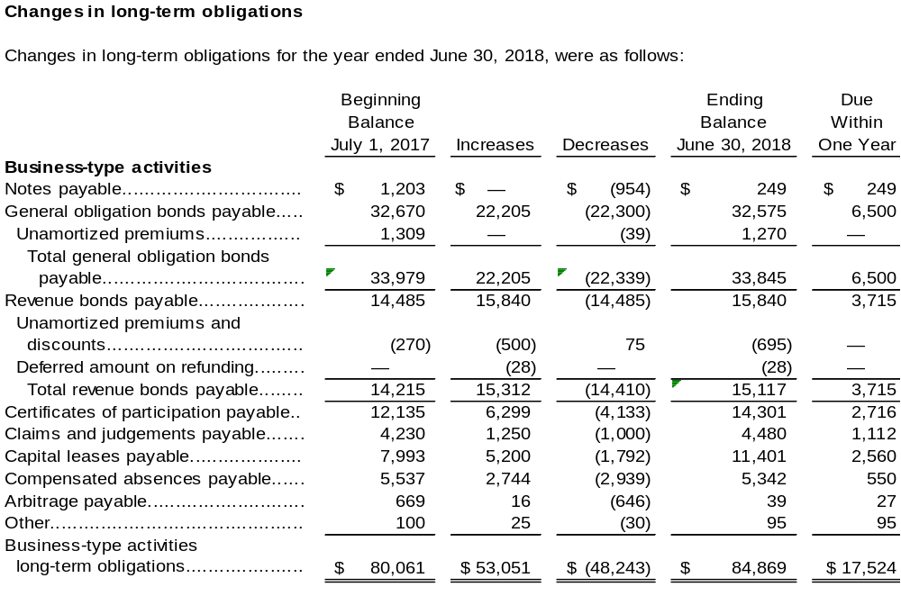

Debt Service to Maturity
Paragraph 10 of GASB 38 requires governments to disclose the following details of debt service requirements to maturity:
- Principal and interest requirements to maturity, presented separately, for each of the five subsequent fiscal years and in five-year increments thereafter. Interest requirements for variable-rate debt should be determined using the rate in effect at the financial statement date.
- The terms by which interest rates change for variable-rate debt.
Agencies must disclose debt service requirements as described above.

The example below, adapted from the note on page 68 of the second GASB 34 Implementation Guide, is intended to illustrate the minimum level of detail that the Comptroller General’s Office must obtain from agencies regarding their debt service requirements in order to comply with GASB 34 and GASB 38. The total principal amounts in the note must agree to the corresponding debt amounts shown on the Balance Sheet or Statement of Net Position. This may require insertion of one or more pairs of total columns in the note if general obligation and revenue debt were not segregated in the financial statements.

The State’s requirement to segregate general obligation and revenue debt also applies to the schedules that present debt service to maturity.
The illustration below is for governmental activities, but GASB 34 also requires a similar display for business-type activities. (NOTE: This illustration assumes that the State agency reports a single Bonds Payable account in its financial statements.)
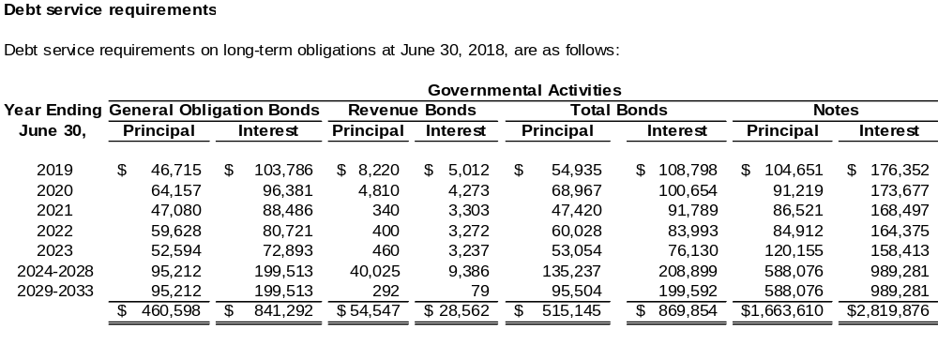

REFUNDINGS OF DEBT
For current refundings and advance refundings resulting in defeasance of debt reported by proprietary funds, the difference between the reacquisition price and the net carrying amount of the old debt should be classified as either deferred outflows of resources or deferred inflows of resources and amortized as a component of interest expense in a systematic and rational manner over the remaining life of the old debt or the life of the new debt, whichever is shorter.
When applicable, the notes to the financial statements must provide the deferred amount on refundings. For statewide ACFR presentation, the amount is shown at the bottom of the debt service to maturity schedule in order to reconcile the total future principal debt service amount to the outstanding debt liability shown in the financial statements. All disclosures required by GASB 23 for refundings also should be included in the notes.

LEASES
Most lease payment disclosure requirements for leases and for short-term leases come from GASB 87.

Separate Presentation for Leases with Different Types of Parties
For leases and short-term leases, agencies must separately present the disclosures required by GAAP for transactions with each of the following three groups: (a) other funds, other State agencies, and blended component units, (b) discretely presented component units of the State, and (c) external parties (i.e., those entirely outside the State’s financial reporting entity). This includes the disclosures for (a) the interest rate and any executory fees on leases, (b) the schedules for future payments (principal and interest) under all leases, (c) the schedule of capital assets under leases, and (d) the amount of leased assets by major classes of underlying assets, disclosed separately from other capital assets.
The Comptroller General’s Office requires these details because it must treat leases between funds, State agencies, and State blended component units as internal transactions rather than as debt. Likewise, special rules apply to transactions between the State’s primary government and its discretely presented component units. (See GASB Cod. Sec. L20.119 through L20.124.) Contact the Financial Reporting Division of the Comptroller General’s Office if you have questions. APPENDIX B—THE STATE’S DISCRETELY PRESENTED COMPONENT UNITS and APPENDIX C—AGENCIES BY FUNCTION should help agencies to apply this guidance.

Five-Year Increments after the First Five Subsequent Fiscal Years
GASB 87 requires the State to disclose the future minimum payments for each of the five subsequent fiscal years and in five-year increments thereafter for its obligations under leases.

Current Year Lease Payments
GASB 87 also requires the disclosure of the related principal, interest and executory costs of lease payments for the current fiscal year for all leases.

Schedules of Leases
Several of the disclosure requirements for leases could be satisfied by presenting a schedule for all leases with the following rows and columns:
Rows for each of the following:
- Each of the next five years.
- Separate five-year increments thereafter.
- Total payments (principal and interest separately reported in columns), excluding contingent leases.
Columns for each of the following:
- Leases with other State agencies and blended component units.
- Leases with discretely presented component units.
- Leases with external parties.

Assets Acquired under Leases
GASB 87 requires separate presentation of the following: (a) total estimated value, at lease inception, of the assets recorded under a lease at the end of the fiscal year, detailed by the major asset categories used in the capital asset disclosures; (b) the accumulated amortization amount associated with total capital assets acquired under leases at the end of the fiscal year; and (c) total assets acquired under leases, net of accumulated amortization, at the end of the fiscal year. GASB 104 requires lease assets to be disclosed separately by major class of underlying asset and not combined with owned capital assets of the same type. Calculate item (c) as the total in (a) minus (b).
Presenting a schedule with the following rows and columns could satisfy the GASB 87 disclosure requirements:
Rows for each of the following:
- Each asset category having leased assets.
- Total assets acquired under leases (before accumulated amortization).
- Less: Accumulated amortization.
- Total assets acquired under leases, net.
Columns for each of the following:
- Leases with other State agencies and blended component units.
- Leases with discretely presented component units.
- Leases with external parties.

Facilities Leased to Others
The total cost of property leased to others under leases must be disclosed. Presenting a schedule with the following rows and columns could satisfy this requirement:
Rows for each of the following:
- Each category of capital assets as described in CAPITAL ASSETS—CATEGORIES FOR FINANCIAL REPORTING.
- Less: Depreciation.
- Total carrying value.
Columns for each of the following:
- Leased to other State agencies and blended component units.
- Leased to discretely presented component units.
- Leased to external parties.
In addition, the future minimum lease payments to be received from others must be disclosed. Presenting a schedule with the following rows and columns could satisfy this requirement:
Rows for each of the following:
- Each of the next five years.
- Separate five-year increments thereafter.
- Total future minimum payments to be received.
Columns for each of the following:
- Leased to other State agencies and blended component units.
- Leased to discretely presented component units.
- Leased to external parties.

Contingent Rentals Associated with Leases
Contingent rentals are rentals on which the amounts paid are dependent on some factor other than the passage of time.
GASB 87 requires disclosure of the contingent rental expense as a separate amount, along with the basis on which contingent rental payments are determined. For copier leases paid on a cost-per-copy basis, the basis is “cost per copy.” Future contingent rentals need not be disclosed; disclose only the contingent rental amount paid during the current fiscal year. This disclosure for contingent rental expenses is separate from, and in addition to, the minimum lease payment information.
In addition, the following must be disclosed in this situation:
- • Contingent rentals paid during the current year to other State agencies and blended component units under leases.
• Contingent rentals paid during the current year to discretely presented component units under leases.
• Contingent rentals paid during the current year to external parties under leases.

DETAIL OF STATE APPROPRIATIONS RECORDED AS REVENUE
The Comptroller General’s Office must reclassify State General Fund appropriations used by other GAAP funds to present them as transfers from the General Fund to other GAAP funds in the statewide ACFR. Transfers into the other funds must equal transfers out of the General Fund. Accordingly, the Comptroller General’s Office must reconcile appropriations recorded as revenue on agency fund financial statements with the corresponding amounts recorded in the General Fund in SCEIS.

Agencies are required to present a detailed schedule of State General Fund appropriations, either in the notes to their financial statements or following the basic financial statements (i.e., as supplementary information). State appropriations that your agency receives from another agency should be listed separately. Proprietary funds must separately report the details of State non-capital appropriations (recorded as non-operating revenues) and capital appropriations. The schedule should display all of the following details that are applicable:
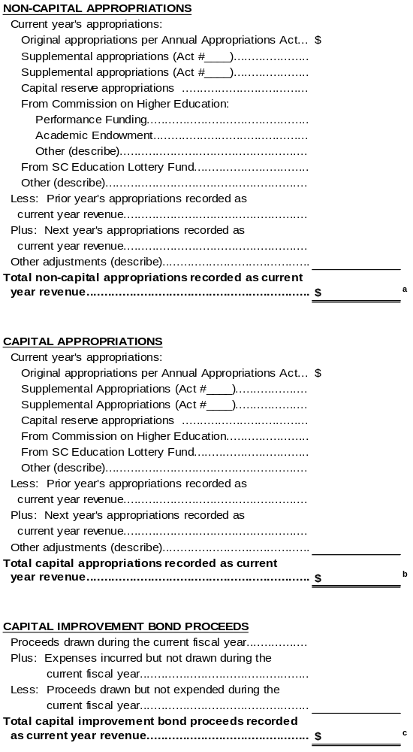
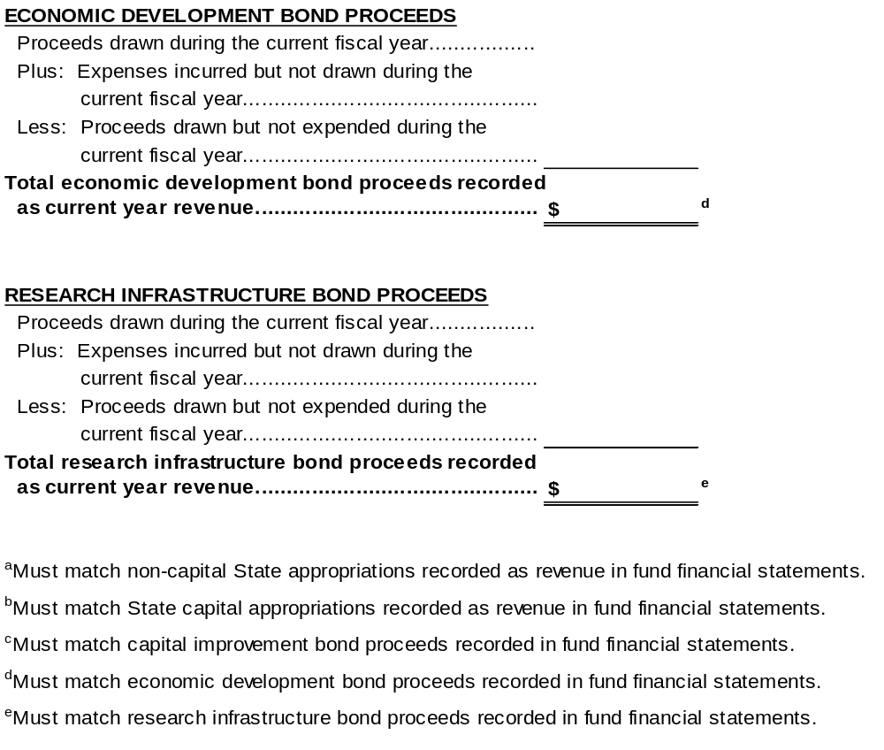
Please show appropriation reduction amounts separately—either on the schedule as an adjustment to the relevant type of appropriation, as an “other adjustment” on the schedule, or in a note or narrative associated with the schedule.
GASB Cod. Sec. 1800.112 requires that governmental entities report both governmental and proprietary fund revenues by major source. The above schedule provides readers of agency financial statements with pertinent information regarding the sources of the agency’s appropriations recorded as revenue as well as providing data to the Office of the Comptroller that is needed for preparation of the statewide ACFR.

REQUIRED DISCLOSURE OF UNRECOGNIZED PLEDGES DEEMED NOT MEASURABLE
The State generally is required to recognize receivables and revenues for pledges (see REQUIRED RECOGNITION OF PLEDGES AS RECEIVABLES AND REVENUES for more details). In addition, Generally Accepted Accounting Principles require disclosure of “transactions that are not recognizable because they are not measurable.” Accordingly, a disclosure is necessary if certain pledges are not recognizable because they are not measurable.
As a matter of policy, the State has adopted the following standards relative to the disclosure of pledges that were not recognized as receivables and revenues because they were deemed “not measurable” (i.e., not capable of estimation).
- The disclosure must describe the particular unrecognized pledges in such a way that the reader can distinguish those pledges from the majority of other pledges to State agencies that are measurable and/or are recognized as revenue.
- The disclosure must include specific reasons why the particular pledges under discussion are not considered measurable. It is not sufficient to say that the amount of the pledges could not be estimated because that is merely providing a generic synonym for “not measurable.”
- If the specific reason for deeming a pledge as “not measurable” relates in some way to the pledge being deemed “not verifiable,” “not probable of collection,” or to the existence of currently unmet eligibility requirements, the disclosure should explain specifically how these additional deficiencies relate to the lack of measurability.
- If your agency wishes to disclose measurable pledges that were not recognized as revenue during the current fiscal year for valid reasons other than lack of measurability (for example, eligibility requirements were not yet met, or the pledge was deemed “not verifiable” or “not probable of collection”), please clearly distinguish the measurable pledges from those that are not measurable.

INTERNAL SERVICE FUNDS—REVENUE FROM INTERNAL CUSTOMERS
For internal service funds, the notes to the financial statements must include a breakdown of revenue derived from internal customers. For governmental payer funds, revenue must be reported by function (see APPENDIX C—AGENCIES BY FUNCTION). For proprietary payer funds, revenue must be reported by activity. For more information, please see Section 5, FINANCIAL STATEMENT COMPONENTS.

SEGMENT REPORTING
Paragraph 122 of GASB 34 as amended by paragraph 17 of GASB 37 states that governments reporting enterprise funds or using enterprise fund accounting to report their activities are required to present segment information for those activities in the notes to the financial statements. For purposes of this disclosure, a segment is an identifiable activity (or grouping of activities), as discussed in paragraph 39b, footnote c, reported as or within an enterprise fund or another stand-alone entity that has one or more bonds or other debt instruments (such as certificates of participation) outstanding, with a revenue stream pledged in support of that debt. In addition, the activity’s revenues, expenses, gains and losses, assets, and liabilities are required by an external party to be accounted for separately. For example, accounting and reporting requirements commonly are set forth in bond indentures. Also see Questions 7.86.5 and 7.86.3 in the GASB’s 2015 Implementation Guide).
Generally Accepted Accounting Principles do not require segment reporting when an individual fund both is a segment and is reported as a major fund. In some cases, however, an agency’s major fund may constitute only a part of one of the State’s major funds. In this situation, GAAP would require that the statewide ACFR present segment disclosure for the agency’s major fund.
An agency must identify, by name, within the notes to its financial statements, any of its major funds that are segments.

RELATED ORGANIZATIONS, RELATED PARTY TRANSACTIONS, AND TRANSACTIONS WITH DISCRETELY PRESENTED COMPONENT UNITS
Professional literature requires disclosures about material transactions with related parties outside the State’s financial reporting entity as defined by GASB Statement 14 (as amended by GASB 39). In accordance with this guidance, the State’s policy is to present the following disclosures regarding related parties:
- Name of the organization if its total assets exceed
$2 million.
- A description of the transactions between the State and such organization, including dollar amounts and such other information as is deemed necessary for an understanding of the effects of the transactions on the State’s financial statements. Such transactions and amounts disclosed for each organization with assets in excess of $2 million shall include each of the following, if applicable:
- Receivables from the related organization recorded by the State at June 30.
- Payables to the related organization recorded by the State at June 30.
- Donations of cash and other assets from the organization to the State.
- State expenditures/expenses paid to the organization.
- Reimbursements to the State for expenditures/expenses the State incurred on behalf of the organization.
- Data regarding any other related party transactions having a significant effect on the statewide financial statements.
- In addition, GASB Cod. Sec. 2600.110 (Paragraph 128 of GASB 34) requires that notes to the financial statements disclose, for a discretely presented component unit: “the nature and amount of significant transactions with the primary government and other component units.” Under the criteria of GASB 39, agency financial statements may include a discretely presented component unit that the State of South Carolina treats as a related party.
At a minimum, agency financial statements incorporated into the statewide ACFR shall include the above disclosures regarding significant transactions of the primary government with:
(a) its related organizations and (b) its discretely presented component units. Agencies are encouraged to use a tabular format if there are two or more related organizations or discretely presented component units.
If the agency’s footnotes do not disclose the total assets of the related organization, the agency should provide this information in a separate communication addressed to the Financial Reporting Division of the Comptroller General’s Office. This supplementary information is necessary to help ensure that the State’s disclosure focuses on significant organizations and their transactions with the State.

REQUIRED INFORMATION ON BUSINESS-TYPE ACTIVITIES FOR THE GOVERNMENT-WIDE STATEMENT OF ACTIVITIES
Enterprise funds, if not required by GAAP to present government-wide financial statements, must provide information needed on business-type activities for the State’s government-wide Statement of Activities within the notes to the agency’s financial statements. [Authority for this requirement appears to be provided by paragraph 12.75 of Audits of State and Local Governments (GASB 34 Edition) (AICPA, May 1, 2003)].
The following information must be included in the footnote:
- Charges for services (revenues).
- Operating grants and contributions (revenues).
- Capital grants and contributions (revenues).
- Expenses.
- Earnings on investments.
- Unusual or infrequent items.
- State appropriations.
- Other transfers in from other State agencies/funds.
- Transfers out to other State agencies/funds.

The example below is intended to illustrate the minimum level of detail that the Comptroller General’s Office must obtain from agency financial statements. The notes to an agency’s financial statements must present this information separately for:
- Any portion of its operations that is incorporated into one of the State’s major enterprise funds (see APPENDIX D—THE STATE’S MAJOR ENTERPRISE FUNDS).
- Each different identifiable activity accounted for within the State’s non-major enterprise funds.
- Each discretely presented business-type component unit (see APPENDIX B—THE STATE’S DISCRETELY PRESENTED COMPONENT UNITS).

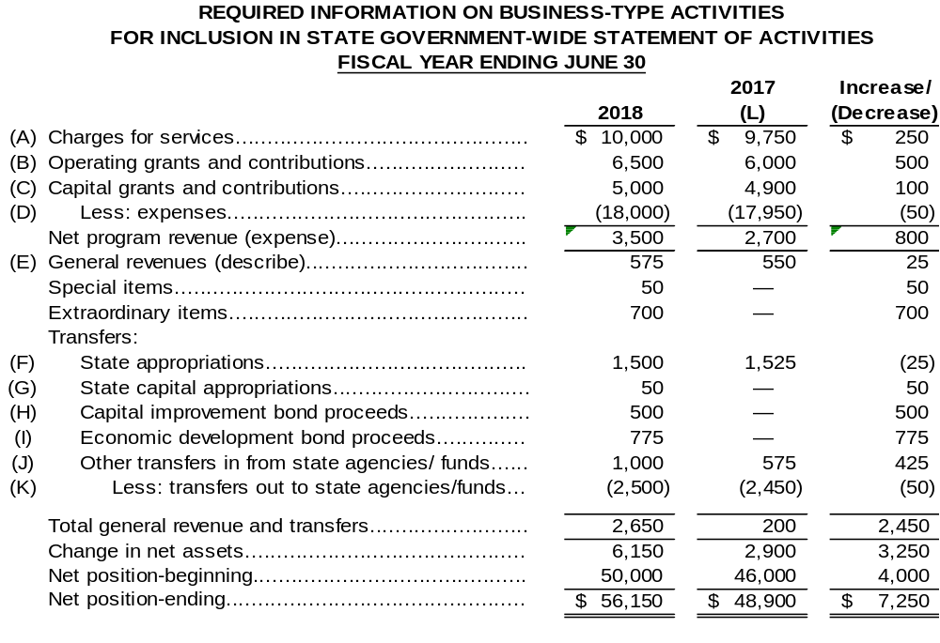
NOTE: Additional columns should be presented in the above display for each blended component unit.
COMMENTS/INSTRUCTIONS CORRESPONDING TO THE PARENTHETICAL LETTERS IN THE PRECEDING ILLUSTRATION:
- Fees and operating grants. Operating grants (see paragraph 102 of GASB 34) received from other governments should be included in Charges for Services, because paragraph 49 of GASB 34 says, “Payments from other governments that are exchange transactions ... also should be reported as charges for services.”
- Federal, State, and local grants and contracts (nonoperating), other operating revenues, earnings on investments, county appropriations, and gains on sales of assets. See (A) above for operating grants received from other governments.
- Capital appropriations excluding State capital appropriations and capital improvement bond proceeds. Also see (F) and (G) below.
- Total operating expenses plus interest expense on capital asset-related debt and losses on disposal of capital assets.
- When preparing the supplemental schedule for the Comptroller General’s Office, amounts reported in the General Revenues section are funds that are available to the State to use for purposes other than those of the reporting agency.
- State appropriations excluding State capital appropriations.
- State capital appropriations (from State General Fund).
- Capital improvement bond proceeds (from State capital projects fund).
- Economic development bond proceeds (from State capital projects fund).
- Transfers in from other State agencies.
- Transfers out to other State agencies.
- Include a column displaying last year’s amounts. If there were any errors (including needed reclassifications) in last year’s amounts, please restate these amounts.

NET POSITION CATEGORIZED DIFFERENTLY IN STATEWIDE ACFR THAN IN AGENCY FINANCIAL STATEMENTS
In some cases, net position may be categorized in a particular manner within the agency’s audited financial statements but should be categorized differently within the statewide ACFR. For example, suppose that an economic development agency presents a portion of its net position as unrestricted in its agency’s financial statements because the corresponding net position may be used for any legitimate agency purpose (and/or for any purpose within the State’s economic development function). This net position, however, should be presented as restricted in the statewide ACFR because they may not be used by different functions within State government (e.g., transportation, social services, etc.).
Agency financial statements must disclose (either within the Notes to the Financial Statements or within supplementary information) any situations where net position in the agency’s financial statements should be classified differently within the statewide ACFR. The disclosure should provide full explanations/reasons for the difference in presentation.

SECTION 7—DEPARTMENT OF TRANSPORTATION
This section of the policy manual applies only to the Department of Transportation (DOT). DOT should follow the policies and guidance in this section along with the policies and guidance in sections 1 through 6.

INFRASTRUCTURE
The Comptroller General’s Office will limit the reported “infrastructure” category of capital assets within the State’s primary government to the Department of Transportation’s (DOT’s) roads and bridges. The DOT will report the roads and bridges owned by the State. In addition, in the absence of clear title to a particular roadway or bridge, the DOT should report the asset if the State is responsible for future maintenance.
The Department of Transportation’s roads and bridges meet the definition of general infrastructure assets.
The term general infrastructure assets refer to those infrastructure assets that are associated with, and generally arise from, governmental activities.
Infrastructure assets consist of networks and subsystems. A network is comprised of all assets that provide a particular type of service for our government, and a subsystem consists of all assets that make up a portion or segment of a network. For example, DOT could define the State’s transportation system as a network and the roads and bridges as two subsystems of the network. DOT could also consider the roads and bridges to be two networks, with interstate highways, State highways, and rural roads as subsystems of the road network.

Reporting Roads and Bridges
All infrastructure assets acquired by governmental funds must be reported in the separate infrastructure category of depreciable capital assets if the cost of the asset exceeds the $500,000 capitalization limit for infrastructure.
If the DOT is unable to properly apply the State’s $500,000 capitalization limit to infrastructure assets acquired on or before June 30, 2001, then the DOT should fully disclose its policy of capitalizing all projects that were initiated on or before June 30, 2001, regardless of cost. This disclosure should include the total dollar amount of capitalized infrastructure acquired on or before June 30, 2001, until this amount is deemed too immaterial to disclose.

Depreciation of Roads and Bridges
The State’s roads and bridges should be depreciated using the straight-line method over a
75-year useful life for roads and a 50-year useful life for bridges. The Comptroller General’s Office recommends that the DOT take a full year of depreciation in the year of acquisition and take no depreciation in the year of disposition. However, the DOT may use a different straight-line convention (such as the mid-month convention) if it has a valid reason to do so.

Maintenance of Infrastructure Records
The Department of Transportation is required to maintain complete auditable records of all infrastructure assets in a level of detail that allows for accurate reporting of these assets. Infrastructure records should include such information as acquisition date, historical or estimated historical cost, a policy for distinguishing between capitalizable costs and repair/maintenance costs, and an estimated useful life for costs determined to be capitalizable.

CAPITAL OUTLAY
The term capital outlay refers to the exchange of one asset (cash) for another asset (capital asset). Therefore, expenditures in the Capital Outlay category reported in the Statement of Revenues, Expenditures, and Changes in Fund Balances, Governmental Funds, must include only those expenditures that are capitalized in the government-wide Statement of Net Position. Capital outlay expenditures for infrastructure include only those expenditures that increase capacity (for example, construction of a new bridge, widening of an existing road, or the addition of interstate entrance and exit ramps). Capital outlay expenditures do not include resurfacing or other repair and maintenance costs.

CLASSIFICATION OF STATE HIGHWAY BONDS
State Highway Bonds should be classified as general obligation bonds.

REQUIRED SUPPLEMENTARY INFORMATION—BUDGETARY COMPARISON
The Department of Transportation (DOT) is the only entity incorporated into the statewide ACFR from audited financial statements that includes an entire major special revenue fund of the State: the DOT Special Revenue Fund. If the State General Assembly prepares a separate budget for this fund, the State's ACFR must include a budgetary comparison schedule (as Required Supplementary Information) in conformity with paragraph 16 of GASB 103.
Under GASB 103, paragraph 16, budgetary comparison information is presented as RSI using a single method of communication and should include variances between original and final budget amounts and variances between final budget and actual amounts. DOT should follow the statewide guidance in Section 3, Required Supplementary Information—Budgetary Comparison, including the GASB 103, paragraph 16 requirements for presentation, variance reporting, and explanations of significant variances in notes to RSI. This DOT section should include only DOT-specific application matters, if any.

The Comptroller General’s Office will incorporate into the statewide ACFR any required budgetary comparison information for the DOT Special Revenue Fund from the DOT's separately issued audited financial statements.

SECTION 8—COLLEGES AND UNIVERSITIES
GASB 35 established accounting and financial reporting standards for public colleges and universities within the financial reporting guidelines of GASB 34. Additional reporting guidance can be obtained from the AICPA’s Audits of State and Local Governments (GASB 34 Edition) which applies directly to South Carolina’s State-supported colleges and universities as well as to other State agencies. Specifically, paragraphs 12.58 through 12.87 of this publication contain material regarding the following topics that are of interest exclusively to colleges and universities: tuition and fees, scholarship discounts and allowances, Pell grants, research grants and contracts, state and local government appropriations, federal land grant income, third-party student loans, institutional student loans, investment income on endowment resources, government-wide revenue classification, endowments, split-interest agreements, fund-raising costs, affiliated organizations, and federal unrelated business income taxes.
This section of the Comptroller General’s Office’s policy manual provides additional policies and guidance in financial accounting and reporting areas unique to South Carolina’s State-supported colleges and universities.
The Comptroller General’s Office requests that the State’s colleges and universities follow the policies and guidance included in Sections 1 through 6 of this manual unless it conflicts with information provided in Section 8 or in the instructions provided within the College and University Financial Statement Spreadsheets. Review these sections of the manual carefully to ensure that all applicable policies and guidance are incorporated in an institution’s separately issued financial statements.
Colleges and universities are not required to disclose the information in the subsection REQUIRED INFORMATION ON BUSINESS-TYPE ACTIVITIES FOR THE GOVERNMENT-WIDE STATEMENT OF ACTIVITIES in Section 6 of this policy manual. Completion of the required financial statement templates provides the necessary Statement of Activities categorization for State ACFR presentation.

FINANCIAL STATEMENT PRESENTATION—GENERAL
GASB 35 permits public colleges and universities, in separately issued financial statements, to use the guidance for special-purpose governments included in paragraphs 134 through 138 of GASB 34. The South Carolina College and University Controller’s Group, as approved by the Comptroller General’s Office, has chosen to report as business-type activities (BTA).
The State requires that all colleges and universities report as business-type activities. The State’s colleges and universities will be reported as discretely presented component units in the State’s ACFR.
Colleges and universities should present the basic financial statements and required supplementary information (RSI) required by paragraph 138 of GASB 34. Paragraph 138 requires that governments engaged only in BTAs should present basic financial statements and RSI that consist of the following:
- MD&A (paragraphs 8 through 11, as appropriate).
- Enterprise fund financial statements (paragraphs 91 through 105), consisting of:
- Statement of Net Position or Balance Sheet.
- Statement of Revenues, Expenses, and Changes in Fund Net Position.
- Statement of Cash Flows.
- Notes to the Financial Statements (paragraphs 113 through 123).
- Required Supplementary Information (RSI) other than MD&A, if applicable (paragraphs 132 through 133).

STATEMENT OF REVENUES, EXPENSES, AND CHANGES IN NET POSITION
GASB 103, paragraphs 11–14, establish the current presentation requirements for the Statement of Revenues, Expenses, and Changes in Net Position for proprietary funds and business-type activities. Colleges and universities should distinguish operating revenues and expenses from nonoperating revenues and expenses using GASB 103, paragraph 13, present revenues by major source, identify revenues used as security for revenue bonds, and present operating income (loss) and noncapital subsidies as a subtotal before other nonoperating revenues and expenses in accordance with GASB 103, paragraph 12. Paragraph 123 of GASB 34, as amended, has been interpreted as allowing colleges and universities to choose between reporting operating expenses by natural or functional classification. The South Carolina College and University Controller’s Group, as approved by the Comptroller General’s Office, has chosen to report expenses in the Statement of Revenues, Expenses, and Changes in Net Position using the natural expense classification.
The State requires that all colleges and universities report operating expenses in their separately issued financial statements using the natural expense classification.

FINANCIAL STATEMENT PRESENTATION—COLUMNS
Question 7.97.4 in the GASB’s Implementation Guide indicates that an institution may present its core activities in a single column or in multiple columns (i.e., separately reporting auxiliary enterprises or healthcare facilities, for example) in its basic financial statements. Exercise of this flexibility, however, would not allow for a consistent manner of incorporating higher education institutions into the statewide ACFR, because Question 7.47.23 in the GASB’s Implementation Guide states that internal transactions between the institution and its auxiliary enterprises must be eliminated in the consolidation process if a single column presentation is selected.

Each of South Carolina's colleges/universities must present a single consolidated enterprise fund column for its core activities, including auxiliary enterprises and healthcare facilities. Internal transactions (such as those between the university and its auxiliary enterprises) must be eliminated. In addition, as discussed in Section 4, COMPONENT UNITS, component units must be presented in separate columns.

FINANCIAL SPREADSHEETS
The colleges and universities will be included in the State’s basic financial statements as discretely presented component units. To allow for consistency of reporting among the twenty-six institutions included in the State’s ACFR, the Comptroller General’s Office has developed the financial statement spreadsheets and related instructions included in Appendix E of this manual.
Colleges and universities must complete electronic worksheet files and must submit them to the Comptroller General’s Office for the following statements:
- Statement of Net Position.
- Statement of Activities.
Additionally, consistent with prior years, audited financial statements of each institution will be required to be submitted to the Comptroller General’s Office.
The Comptroller General’s Office must have this reporting package data in order to:
- Provide data that may not appear in the college and Universities’ separate financial statements but must appear in the State’s basic financial statements.
- Eliminate or reclassify data appearing in college and universities’ separate financial statements that is not appropriate for statewide financial reporting.
For specific requirements related to college and university actions required and due dates for submission of the requested information to the Comptroller General’s Office, refer to APPENDIX E—FINANCIAL STATEMENT SPREADSHEETS AND FORMS,
COLLEGES AND UNIVERSITIES of this manual.

CLASSIFICATION OF STATE INSTITUTION BONDS
State Institution Bonds should be identified as general obligation bonds in college and university financial statements.

SCHOLARSHIP ALLOWANCES
Footnote 41 of paragraph 100 of GASB 34, requires that revenues should be reported net of discounts and allowances with the discount or allowance amount parenthetically disclosed on the face of the statement or in a note to the basic financial statements. Alternatively, revenues may be reported gross with the related discounts and allowances reported directly beneath the revenue amount.
A scholarship allowance is defined as the difference between the stated charge for goods and services provided by the institution and the amount that is billed to the student and/or third parties making payments on behalf of the student. The reduction of student fees below the published rate either by governmental mandate or a separately negotiated contract rate is not considered a scholarship allowance.
In agreement with the colleges and universities, the State’s policy is to allow colleges and universities to use the NACUBO AR 2000-05 Alternate Method to determine that portion of the applicable financial aid support to be applied as scholarship allowances and student aid expenses.
Data needed to determine the portion of applicable financial aid support to be applied as scholarship allowances and student aid expenses using the Alternate Method include, but are not limited to, the following:
- Financial aid not recognized as revenue of the institution
- Institutional resources provided as financial aid
- Third-party payments
- Total payments by students
- Total refunds made to students
- Total non-monetary institutional waivers (discounts) applied to students’ accounts.

Federal Pell Grant Activity
GASB 24 includes guidance that recipient governments report pass-through grants as revenues and expenses in their financial statements if there is any administrative or direct financial involvement in the program, including grantor-established criteria. Because colleges and universities determine eligible secondary recipients of Pell Grant funds, Pell Grants meet the administrative requirement. However, the treatment for Pell Grants was updated pursuant to the adoption of GASB 103. In the GASB’s implementation guide question 7.72.10, it was noted that Pell Grants are considered operating revenue. They do not meet the definition of a subsidy; are not contributions/endowments; are not revenues related to financing; are not resources from the disposal of capital assets; or are not investment income or expenses.

FEDERAL PERKINS LOAN PROGRAM ACTIVITY
The federal Perkins loan program is a revolving student loan program that initially was capitalized by a combination of federal and State monies. Common practice under the AICPA’s accounting model for higher education institutions resulted in inclusion of the federal capitalization payments in fund balance. Further, assets and liabilities associated with the program were not necessarily reported as restricted.
Beginning July 1, 2001, concurrent with its implementation of GASB 34/35, the State’s policy is to record balances associated with the federal Perkins loan program at June 30 as follows:
- Record the entire balance of Perkins loans receivable as Non-Current Restricted Assets, Student Loans Receivable.
- Record any cash on hand associated with the program as Non-Current Restricted Assets, Cash.
- Record any outstanding administrative expenses associated with the program as Liabilities Payable from Current Restricted Assets.
- Record a liability, Perkins Loan Program—Federal Liability, to reflect the amount of “federal capital contributions” and any other amounts that ultimately are refundable to the federal government. This total must be at least as large as the amount shown in Part III, Section A, Line 19 (federal capital contributions) on the institution’s Fiscal Operations Report and Application to Participate (FISAP) that has been (or will be) submitted to the United States Department of Education for the period ending June 30.
Colleges and universities must report balances associated with the Perkins loan program in their agency financial statements as described above. These policies have resulted from ongoing discussions between the Comptroller General’s Office and the statewide auditors.

THIRD-PARTY STUDENT LOANS
Paragraph 12.72 of Audits of State and Local Governments
(GASB 34 Edition) (AICPA, May 1, 2003) indicates that third-party student loans are transactions between the students or parents and the lender, where the institution receives the funds from the lenders and then disburse funds to students or apply amounts to the student’s accounts. These guidance further states: “These third-party transactions are not within the scope of GASB Statement No. 24 because they are not pass-through grants. There is no governmental standard that requires institutions to report the loan amounts received and disbursed as revenues. Institutions that report as engaged only in business-type activities and that have an accounting policy to report undisbursed loans at year-end as assets and liabilities in an enterprise fund statement of fund net position should report the cash flows for these third-party student loans in the enterprise fund statement of cash flows.”
Colleges and universities should report undisbursed third-party loans at year-end as assets and liabilities on the statement of net position and should report the related inflows and outflows of cash as gross amounts in the operating activities section of the cash flows statement.

ACTIVITIES ACCOUNTED FOR IN fiduciary Funds under the AICPA Model
Question/Answer 2.7.2 of the GASB’s Implementation Guide addresses certain issues related to activities previously accounted for in Fiduciary funds under the now-obsolete AICPA college/university model. Specifically, if the institution reports the cash and cash equivalent balances of such an activity on its statement of net position, then the related receipts and disbursements also must be reported in its statement of cash flows.

Footnote disclosure for DEBT SERVICE LIMITATION ON STATE INSTITUTION BONDS
South Carolina Code of Laws Section 59-107-90 states that the maximum amount of annual debt service on State Institution Bonds for each institution shall not exceed ninety percent of the sums received from tuition fees for the preceding fiscal year. As stated in Section 59-107-30, the term “tuition fees” includes fees charged for tuition, matriculation, and registration. The term “tuition fees” does not include fees charged for enrolling in courses or classes offered at any summer school term or in any special seminar.
The statewide ACFR includes certain disclosure information related to this maximum debt service calculation in order to meet the GFOA requirement to disclose any legal debt limits. Consistent with prior years, the Comptroller General’s Office must require each of the colleges and universities to provide certain information for disclosure purposes.
Each college and university must include, as a footnote disclosure in its separately issued financial statements, the amount of the institution’s tuition fees (as defined by
Code Section 59-107-30) for the preceding fiscal year.

Footnote disclosure for Donor-restricted endowments
Paragraph 121 of GASB 34 requires the following separate note disclosure about donor-restricted endowments:
- The amounts of net appreciation (depreciation) on investments or donor-restricted endowments that are available for authorization for expenditure by the government board, and how those amounts are reported in net position.
- The State law regarding the ability to spend net appreciation.
- The policy for authorizing and spending investment income, such as a spending-rate or total-return policy.
Accordingly, colleges and universities must include this footnote disclosure for any donor-restricted endowments in their separately issued financial statements.

APPENDIX A—THE STATE’S DISCRETELY PRESENTED COMPONENT UNITS
- The following entities are discretely presented component units of the State:
- Public Service Authority (Santee-Cooper) – Major discretely presented component unit
- State Ports Authority – Major discretely presented component unit
- Housing Authority – Major discretely presented component unit
- South Carolina Lottery Commission – Major discretely presented component unit
- Connector 2000 Association, Inc.
- South Carolina Education Assistance Authority
- Jobs-Economic Development Authority
- Patriots Point Development Authority
- South Carolina Medical Malpractice Association
- South Carolina First Steps to School Readiness Board of Trustees
- Children’s Trust Fund of S.C., Inc.
- South Carolina Research Authority

- Colleges and Universities:
- The Citadel
- including The Citadel Trust and The Citadel Foundation
- Clemson University – Major discretely presented component unit
- including Clemson University Foundation
- Coastal Carolina University
- College of Charleston
- including College of Charleston Foundation
- Francis Marion University
- including Francis Marion University Education Foundation and Francis Marion University Development Foundation
- Lander University
- including The Lander Foundation
- Medical University of South Carolina – Major discretely presented component unit
- including University Medical Associates, Medical University Facilities Corporation, CHS Development Corporation, Medical University Hospital Authority, and the MUSC Foundation)
- South Carolina State University
- University of South Carolina – Major discretely presented component unit
- including USC Educational Foundation
- Winthrop University
- including The Winthrop University Foundation

- Aiken Technical College
- Central Carolina Technical College
- Denmark Technical College
- Florence-Darlington Technical College
- Greenville Technical College
- including Greenville Tech Foundation, Inc.
- Horry-Georgetown Technical College
- Technical College of the Lowcountry
- Midlands Technical College
- including Enterprise Campus Authority
- Northeastern Technical College
- Orangeburg-Calhoun Technical College
- Piedmont Technical College
- including Piedmont Technical College Foundation
- Spartanburg Community College
- including Spartanburg Community College Foundation
- Tri-County Technical College
- including Tri-County Technical College Foundation, Inc.
- Trident Technical College
- including Enterprise Campus Authority
- Williamsburg Technical College
- York Technical College
- including York Technical College Foundation

APPENDIX B—AGENCIES BY FUNCTION

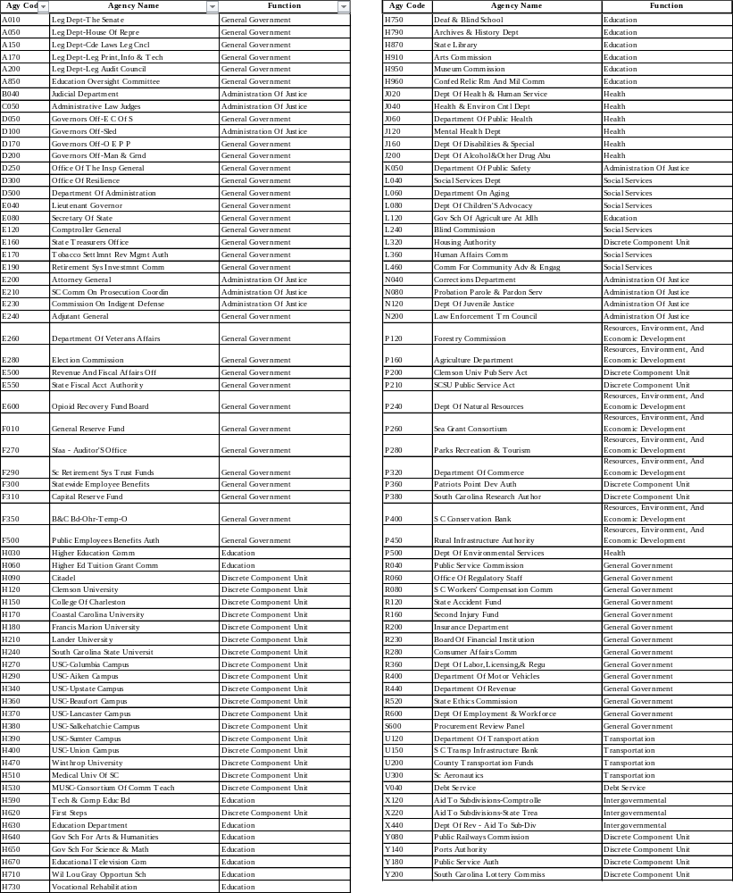

APPENDIX C—THE STATE’S MAJOR ENTERPRISE FUNDS
For the prior fiscal year, the State reported the following as its major enterprise fund:

- Unemployment Compensation Benefits Fund
- Second Injury Fund

No changes are anticipated for the current fiscal year.

APPENDIX D—FINANCIAL STATEMENT SPREADSHEETS AND FORMS,
COLLEGES AND UNIVERSITIES

INTRODUCTION
Generally Accepted Accounting Principles require that the State incorporate public, State-supported colleges and universities within its financial statements. Because South Carolina has twenty-six such public institutions, it is important that the Comptroller General’s Office receive financial statement data from these entities in a consistent manner. The Comptroller General’s Office achieves consistency by requiring that institutions submit two spreadsheets that are packaged together in a single Excel workbook.
The Comptroller General’s Office requires the following from each of the public colleges and universities:
- The completed forms and Excel spreadsheets are described in this appendix:
- An Excel workbook (.xlxs) file with separate sheets for the two basic financial statements.
- An Excel workbook completed for the cash and investment reconciliations
- Additional completed forms as described.
- Additional information in detailed written explanations, as applicable (e.g., explanations of any unusual or infrequent items under GASB 103, paragraphs 9–10, if not described in detail in the audited financial statements).
- Your institution's audited financial statements.
The Comptroller General’s Office needs this financial data:
- To allow reconciliation between your institution's balances and records maintained elsewhere within State government. (The auditors of the State's financial statements will need these reconciliations.)
- To provide data that does not appear in your institution's separately issued financial statements but must appear in the State's financial statements.
- To eliminate data appearing in your institution's separate financial statements that is not appropriate for statewide financial reporting.

ACTION REQUIRED BY THE INSTITUTION
- Obtain a copy of your institution's audited financial statements. Use the published statements if available. Otherwise, use draft financial statements that you or your auditors have prepared.
- Download the Excel workbook file and read-only Acrobat forms from the Comptroller General’s Office’s Internet website. Rename the Excel workbook xxx-Higher Ed.xlxs (providing your Business Area (previously referred to as agency code) to replace xxx in the name of the file).
- Reconcile cash and investments as presented on Statement of Net Position and disclosed within notes to confirmation provided by the Comptroller General’s Office
- Reconcile state appropriations as presented within Statement of Net Position, Statement of Activities and note disclosures to confirmation provided by the Comptroller General’s Office
- Input the required amounts into the following two Excel spreadsheets:
- Statement of Net Position.
- Statement of Activities.
- Keep a copy of the completed workbook for your records.
- Complete the College/University Checklist.
- On or before the due dates specified below, return to the Comptroller General’s Office:
- A copy of your institution’s audited financial statements, preferably via email in .pdf format to ACFR@cg.sc.gov.
- The completed Excel workbook file reflecting data shown on your audited financial statements, submitted via email to ACFR@cg.sc.gov.
- The additional completed forms along with any additional explanations, as appropriate, preferably via email in .pdf format to ACFR@cg.sc.gov.
- Hard copies are not required in addition to electronic submission.

DUE DATES
Timeliness is extremely important. To meet our goals, the Comptroller General’s Office must receive your draft and final audited financial statements on or before the due date(s) specified below.

Due dates for universities:
- Your draft audited financial statements are due to the Comptroller General’s Office no later than September 15. If the due date specified in the audit contract is sooner than September 15, the earlier date is your due date.
- The completed Excel workbook and additional forms corresponding to the above draft statements are due within 3 business days of the draft.
- The final audited financial statements are due no later than October 1. If the due date specified in the audit contract is sooner than October 1, the earlier date is your due date.
- The updated Excel spreadsheets and revised additional forms corresponding to the final financial statements are due no more than 2 business days later. Clearly identify any changes between the draft and the final audit report.
Due dates are as follows for technical colleges:
- Your final audited financial statements are due to the Comptroller General’s Office, preferably by September 30 or earlier but no later than October 1.
- The completed Excel workbook and additional forms corresponding to the final financial statements are due no more than 3 business days after the final is due.

WORKING PAPERS
The Comptroller General’s Office’s staff and/or the statewide joint audit team may ask questions of your institution that require reference to working papers used in preparing the materials discussed in this appendix. Accordingly, each college and university should keep:
- A copy of the completed Excel workbook file.
- Copies of the completed forms.
- A copy of the audited financial statements used to complete the spreadsheets and forms. (These statements may be either published or draft statements.)
- Working papers that support each figure in the completed package.

GENERAL INSTRUCTIONS—RESPONSIBILITY AND ACCURACY FORM
- The Responsibility and Accuracy Form (Assertions tab) documents certain general information that applies to all forms and electronic files that your institution submits to the Comptroller General’s Office.
- Please enter written signatures on this form.
- Complete and return the form preferably in .pdf format via email to the Comptroller General’s Office with your other forms and the Excel workbook file.
- The contact person should keep a copy of all completed forms and the Excel workbook file. The Comptroller General’s Office will call this person if there are questions.
- We have not reproduced the Responsibility and Accuracy Form in this manual. Please download the blank form from the Internet and complete it in accordance with the instructions provided here and below.

SPECIFIC INSTRUCTIONS—RESPONSIBILITY AND ACCURACY FORM
- Select the institution's name from the drop-down box in cell A7.
- Include signature and job title for any person completing any of the other forms/spreadsheets.
- The person responsible for overall review of all forms should complete this information. Include signature, job title, email address, telephone number, and completion date of the review.
- Decide who should answer any questions the Comptroller General’s Office may have regarding any of the completed forms. Enter the name, job title, email address, and telephone number of this person.

GENERAL INSTRUCTIONS—FOUNDATIONS ANALYSIS FORM
- The Foundations Analysis Form (Foundations tab) determines which, if any, of the College’s or University’s Foundations should be reported in the State’s ACFR.
- Input total assets and total revenues of the College or University and total assets and total revenues of each Foundation to determine which Foundations are material to the College or University.
- Amounts on this sheet should come from your audited financial statements.
- Return this Foundations Analysis Form to the Comptroller General’s Office along with the other required materials on or before the specified due date (see DUE DATES subsection above).
- The contact person should keep a copy of the completed Excel spreadsheet file. The Comptroller General’s Office will call this person if there are questions.
- We have not reproduced the Foundations Analysis Form in this manual. Please download the blank spreadsheet from the Internet and complete it in accordance with the instructions provided here and below.

SPECIFIC INSTRUCTIONS—FOUNDATIONS ANALYSIS FORM
- Input the College’s or University’s Total Assets and Total Revenues in cells E8 and G8.
- Input the name of each Foundation and the Foundation’s Total Assets and Total Revenues beginning on row 18.
- You are required to provide financial information on the Statement of Net Position (SONP tab) and the Statement of Activities (SOA tab) for foundations that have total assets or total revenues equal to or in excess of 15% of total assets or total revenues of the primary entity. (See footnote on Foundations Analysis Form regarding consistency between fiscal years.)
- A separate cash and investment reconciliation excel file will need to be prepared for each foundation that meets the materiality threshold for disclosure to the CGO.

GENERAL INSTRUCTIONS—STATEMENT OF NET POSITION SPREADSHEET
- In the downloaded Excel workbook, click the tab for the sheet named SONP.
- Input financial data for your institution’s primary entity into the column entitled Primary Institution. This should include educational activities as well as auxiliary enterprises. This column also includes all related capital asset and debt balances.
- Input financial data of each component unit (foundation, trust, enterprise campus authority) that is required to be included in the State’s ACFR into the Component Units columns. Enter each component unit into a separate column and enter the name of the component unit in the column heading area.
- Eliminate any balances between the primary entity and its reported component units in the Eliminations column.
- Ignore the numeric codes that appear to the left of the account code titles. These are for the Comptroller General’s Office's use only.
- Round all dollar amounts to the nearest whole dollar. Key a minus sign in front of each negative figure. Excel will print negative numbers in parentheses.
- Amounts on this sheet should come from your audited financial statements or the notes to the financial statements.
- Return this SONP file to the Comptroller General’s Office along with the other required materials on or before the specified due date (see DUE DATES subsection above).
- The contact person should keep a copy of the completed Excel spreadsheet file. The Comptroller General’s Office will call this person if there are questions.
- The Statement of Net Position spreadsheet is not reproduced in this manual. Please download the blank spreadsheet from the Internet and complete it in accordance with the instructions provided here and below.

SPECIFIC INSTRUCTIONS—STATEMENT OF NET POSITION SPREADSHEET
- Classified Format: The State’s ACFR will not present a classified statement of net position for its discretely presented component units, with the exception of long-term liabilities. The SONP spreadsheet does contain current and non-current accounts for most items. Please enter balances as they are presented on the stand-alone financial statements and related note disclosures for ease in agreeing the SONP spreadsheet to the stand-alone financial statements. Long-term debt must be split into current and non-current portions even if not presented that way on the stand-alone financial statements. (Please see additional instructions in footnotes on the SONP tab in the Excel workbook.)
- Receivables: The State’s ACFR will present only net receivables for its discretely presented component units. The SONP spreadsheet does contain gross and allowance accounts, but it is your choice whether to enter gross and allowance amounts or net balances.
- Accounts Receivable (Miscellaneous): Use Accounts Receivable (Miscellaneous) to record any receivable accounts included in your financial statements that are not separately identified in the SONP spreadsheet.
- Due from others within your reporting entity (to be eliminated): You may use this row of the SONP spreadsheet to record any amounts due from entities within your stand-alone financial statements that are also reported in the State’s ACFR. These balances must be eliminated in the Eliminations column. (Please see additional instructions in footnotes on the SONP tab in the Excel workbook.)
- Due from State General Fund and other State agencies (Primary Government): Use this row to record any amounts due from the Primary Government (the State’s General Fund or other State agencies).
- Restricted Assets: Use restricted assets accounts for any restricted assets (for example, restricted due to bond covenants, restricted for federal Perkins loan program, etc.).
- Due to others within your reporting entity (to be eliminated): You may use this row of the SONP spreadsheet to record any amounts due to entities within your stand-alone financial statements that are also reported in the State’s ACFR. These balances must be eliminated in the Eliminations column. (Please see additional instructions in footnotes on the SONP tab in the Excel workbook.)
- Due to State General Fund and other State agencies (Primary Government): Use this row to record any amounts due to the Primary Government (the State’s General Fund or other State agencies).
- Liabilities Payable from Restricted Assets: Liabilities Payable from Restricted Assets should include any liabilities associated with administrative expenses of Perkins loan program activities.
- Bonds Payable: Assign bond liability amounts to the appropriate current and
non-current bond payable categories. These amounts must agree to your institution’s footnote disclosure for long-term debt. Report unamortized premiums/discounts on the separate rows provided on the template (no current/non-current split).
- Notes Payable To (or Advances From) Other State Agencies: If your institution has notes payable to (or advances from) other State agencies, please report the payable amounts as part of Due to State General Fund and other State agencies (Primary Government).
- Line of Credit: If at year-end your institution had any balance outstanding on a line of credit, please report the balance as part of Loans and Notes Payable. For information about note disclosures required for lines of credit, please see SHORT-TERM DEBT in Section 6 (Footnote Disclosure) of this policy manual.

- In addition to the above instructions, please carefully review all footnotes at the bottom of the SONP spreadsheet in the Excel workbook. There are additional detailed instructions primarily related to including FASB Foundations for those colleges and universities required to report material Foundations.

GENERAL INSTRUCTIONS—STATEMENT OF ACTIVITES SPREADSHEET
- In the downloaded Excel workbook, click the tab for the sheet named SOA.
- Input financial data for your institution’s primary entity in the column entitled Primary Institution. This should include educational activities as well as auxiliary enterprises.
- Input financial data of each component unit (foundation, trust, enterprise campus authority) that is required to be included in the State’s ACFR into the Component Units columns. Enter each component unit into a separate column and enter the name of the component unit in the column heading area.
- Eliminate any balances between the primary entity and its reported component units in the Eliminations column.
- Ignore the numeric codes that appear to the left of the account code titles. These are for the Comptroller General’s Office's use only.
- Round all dollar amounts to the nearest whole dollar. Key a minus sign in front of each negative figure. Excel will print negative numbers in parentheses.
- Amounts on this file should come from your audited financial statements or the notes to the financial statements.
- Return this SOA file to the Comptroller General’s Office along with the other required materials on or before the specified due date (see DUE DATES subsection above).
- The contact person should keep a copy of the completed Excel spreadsheet file. The Comptroller General’s Office will call this person if there are questions.
- The Statement of Activities is not reproduced in this manual. Please download the blank spreadsheet from the Internet and complete it in accordance with the instructions provided here and below.

SPECIFIC INSTRUCTIONS—STATEMENT OF ACTIVITIES SPREADSHEET
- Statement of Activities format: The SOA spreadsheet is presented in the manner in which discretely presented component units will be presented in the State’s ACFR. Within each Statement of Activities category are the accounts generally presented on the Statement of Revenues, Expenses, and Changes in Net Position. Please enter accordingly for ease in agreeing the SOA spreadsheet back to the stand-alone financial statements.
- Expenses: Include all expenses within this section, including operating, non-operating, and transfers (which are recorded as expenses for discretely presented component units). Payments to entities within your stand-alone financial statements that are also reported in the State’s ACFR must be eliminated in the Eliminations column. (Please see additional instructions in footnotes on the SOA tab in the Excel workbook.)

GENERAL INSTRUCTIONS—CASH AND INVESTMENTS
The purpose of this section is to reconcile the final versions of cash and investment per the entity’s statement of net position back to the confirmation/reconciliation of cash and investments that will be provided to your agency by the CGO.
Confirmations from the CGO will be sent out roughly in the second week of August to entities and their auditors and will serve as a reconciliation template between the Statements of Net Position and note disclosures.

Information included on the confirmation include:

Cash and Investments the State Treasurer: Cash and Investments held for the entity by the State Treasurer.
The confirmations will contain the entities’ cash and investment holdings at the STO as detailed by:
- STO Pooled Cash and Investments at FMV by Business Area and Fund (to be reported as cash and cash equivalents)
- STO Pooled Cash timing adjustments
- STO total composite reservoir balance by bank account
- STO total LGIP holdings for entity
- Footnote disclosure of FMV and unrealized gain/loss
Confirmation balances plus any auditor approved timing adjustments to composite reservoir bank balances must cash and cash equivalents held by the STO as disclosed in the notes.

Cash and Investments Held by Entity: Cash and Investments held by the entity, outside of the STO’s control.
Agency to detail amounts on the confirmation from CGO and return to the CGO upon submission of financial statements and related data.
- Petty Cash-Cash on hand
- Cash held by Entity-carrying value of cash held by entity at banking institutions outside of STO control
- Cash held by Entity Bank-bank balance of cash held by entity at banking institutions outside of STO control
  - Custodial credit risk must be provided for bank balance
- FMV of Investments Held by Entity-FMV of investments held by entity. Include in this any investments that are held at net asset value (NAV).

Reconciliation of Worksheets to Statement of Net Position: The total of Cash per Financial Statement Held by State Treasury (with auditor approved timing adjustments) and Cash and Investments Held by Entity must equal cash and investments per the statement of net position. A variance indicates that an error has been made on the cash and investments worksheet as it does not agree to total cash and investments per the face of the financial statement.

Exposure of Custodial Credit Risk for Cash Held by Entity: Total cash held by entity must be disclosed by custodial credit risk according to the four levels.

Custodial credit risk is defined as the risk that, in the event of the failure of the counterparty, the Entity will not be able to recover the value of its investments or collateral securities that are in the possession of an outside party.
Custodial Credit Risk disclosure in total must agree to total cash held by an entity.
- FDIC & Other Coverage-Portion of Cash Held by entity that is FDIC insured or otherwise fully insured.
- Category A-Portion of Cash Held by Entity that is uninsured but collateralized, but the collateral is held by the pledging financial institution itself.
- Category B -Portion of Cash Held by Entity is collateralized and the collateral is held by either the financial institution trust department or agent, but the collateral is not held in the name of the depositor government.
- Category C-Portion of Cash held by Entity that is not collateralized, not insured.

SPECIFIC INSTRUCTIONS—CASH AND INVESTMENTS
- Confirmations: Confirmation balances plus any auditor approved timing adjustments for composite reservoir bank balances must equal final balance of Cash per Financial Statement Held by the STO as disclosed in the financial statements.
- Cash and Investments Held by Entity: Cash and Investments held by the entity, outside of the STO’s control, do not need to be detailed by fund and/or holding institution on worksheet.
- Reconciliation of Worksheets to Statement of Net Position: The total of Cash per Financial Statement Held by State Treasury (with auditor approved timing adjustments) and Cash and Investments Held by Entity must equal cash and investments per the statement of net position. A variance indicates that an error has been made on the cash and investments worksheet as it does not agree to total cash and investments per the face of the financial statement.
- Exposure of Custodial Credit Risk for Cash Held by Entity: The sum of the disclosures of custodial credit risk must equal total cash held by entity (outside of the STO).
- Agency will submit completed cash and investment confirmation/reconciliation and return to the Comptroller General’s Office by October 1.

GENERAL INSTRUCTIONS—COLLEGE/UNIVERSITY CHECKLIST
- The purpose of this checklist is to help ensure that the information on your forms and spreadsheets is reliable. Your completion of these steps should reduce the need for telephone calls from the Comptroller General’s Office and resulting delays in incorporating your financial statement data into the statewide ACFR. The Comptroller General’s Office also will show this checklist to auditors of the statewide financial statements.
- Complete this form only after you have completed all other forms and spreadsheets in this appendix.
- Sign and date each review step as you complete it.
- Complete and return the form preferably in .pdf format via email to the Comptroller General’s Office no later than the specified due date(s).
- The contact person should keep a copy of the completed form. The Comptroller General’s Office will call this person if there are questions.
- The College/University Checklist is not reproduced in this manual. Please download the blank form from the Internet and complete it in accordance with the instructions provided here and below.

SPECIFIC INSTRUCTIONS—COLLEGE/UNIVERSITY CHECKLIST
- Enter the fiscal year for which this form applies.
- Enter the institution's name and the Business Area (previously referred to as agency code).

APPENDIX E—CLASSIFICATION OF AMOUNTS RECEIVED BY COLLEGES AND UNIVERSITIES FROM THE COMMISSION ON HIGHER EDUCATION (CHE)
Revenue Type | GASB 103 Classification | Notes/Comments
LIFE Scholarship | Operating Revenue | Portable student aid similar to Pell; paid on behalf of the student and expected to follow the student.
HOPE Scholarship | Operating Revenue | Portable scholarship benefiting eligible students; analogous to LIFE and Pell treatment.
Palmetto Fellows | Operating Revenue | Portable student aid; funding follows the student.
Educational Endowment | See Notes/Comments | Does this follow the student? If so, then it should be classified as operating revenue. If not, then it should be classified as a noncapital subsidy.
Need Based Grants | Operating Revenue | Generally, student financial assistance paid on behalf of students and tied to enrollment; similar to Pell concept.
Lottery Tuition Assistance | Operating Revenue | Portable tuition assistance provided for students attending eligible institutions.
Centers of Excellence | Noncapital Subsidy | State support for institutional operations rather than exchange-based revenue; review grant terms.
Teacher Recruitment | Noncapital Subsidy | State support program intended to subsidize educational objectives; review program agreement.
DDE Math and Science | Noncapital Subsidy | State educational support funding; classification depends on whether specific deliverables are required.
Performance Funding | Noncapital Subsidy | State appropriations/support based on performance metrics generally support institutional operations and may keep tuition lower.
Higher Education Awareness Program | Noncapital Subsidy | Programmatic support provided without exchange consideration, correct?
SC Alliance for Minority Participation | See Notes/Comments | These monies are NOT considered research grants and are NOT considered portable tuition assistance, correct? If so, these would be classified as noncapital subsidies. If they are R&D, then see EPSCoR notes below. If they are portable tuition assistance, then they would be classified as operating revenue.
SC Experimental Program to Stimulate Competitive Research (EPSCoR) | See Notes/Comments | Are these monies considered research grants? If so, the classification will depend on GASB's decision on Question #4.4 in the Proposed Implementation Guidance for Subsidies, which has not been finalized yet.
Academic Endowment | Other Nonoperating Revenue - Endowment Contribution | Contributions to permanent or term endowments are classified outside operating revenues and subsidies under GASB 103.
Technology Grant Program (Noncompetitive Portion) | Noncapital Subsidy | Appears to be support funding rather than payment for research or services; review terms for deliverables.

Section 75.2 of the State’s General Appropriations Bill.
See Section 75.2 of the State’s General Appropriations Bill.
GASB 76, The Hierarchy of Generally Accepted Accounting Principles for State and Local Governments (June 2015).
Paragraph 62 of GASB 34 explains that although internal service funds are reported as proprietary funds in the fund financial statements, the activities accounted for in them (the financing of goods and services for other funds of the government) are usually more governmental than business-type in nature. Therefore, internal service funds are reported as governmental activities in the government-wide financial statements.
Footnote 23 of GASB 34 (as amended by GASB 63) and the answer to Question 81 in the first GASB 34 Implementation Guide (Question 7.22.1 in Comprehensive Implementation Guide—2011-2012) make it clear that governments may use a classified format for their government-wide statements of net position.
Page 304, 2005 edition, Governmental Accounting, Auditing, and Financial Reporting, published by the Government Finance Officers Association.
Page 191, 2005 edition, Governmental Accounting, Auditing, and Financial Reporting, published by the Government Finance Officers Association.
GASB Cod. Sec. 1300.118.
The GOFER website www.gfoa.org under Publications; select the Best Practices & Advisories in the left selection panel. Select Accounting, Auditing, and Financial Reporting to Access the selection for Improving the Effectiveness of Fund Accounting (2004). A PDF option is in the upper right corner.
Paragraphs 61 and 112, GASB 34; GASB Cod. Sec. 2600.116 and 1800.102.
GASB Cod. Secs. 2600.117 and L20.121.
See Question 15-001-03 on the GFOA’s General Purpose Checklist available under GFOA Award Programs, (COA) Award Program, Comprehensive General-Purpose Checklist at the GFOA website (site referenced previously).
Paragraph 61, GASB 34; GASB Cod. Sec. 2600.116.
GASB Cod. Secs. 2600.117 and L20.122.
Footnote 23 and paragraph 99 of GASB 34 (GASB Cod. Sec. 2200.165) and paragraph 2.56 of Audits of State and Local Governments (GASB 34 Edition) (AICPA, May 1, 2003).
2024 edition of the GFOA’s Governmental Accounting, Auditing and Financial Reporting.
However, a college with no blended component units may satisfy this requirement by providing this level of detail to the Comptroller General’s Office on the spreadsheet version of its Statement of Net Position.
See paragraph 50, GASB 34, and Question 7.34.6 in the GASB’s Comprehensive Implementation Guide—2011-2012).
Paragraph 25 of GASB 33; GASB Cod. (2001-2002 GASB 34 Edition) Sec. N50.122.
Paragraph 69 of GASB 34.
Section 2600.120 of the Codification of Governmental Accounting and Financial Reporting Standards.
Section 2600.120 of the Codification of Governmental Accounting and Financial Reporting Standards.
See GASB codification section 2450.705-2
Question 2.13.3 in the GASB’s 2015 Implementation Guide addresses restricted cash by clarifying that GASB 9 disregards restriction of use as a factor in determining whether an asset meets the definition of cash or cash equivalent.
See definition in the Glossary in Paragraph 22 of GASB 31.
This statement supersedes GASB Technical Bulletin 2003-1.
GASB Codification Section 2300.113.
GASB 23, paragraph 4, as amended by GASB 34 paragraphs 15 and 91 and GASB 65 paragraph 6.
Paragraph 11 of GASB 33; GASB Cod. Sec. N50.108 (2001-2002 GASB 34 Edition).
Alternatively, see GASB Cod. Secs. 2500.101 through .102 and the no authoritative discussion at GASB Cod. Sec. 2500.901.
Paragraph 17 of GASB 37; footnote g to paragraph 17 of GASB 37.
Footnote 48, GASB 34 (also Footnote 1, GASB Cod. Sec. 2500.101).
Paragraphs 4-7 of GASB 56, Codification of Accounting and Financial Reporting Guidance Contained in the AICPA Statement and Auditing Standards (March 2009).
Adapted from Section R36.102, FASB Accounting Standards as of June 1, 2006.
GASB Codification 2200.714-5 Since most of the revenues of a business-type component unit derive from “programmatic” activity and thus qualify as program revenues.
See Question 286 of the first GASB 34 Implementation Guide, 2001 (Question 7.12.14 in the GASB’s Comprehensive Implementation Guide—2011-2012).
Please contact the Central State Financial Reporting Division, Comptroller General’s Office, for more detailed reasons underlying these policies.

