Katherine Kip, CPA and James Torbert, CPA
kkip@cg.sc.gov, jtorbert@cg.sc.gov
Abstract
Required Implementation beginning July 1, 2022
Gasb 96 subscription based information technology agreements
GUIDANCE FOR YOUR AGENCY’S ACCOUNTING TEAM

The Governmental Accounting Standards Board (GASB) issued Statement No. 96, Subscription-Based Information Technology Arrangements, on June 5, 2020.
To access full statement click-GASB 96

The new guidance is intended to reduce inconsistencies and improve the accounting and financial reporting of subscription-based information technology arrangements (SBITAs).

Key Provisions
Prior to the issuance of Statement No. 96, there was no accounting or financial reporting guidance specifically for government end users of SBITAs. Statement No. 96 establishes a definition for SBITAs and provides guidance on the accounting and financial reporting for such arrangements.
An overview of the new guidance is provided below.

Scope
Statement No. 96 defines a SBITA as a contract that conveys control of the right to use another party’s IT software, alone or in combination with tangible capital assets, as specified in the contract for a period of time in an exchange or exchange-like transaction.
To determine whether a contract conveys control of the right to use the underlying IT assets, a government should assess whether it has both of the following:
- Right to obtain the present service capacity from use of the underlying IT assets as specified in the contract
- Right to determine the nature and manner of use of the underlying IT assets as specified in the contract
Subscription Term
The subscription term is the period during which a government has a noncancellable right to use the underlying IT assets in addition to the following:
- Periods covered by an option to extend if it is reasonably certain that the government or vendor will exercise that option
- Periods covered by an option to terminate if it is reasonably certain that the government or vendor won’t exercise that option
Periods for which both the government and the SBITA vendor have an option to terminate the SBITA without permission from the other party (or if both parties have to agree to extend) are cancellable periods and are excluded from the subscription term.*
*Note- A fiscal funding or cancellation clause in a SBITA should affect the subscription term only if it is reasonably certain that the clause will be exercised (i.e.-severe state cutbacks). If it is reasonably certain that the contract will NOT be cancelled due to funding, your agency must include the SBITA.

Recognition and Measurement
At the commencement of the subscription term, a right-to-use subscription asset—an intangible asset—and a corresponding subscription liability should be recognized. The commencement of the subscription term begins when the subscription asset is placed into service. This occurs when:
- The initial implementation stage is completed—described below.
- The government has obtained control of the right to use the underlying IT assets.

Subscription Liability
The subscription liability should be initially measured at the present value of subscription payments expected to be made during the subscription term including the following:
- Fixed payments
- Variable payments that depend on an index or a rate (such as the Consumer Price Index or a market interest rate), measured using the index or rate as of the commencement of the subscription term
- Variable payments that are fixed in substance
- Payments for penalties for terminating the SBITA, if the subscription term reflects the government exercising an option to terminate or a fiscal funding or cancellation clause
- Any subscription contract incentives receivable from the vendor
- Any other payments to the vendor associated with the contract that are reasonably certain of being required based on an assessment of all relevant factors
Future subscription payments should be discounted using the interest rate the vendor charges the government, which may be implicit in the contract. If the interest rate is not readily determinable, the government’s incremental borrowing rate should be used. Amortization of the discount on the subscription liability should be reported as an outflow of resources— interest expense.

Subscription Asset
The subscription asset should be initially measured as follows:
- Initial subscription liability amount
- Plus, payments made to the vendor before commencement of the subscription term
- Plus, implementation costs that can be capitalized
- Less any incentives received from the SBITA vendor at or before commencement of the subscription term
The subscription asset should be amortized in a systematic and rational manner over the shorter of the subscription term or the useful life of the underlying IT asset. Amortization of the subscription asset should be recognized as an outflow of resources—amortization expense.

Short-Term Exception
Statement No. 96 provides an exception for short-term SBITAs, which have a maximum possible term under the SBITA contract of 12 months or less. Subscription payments for short-term SBITAs should be recognized as an outflow of resources.

Implementation Costs
Activities associated with a SBITA should be grouped into one of three stages, detailed in the table below, and their costs should be accounted for accordingly. In classifying outlays into the appropriate stage, the nature of the activity should be the determining factor.
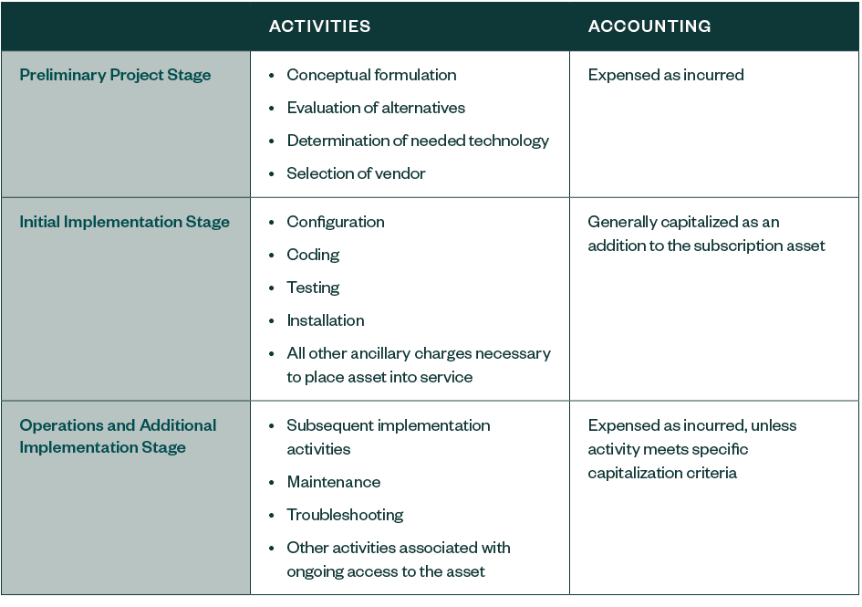
Training costs should be expensed as incurred regardless of the stage in which they’re incurred.

Components
If a contract contains both a subscription component and a nonsubscription component, the subscription and nonsubscription components should generally be accounted for as separate contracts.
The contract price should generally be allocated to the different components based on the stand-alone price of each component included in the contract.

Disclosure Requirements
Under the updated guidance in Statement No. 96, a government should disclose descriptive information about its SBITAs (excluding short-term SBITAs) in the notes to the financial statements, including:
- General description of its SBITAs, including the basis, terms, and conditions on which variable payments not included in the measurement of the subscription liability are determined
- Total amount of subscription assets, and the related accumulated amortization, disclosed separately from other capital assets
- Amount of outflows of resources recognized in the reporting period for variable payments not previously included in the measurement of the subscription liability
- Amount of outflows of resources recognized in the reporting period for other payments, such as termination penalties, not previously included in the measurement of the subscription liability
- Principal and interest requirements to maturity, presented separately, for the subscription liability for each of the five subsequent fiscal years and in five-year increments thereafter
- Commitments under SBITAs before the commencement of the subscription term
- Components of any loss associated with an impairment

Effective Dates
The statement is effective for fiscal years beginning after June 15, 2022 (fiscal year 2023), and all reporting periods thereafter.

What should you do?

Step 1: Visit www.cg.sc.gov for additional GASB 96 implementation guidance.

- The “GASB 96 SBITA - Potential GL Accounts & Vendors” lists have been provided to assist your agency in researching and identifying SBITAs.
  - The GL accounts are pulled from the “Expenditure General Ledger Account Definitions” on the CG’s website based on software related definitions. They are not all inclusive but will hopefully provide a good starting point for your research.
  - The potential vendors are pulled from MMO statewide contracts related to IT. The vendor list is not all inclusive and may contain vendors that provide hardware rather than just software. Your agency should use this vendor list as a starting point for your research.
- The “GASB 96 Introduction for Agencies” video walks through the high-level concepts for GASB 96.
- The “GASB 96 Implementation File” will serve as core worksheet for gathering and recording the SBITAs. This file is very similar to the GASB 87 Implementation File.
- Read GASB 96 Official Statement for any issues not covered in the Comptroller General’s guide that may be applicable to your Agency. Click link to follow: GASB 96

Step 2: Identify existing software subscription contracts.

- Review GL expenditures related to software and IT subscriptions.
- Review IT vendor activity for software subscriptions contracts.
- Consult with your IT department for inventory of software.
- Review existing IT leases for significant software components.
- EXCLUDE any software subscription contracts that your agency subscribes to through SC Division of Technology. These would be software subscriptions where DTO bills your agency. (Example: If your agency pays DTO for Adobe Pro licenses).

Step 3: SBITA Qualifications.
Determine if each software subscription contract identified in Step 2 qualifies as a SBITA. The following are a few important questions to ask yourself when determining if a SBITA exists:

Question 1- Will this software no longer work/will we no longer be able to log in once the contract term ends?
If your answer is “yes, we will not be able to access the software at the end of the contract”, it is likely that a SBITA exists*
*Note-Perpetual software licenses are excluded from GASB 96 (think your Excel version 95 that has been hanging around forever)
Question 2- Does the contract provide the Agency the right to use the IT software? *

If your answer is “yes”, it is likely that a SBITA exists

*Further discussion-GASB 96 covers temporarily leased software, not internally created software. GASB 96 also excludes contracts that provide solely maintenance, support, or training IT services. GASB 96 is very specific and focused on contracts that provide the right to determine the nature and manner of use of IT software. A good analogy would be an agency leasing a backhoe and putting an employee in the backhoe to tear up the parking lot for the three years (SBITA!!) vs. hiring a contractor who uses their backhoe to tear up your parking lot for three years (not a SBITA!!).
Question 3-. Is the maximum contractual term of our contract, including any contractually bound options to extend (by lessee or lessor) 12 months or less? *

If your answer is “yes”, then this is short-term and should be expensed.
If your answer is “no”, it is likely that a SBITA exists.

*Further discussion-GASB 96 specifically covers intent to extend outside of contract. This should not be included in the life of the asset. Only the legally covered, contractually bound lease period is considered the life of the asset, regardless of whether the Agency will pursue renewing the lease at the end of the contract. Refer to GASB 96 for further guidance.
If the software subscription contract qualifies as a SBITA, then Steps 4-8 will need to be performed. These steps are written from a high concept level. Refer to the GASB 96 Implementation File for the detailed process of calculating the subscription asset and liability.

Step 4: Determine the length of the subscription term
The subscription term starts when a governmental entity has a non-cancellable right to use the underlying IT assets. This is the period during which the SBITA vendor does not have the ability to cancel the contract, increase or decrease rates, or change the benefits/terms of the service. The contract language for this period can also include an option for the Agency or the SBITA vendor to extend or terminate the contract, if it is reasonably certain that either of these options will be exercised.
Once a subscription term is set, your Agency should revisit the term if one or more of the following occurs:
- The potential option (extend/terminate) is exercised by either the entity or the SBITA vendor
- The potential option (extend/terminate) is not exercised by either the government or the SBITA vendor
- An extension or termination of the SBITA occurs
If the maximum possible term under the SBITA contract is 12 months or less, including any options to extend, regardless of their possibility of being exercised, an exception for short-term SBITAs has been provided under the statement. Such contracts do not need to be recognized under the Statement and the subscription payments will be recognized as outflows of resources.
- The “GASB 96 Implementation File” will serve as core worksheet for gathering and recording the SBITAs. This file is very similar to the GASB 87 Implementation File. It can help you determine the length of the subscription term.

Step 5: Measurement of subscription liability
The subscription liability is measured at the present value of the subscription payments expected to be made over the life of the contract. The SBITA contract will include specific measures that should be used in determining the liability that could include the following:
- Fixed payments
- Variable payments****
- Payments for penalties for termination
- Contract incentives
- Any other payments to the SBITA which are included in the contract
- Taxes
The future payments are discounted using the interest rate that the SBITA charges to your Agency. The interest rate may be implicit in the contract. If it is not readily determinable, the rate should be estimated using the State’s incremental borrowing rate (prime rate at the time of the contract).
Your Agency will only need to re-measure the subscription liability is there is a change to the subscription term, change in the estimated amounts of payments, change in the interest rate the SBITA charges to your Agency, or contingencies related to variable payments. A change in the discount rate alone would not require a re-measurement.
****Please Note-Variable payments that are not fixed in nature should not be capitalized. For example, per seat charges that increase or decrease depending on volume are not fixed in nature; therefore, these variable costs would be considered Contingent Expense and would NOT be capitalized. An example of variable payments that are fixed in nature and WOULD be capitalized are variable costs that are indexed to a certain price gauge specified in the contract.
- The Lease Calculator used during GASB 87 will measure your subscription liability. SCEIS assets will be set up after 7/1/2022.

Step 6: Measurement of subscription asset
The SBITA asset should be measured at the total of the following:
- The amount of the initial measurement of the subscription liability (noted in Step 5 above)
- If applicable, any payments made to the SBITA vendor at the beginning of the subscription term
- The capitalized initial implementation costs (noted in Step 7 below)
Any SBITA vendor incentives received should be subtracted from the total.
- The Lease Calculator used during GASB 87 will measure your subscription asset. SCEIS assets will be set up after 7/1/2022.

Step 7: Capitalization of other outlays
Statement No. 96 provides for other outlays associated with the subscription to be capitalized as part of the total subscription asset. When implementing the IT asset, the activities can be divided into three stages:
- Preliminary project stage: May include a needs assessment, selection, and planning activities and should be recorded as expenses.
- Initial implementation stage: May include testing, configuration, installation, and other ancillary charges necessary to implemental the IT asset. These costs should be capitalized and included in the subscription asset.
- Operation and additional implementation stage: May include maintenance and troubleshooting and should be expensed.
- The Lease Calculator used during GASB 87 will measure your capitalization of other outlays. SCEIS assets will be set up after 7/1/2022.

Step 8: Amortization and Subsequent Subscription Payments
The subscription asset is amortized over the shorter of the subscription terms or the useful life of the underlying IT assets. The amortization of the asset is reported as amortization expense or an outflow of resources. Amortization should commence at the beginning of the subscription term.
Subsequent subscription payments should be accounted for as payments of principal and interest according to the subscription liability amortization table. Variable or other costs not included in the subscription liability should be expensed to Contingent Expenses (discussed in Step 5).
- The Lease Calculator used during GASB 87 will measure your amortization of subsequent subscription payments and the GASB 96 Implementation File “Payment Schedules” tab will reconcile back to the G/L as items are posted throughout the year. SCEIS assets will be set up after 7/1/2022.

The amortization schedules with be set up by your Agency and reconciled back to the G/L. A closing package will be required at least yearly to verify that assets in SCEIS are being accounted for according to GASB 87 and 96.
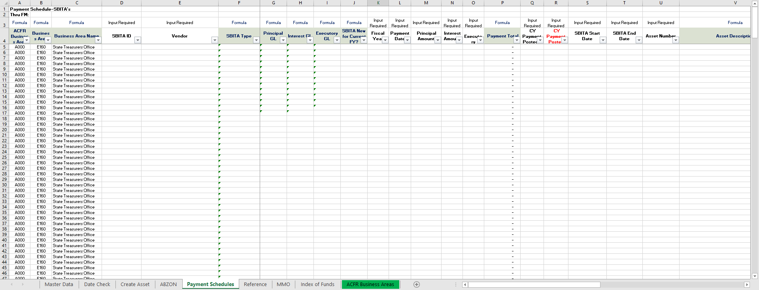
Conclusion
Understanding and implementing GASB 96 will be the responsibility of your Agency’s Accounting department. Please take the time to read the statement. Please call or email with any questions you may have.
Katherine Kip, CPA | James Torbert, CPA
803.734.5043 | 803.734.4178
kkip@cg.sc.gov | jtorbert@cg.sc.gov

